Water recycling

[Prepared by Ram Krishnan – IITM alumni – for the PanIIT 2006 Mumbai event]

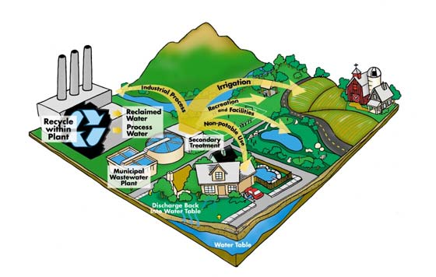

(Graphic above: Courtesy of P.Senthilnathan, IITM alumnus, EnviroGem Inc, Toronto, Canada)

Water recycling refers to reclaiming wastewater from industrial, residential, municipal sources, by treating and purifying the wastewater for reuse. Based on the extent of the treatment and availability of fresh water, the reclaimed water can be used in the industrial process, to irrigate crops, for human consumption (after boiling and filtering).
Water terminology:

White water is it is filtered/chlorinated water from both surface and groundwater sources.
Greywater is wastewater generated from processes such as washing dishes, laundry and bathing.
Blackwater is contaminated with sewage or toxic chemicals.

Reclaiming wastewater involves removing these contaminants: Organic Compounds - generally measured as Biological Oxygen Demand (BOD), Suspended Solids, Oil & Grease, Nitrogen (ammonia, organic nitrogen, etc.), Phosphorus, Inorganic Compounds (metals, salts, etc.)

Community based recycling

Greywater from buildings can be filtered and reused for usage in the toilets. These buildings have ‘double plumbing’. Alacrity Foundation buildings – a large building contractor in Chennai with 40+ buildings, has installed double plumbing in their buildings and the grey water is filtered and recycled. Kitchen water from a pilot hostel in IIT Madras is filtered and used for agriculture instead of being sent as sewage. (Picture: kitchen water being reclaimed for agricultural usage in IITM)

Treated municipal wastewater has nutrients such as nitrogen, phosphorous, and potassium, which are good for the land. Recycling this water for agriculture minimizes the need for chemical fertilizer use (which is made using mined materials and uses a lot of energy to produce). By recycling municipal wastewater, you manage the hydrologic cycle, nutrient cycle and the carbon cycle (since plants sequester carbon and carbon is conserved by not using the energy required for fertilizer production)

NEWater is the brand name given to reclaimed water produced by Singapore's public utilities. It is treated wastewater (sewage) that has been purified using dual-membrane (via micro filtration and reverse osmosis) and ultraviolet technologies, in addition to conventional water treatment processes. The water is potable and is consumed by humans. These older buildings do not have double plumbing and hence the entire sewage water is taken to a central area in the city, filtered and then the recycled water is pumped back.

River water recycling

It is well known that major rivers in the world such as Thames in London, Reine in Germany, Mississippi in the US, have water recycling programs all along the length of the rivers. A township along the river treats its sewage and dumps it into the river. Another township downstream, takes this water, purifies it and uses for potable needs. Such recycling of river water is not common in India. For example, the leather goods manufacturers in the Erode district in Tamil Nadu take the clean waters from the river Kaveri, use it in their manufacturing process, then dump the untreated sewage into the river. After the Ganges River leaves the banks of Varanasi, it collects all the sewage from towns on its banks. By the time Ganges reaches West Bengal, the water looks like used automotive oil.

Industrial Corporations
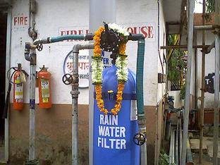
Many manufacturing and processing industries use significant amount of processing water. The contaminated water can be purified, chemically made pH neutral and reused in the manufacturing process. Escorts Ltd in Bangalore, Mico-Bosch, Asian Paints in Mumbai are examples of good corporate citizens regarding water recycling..

Chennai Petroleum in Tamil Nadu purchases the city sewage water at Rs 7 per 1000 litres and purifies it for its usage in its refinery in Manali, near Chennai.

Challenges to Indian industry

[Source: Center for Science and Environment, Delhi]

Water use in Indian industry is very high due to a combination of factors including obsolete process technology, poor recycling and reuse practices and poor wastewater treatment. Water once used is generally thrown without any further use, even if the water is not much contaminated. Segregation of wastewater from various processes into clean wastewater, (that can be reused) and contaminated water is not commonly done. The result is that even the uncontaminated water gets contaminated after mixing and is discharged as effluent.
Indian industry, especially thermal power plants, consume majority of their water for cooling requirements. Majority of industries use 'once-through cooling systems', in which water once used for cooling is discharged. Similarly, reuse of non-contact steam condensate is also not favored in India, though it is virtually clean and can be reused by reducing the total dissolved solids (TDS).
The wastewater treatment system in Indian industry is essentially installed to meet the wastewater discharge norms. The design principles do not consider the possibility of recycling and reusing the wastewater. Inevitably, in all industries the wastewater discharged is seldom suitable for reuse within the industry, though industry expects other users to reuse its wastewater because it is 'treated'. Most industries have their water intake points upstream of their wastewater discharge points. This itself exemplifies the quality and interest of wastewater treatment by Indian industry.
There are enough technologies to solve all water problems and what is more, the prices of these technologies are gradually decreasing. In a nutshell, it quite feasible today for an Indian industry to substantially reduce its water consumption and wastewater discharge by putting efficient systems for recycling and reusing the process water. But for this to happen government policy needs to be overhauled.

What can individuals do?

If you live in a urban city in India, you can join hands with the other tenants in your building, find a way to collect kitchen water (greywater), filter it using a filtering plant bed and divert to outside gardens. Plants such as Canna (kal vaazhai), Banana and Colocasia can be used to filter the greywater.

Recycling was part of the old houses in rural India

Some of these recycling ideas were incorporated in the design of houses in the olden days. In the main house, kitchen and bathroom were included. Grey water from the main house was used for gardening and watering the trees. The toilet was located at one end of the compound as a standalone structure. The black water and the sewage from the toilet was diverted to a soak pit and allowed to dry out. The filtered water would charge the ground and dried out solids were used in agriculture.

Appeal to IIT alumni

Water is given in plenty by Mother Nature, but we need to use it wisely and not fight about allocations for industry, agriculture and domestic use. Wastewater recycling and reuse and Flood Water management through detention basins (RWH) and other recharge techniques are the wise ways to manage water. Proper pricing of water ensures conservation and pays for the Operations & Maintenance costs of distribution (leaking water pipes waste 50% of the water without proper O&M) and treatment facilities.

Learn more about Water and how to reduce your consumption, how to recycle the waste water, how to charge the underground. Countries like India and China are the largest consumers of electric pumps in the world, to pump ground water. In many parts of India, the ground water level is going down by 10 feet every year.

The school children of Rajasthan have this phrase in Hindi – “Jal hai, to kal hai”. (if you have water, then you have a tomorrow). Take action - where you live, where you work, where you shop and where you go for community events. The technology involved is quite simple and inexpensive. Set an example to others. Do not wait for the Government to rescue you.

Contact:
Ram.krishnan@Yahoo.com

