Rain Water Harvesting Intervention in Chured-Dhar Village in Uttarakhand
More erratic and extreme rainfall events leading to longer dry periods sometimes and high water availability at other times in the hilly region of Uttarakhand. Owing to the longer dry periods, available water sources are no longer sufficient, and groundwater levels drop even further, resulting in longer distances to fetch drinking water. This confirms the importance of efficient and effective storage of as much water as possible during the rainy seasons. Rooftop Rain Water harvesting is a traditional practice that dates back hundreds of years, is relatively cheap to implement as compared to gravity piped water scheme. Storage in above-ground Ferro-cement tanks is a technical viable option. In general, Ferro-cement tanks have an estimated lifespan of 15 to 20 years, provided the systems are well-maintained. Since 2001, Sir Ratan Tata Trust (SRTT) supported Water Supply and Sanitation (WATSAN) program is providing potable water supply via gravity piped water supply where source/spring is available and Rain Water Harvesting Tanks (RWHT) where the source/spring is not available and rainfall rate is up to desired mark.

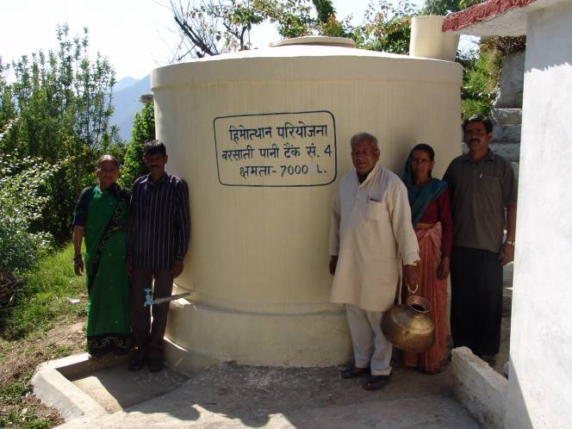
Intervention:
Village Chured-Dhar in Tehri District, Uttarakhand is such village where no gravity source was available, keeping in mind the average 1,395 mm rainfall in the district, the village was selected in 2003 for RWHT intervention under Himmotthan Pariyojana, 59 individual households, RWHT were constructed with community participation having a capacity of 7,000 liters. Post project intervention most part of the year water demand is satisfied from rainwater. Hence, all efforts are being taken to collect quality rain water from roof run-off. The following technical and management strategies being used to satisfy the water demand; (i) Collection of rainwater from the roof; (ii) Cleaning the roof at least twice a month and prior to every rain (especially during the intermittent-rain period). Also more frequent cleaning of the roof during times of high winds; (iii) Having a filter at the bucket installed at the roof of the tank pipe interface and use of the first-flush device effectively; (iv) Cleaning and refilling the filter before the wet season; and (v) Chlorination of the rain water stored in the tank. All these strategies are adapted to maintain the quality of water for consumption purposes. However, when water depletes in the tank, households adopt water-conserving practices and also engage in bringing water from other sources, such as Hand Pump fitted on the road head, usually for washing of clothes and for bathing. During scarce period some hoard water at home in barrels for other household chores besides drinking. This indicates that even during water-scarce periods good quality of drinking water is available in RWHTs.

RWHT has facilitated their requirement of water, several independent reviews have reported that all RWHTs installed in the village are well maintained and are in effective use. The nearby community is also demanding such programme for their village. Women drudgery is reduced by several hours which they used to spend on fetching water for domestic purpose. Village children’s attendance especially of girl child has increased in the school, village households are spending less amount on medical bills. During the wet season when surplus water is available villagers use the surplus in maintaining their kitchen garden. Communities have their own strategies to meet their water demand effectively.

Central Ground Water Board

