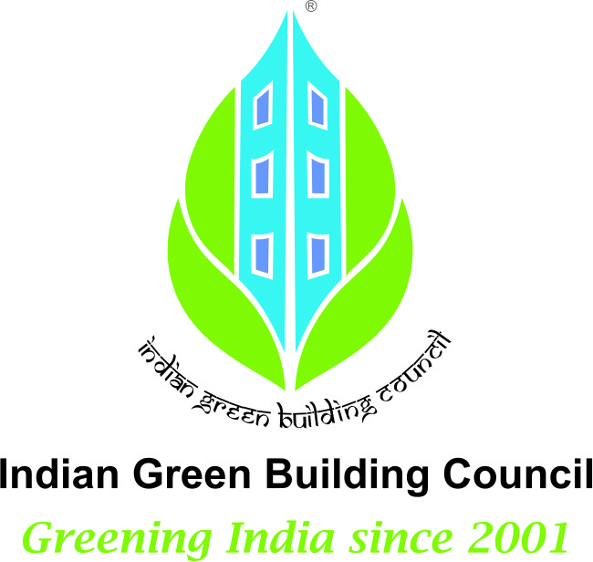
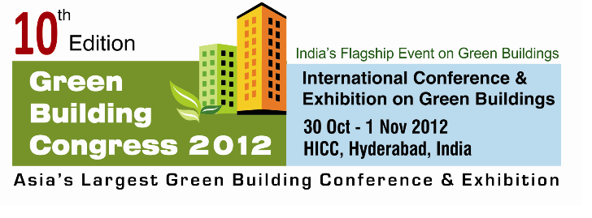


Advanced Training Programme on Green Building Rating Systems
2 & 3 November 2012 : Hyderabad
Registration Form (all the blank fields are mandatory)
We are pleased to nominate the following participant (s) for the training programme
S No. | Name | Designation | Mobile No | Amount ( Rs.)
1
2
3
4
5
6 |  |  |  | Complimentary*
Total Amount

The DD/ Cheque No. _______________ for Rs _____________ towards the delegate fee drawn in favour of “Confederation of Indian Industry”, payable at Hyderabad is enclosed.
*For every five nominations one is complimentary (5+1)
Nominated by:
Name : ………………………………………….. Membership No.: ……………………………………….
Organization : …………………………………..…….. E mail : …………………………………..…….
Designation : …………………………………………… Address 1 : …………………………………..……..
Mobile : ………………………………………….. Address 2 : ……….…………………………………
Tel : …………………………………………… City : ………………………Pin: ………….
Category | Delegate fee (Rs.)
IGBC/CII Member,IGBC AP | INR 7000/-
Non-Member | INR 7500/-
Overseas Delegates | USD 175/-
Students | INR 5000/-
^{INSTRUCTIONS:}
- Delegate fee is inclusive of service tax.
- Delegate fee once paid is non-refundable or adjustable in any other event ; however change in nomination(s) is acceptable
- Payment has to be processed with in 7 days of registration
- Prior registration is essential.
- Membership No is to be mentioned.
- Students have to provide bonafide certificate.
- Programme is non residential
Complete the registration form and e-mail to
----------------------------------------------------------
Shankar Kundu
CII – Sohrabji Godrej Green Business Centre
Survey No 64, Kothaguda Post, Near Hitech City, R R Dist, Hyderabad – 500084
Tel: +91-40-44185 164 / 161 Email: somya.shankar@cii.in
www.igbc.in /www.greenbusinesscentre.com

