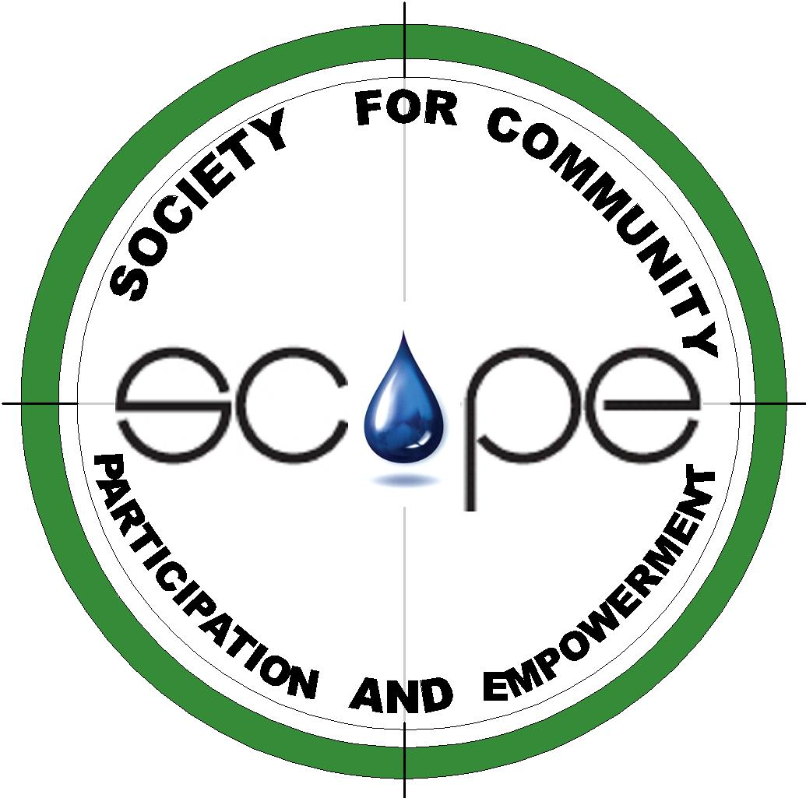
Project Coordinator- WatSan Fellowship

Society for Community participation and Empowerment (SCOPE) seeks applications from for the post of Project Coordinator- WatSan Fellowship to be based at Dharwad, Karnataka, India.
SCOPE is a non- prot society headquartered at Dharwad, Karnataka, India. Started in the year 2000, SCOPE focuses on Rural Development in the areas of sustainable livelihood, natural resource management, improved quality of life and environment.

SCOPE believes in participatory processes leading to mobilization, empowerment and
community actions for sustainable development.

Major activities of SCOPE include;
- community mobilization,
- livelihoods based on natural resources,
- integrated farming systems,
- soil and water conservation, preserving crop and bio diversity in agriculture
- drinking water and sanitation and
- integrated village development
All the programmes of SCOPE are sensitive to environmental sustainability.

The Project:
“Mentoring Young Professionals in Water and Sanitation Management” is a two year project to recruit, train, mentor and place 15 Young Professionals (YPs) in the sector of Water and Sanitation. The first cycle of the fellowship programme was successfully completed in 2013. For the second cycle of the project, SCOPE is looking for a competent person to work as “Project Coordinator”. The Project Coordinator will be guided and supported by the Project Mentor and a Documentationist.

Responsibilities of the Project Coordinator-WatSan Fellowship:
- Day to day running of the programme
- Planning induction, training of YPs
- Planning activities like studies, survey, assessment of YPs’ performances and implementing them
- Financial planning and implementation
- Monitoring of activities and performance of YPs
- Generating MIS of the project
- Liaisoning and reporting with Arghyam regarding routine reporting
- Coordinating training, placements and other logistics on day to day basis
- Arranging mentoring for the YPs
- Liaisoning with line departments, PRIs, People’s Representatives, Community, etc.

Eligibility:
- Post Graduate / Graduates in Life Science, Social Sciences, Engineering, Development subjects, etc.
- Two to three years of experience in development sector
- Conversant in written and spoken English. Knowledge of Kannada is preferable
- Computer skills and internet savvy
- Basic knowledge of accounting practices
- Good HR management skills
- Good communication and presentation skills
- Flair for field work, group interactions

General:
The position is for two years, renewable based on the performance of the incumbent and the Institute's continuing need for the position. Compensation will be based on candidates’ competence.

How to Apply:
The application should include an up-to-date resume, a recent passport size photograph, names and addresses (including phone & e-mail) of two referees. Please send applications by E-mail to dr.bhat@scope-india.org and / or bhatps@gmail.com, latest by 20th April 2014. Only short-listed candidates will be contacted.

