
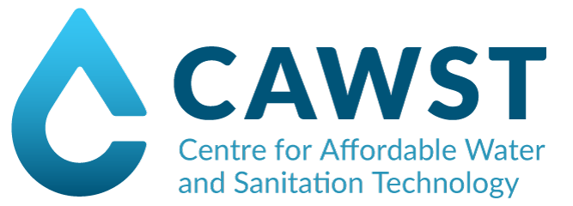
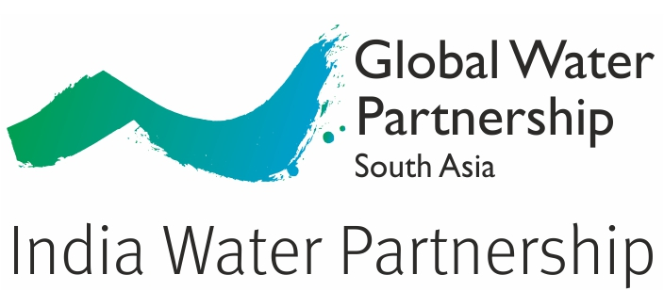

CAWST and Sehgal Foundation
in association with India Water Partnership
invite you to a

Biosand Filter Project Implementation Training

August 29-September 2, 2016

at

Sehgal Foundation

Plot No. 34, Sector 44, Institutional Area, Gurgaon 122003

Nearest Airport: Indira Gandhi International Airport, Delhi

Nearest Train Station: New Delhi Railway Station
Space is Limited – Register Here

Safe drinking water is a right for all!

The biosand filter is an effective and sustainable household
level safe drinking water solution. It can remove pathogens,
iron, arsenic and turbidity from water.

Biosand Filters are currently being used in several countries, and in multiple locations in India. The results have been astounding!

THE FIVE DAY TRAINING WILL COVER:
- Biosand Filter theory and design
- Hands-on fabrication, sand preparation, testing and assessment
- Community health and hygiene practices
- Local implementation models and business planning
- Work with others from around the world implementing
this simple, eco-friendly, low-cost household technology

Following completion of the class, participants will receive a participation certificate and become part of our global family.

FEE: Rs 2000 including seminar registration and food

PARTICIPANT PROFILE:
- Preferably speaks English (if not, Hindi is ok)
- Has an awareness of the need for safe water
- Motivated and prepared to implement the Biosand Filter project
- Capable of organizing projects and is a decision-maker

REGISTRATION: We strongly recommend that at least two people from each organization
attend. Be sure to register for each at Registration link: http://goo.gl/forms/3KQrMKAZO9xhVxzV2

TRAINING GUIDELINES: The training workshop begins on August 29th at 9 am sharp and ends
on August 2nd at 3 pm. You must attend all five days. Please plan your travel accordingly. Wear closed-toe shoes.

Contact: lalit.sharma@smsfoundation.org

