Introduction
Hydroinformatics supports the water resources engineers by utilizing the modern Information and Communication Technology (ICT). For decades numerical modeling has been the core activity for hydroinformatics. With the popularity of World Wide Web (www), web enabled applications are gaining popularity in almost all spheres of our life. The adoption of www technology to hydrology is an important application of hydroinformatics. This opens a new potential for joint modeling in d istributed environments and to set up and apply net based hydrological information systems. The web enabled applications offer hydrologists the opportunity to give a larger audience access to their products in a more structured manner and, at the same time, allows them to benefit from the achievements of others.

In view of the above, it is high time for the water resources professional to be aware and motivated to take advantages of the use of the Web based tools in respect of efficient water resources planning, development and management. This short-term course is intended to focus on the fundamentals of web based systems ad their applicability / utility in water resources planning and management.

Objectives
To interact with personnel engaged in water resources planning, development and management in the country, regarding the utility of web based tools.

This course is being planned as two-way interaction with the participants so that the requirements of the field organizations are also clearly identified and the experiences are shared.

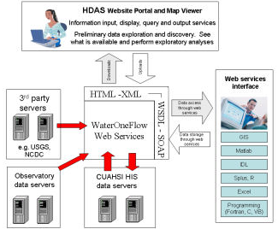

Course Contents
The Course will consist of lectures by experts in their respective fields. The lectures will be supported by computer sessions. The course will include the following:
- Web techniques
- Hydrology resources on web
- Web GIS and its applications in water resources
- Web based Information System for water resource planning and management
- Web based tools for online computation
- Hydrological data availability of web
- Public domain softwares on web

Participants
The course is intended for middle/senior level engineers and officers working in water resources/irrigation and other related departments of Central/State government and those who are in teaching profession. The number of seats is limited to 25 participants. The registration shall be done on the first come first served basis.

Registration
The registration fee per participant is Rs.6000/- (Rs. Six thousand only) for Govt. Institutions and Rs. 8000/- (Rs. Eight thousand only) for Private Institutions & SAARC Countries. The fee includes registration kit, stay at NIH Guest House & Working Lunch. For research scholars from Academic Institutions, registration fee is relaxed to Rs.3500/- (Rs. Three thousand Five hundred only) per participant. The participants need to arrange for TA/DA from their own Organisation. A field trip is also planned.

Participants are requested to register themselves by filling and mailing the registration form latest by 28th February, 2014, along with a demand draft in favour of National Institute of Hydrology, payable at Roorkee.
Venue
The venue of the course shall be National Institute of Hydrology, Roorkee- 247 667. Roorkee is a medium size town of Uttranachal State and it is well connected by road & rail from Delhi, Dehradun, Saharanpur. NIH is situated at about 1 km from Bus stand and 3 km from Railway Station.

National Institute of Hydrology (NIH)
NIH is the premier research institute of India in the field of hydrology. It is an autonomous society under the Ministry of Water Resources, Govt. of India. NIH has six scientific divisions: Surface Water Hydrology, Ground Water Hydrology, Water Resources Systems, Agricultural Hydrology, Environmental Hydrology, and Hydrological Investigations. The institute has oragnised a number of training courses in a wide range of topics dealing with all aspects of hydrology at Roorkee, Patna, Calcutta, Guwahati, Kakinada, Belgaum and Chennai etc. For more details please visit NIH web site www.nih.ernet.in.

Address for Correspondence:
Mrs. Deepa Chalisgaonkar
Scientist F
National Institute of Hydrology
Roorkee - 247 667, India
Tel. : (01332) 249206, Fax: (01332) 272123
E-Mail : deepa@nih.ernet.in
Training Course

On

Web Based Hydrological Tools
(March 11 - 14, 2014)

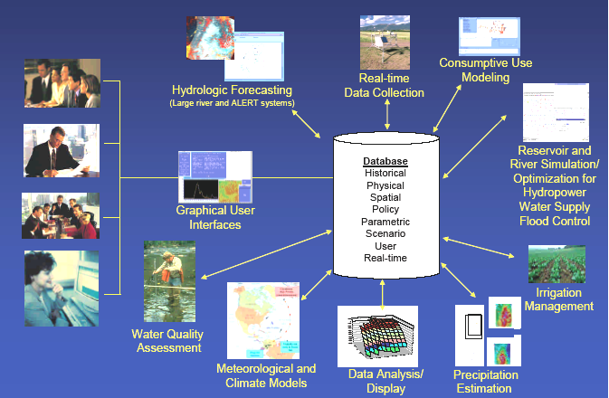
Web
Based
Tools



National Institute of Hydrology
Jal Vigyan Bhawan,
Roorkee-247667
Uttarakhand
Registration Form

Training Course on
Web Based Hydrological Tools
(March 11 – 14, 2014)

Name :……………………………………..

Designation: ..……………………………..

Organization :……………………………..

Address :………………………………….
…………………………………..
…………………………………..

Tel. No. :……………………………………..

Fax ……………………….…………….

Email ……………………………………...

(Signature of Candidate)

SPONSORSHIP CERTIFICATE

Certified that Mr./Ms./Dr. ………………………... has been officially deputed for the above mentioned training course to be conducted by NIH, Roorkee.

Signature of Sponsoring Authority with Office Seal and Date

(Photocopies of this form can be taken as per the need)

