Drought Management

Drought is a natural disaster. Nearly 200 million ha land in India in 135 districts of 13 states are severely affected by drought four times in every 10 years. We can manage drought - by being in a state of readiness to combat it, by forecasting, by mitigating its impact on humans and animals. We may even prevent it if we manage our water resources properly. If we don't, the third world war may be fought for water! Figure 1 shows the nature of drought management.

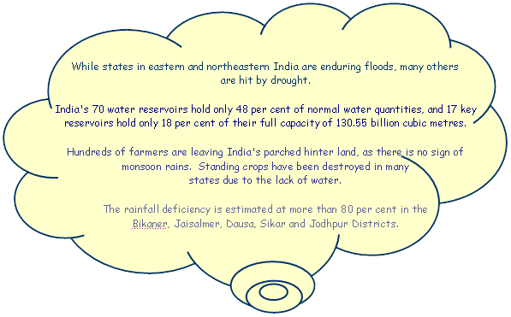

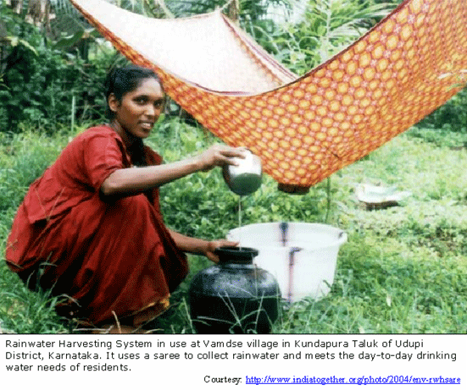

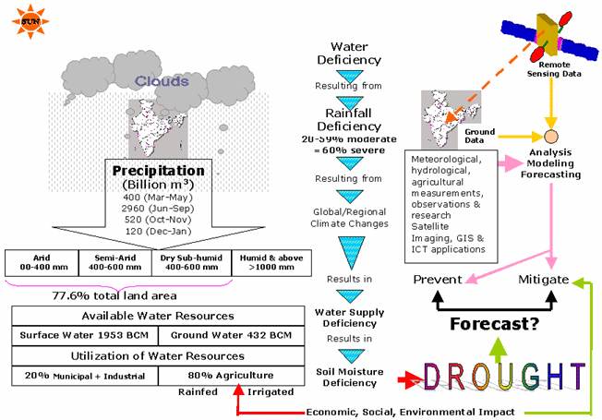
Figure 1: The complex nature of drought management

Table of Content

1. Executive Summary
1.1. Situation before practice
1.2. Challenges
1.3. Strategy
1.4. Results
1.5. Sustainability
1.6. Replicability
2. Sector
3. Sub-sector
4. Policy/ Area - Drought Management
5. Case/ Initiative - Drought Management System in India
5.1. What is drought?
5.2. Drought & Aridity
5.3. Causes & Effects of Drought in India
5.4. Measuring/ Quantifying Drought
6. Contributors and References
6.1. Key Architects
6.2. Implementers/ Stakeholders
6.3. Documenting Authors
6.4. References
7. Organization
8. Project Design
8.1. Key Objectives
8.2. Outcomes
8.3. Strategy/ Approach
8.4. Methodology
8.5. Conceptual Framework
8.6. Presumptions & Risk Assessment
8.7. Using Technology
9. Drought Management - Key Processes and Activities
9.1. Preparedness
9.2. Monitoring
9.3. Responding
10. Time Frame
11. Key Stakeholders, Implementers and Agencies
12. Knowledge Management & Life Cycle Considerations
12.1. Type of Intervention
12.2. Organizational Development
12.3. Lessons Learnt
13. Unfolding the Story
13.1. Overview of the genesis
13.2. Synopsis of the development that led to the initiative
13.3. Present status
14. Audit/ Assessment/ Impact
14.1. Assessment Indicators
14.2. Impact
15. Action following Mid-course Evaluation
16. Feedback
17. Policy Support & Systemic Changes Implemented
18. Infrastructure System Support
19. HR & Capacity Building
20. Change Management Strategy
21. Information & Communication Model
22. Leadership Champion Attributes
23. Standard Operation Procedures/ Standards
24. Performance Progress Monitoring
25. Resource Mobilization
25.1. Calamity Relief Fund (CRF)
25.2. National Calamity Contingency Fund (NCCF)
25.3. Other Sources of Funding
26. Finance & Budget
27. Artifacts

List of Tables

Table 1: Drought Indices
Table 2: Change in farm practice suiting to drought
Table 3: Approximate Time Frame for Drought Management Activities
Table 4: Key Stakeholders/Agencies

List of Annexes

Annex 1: List of information discussed in CWWG
Annex 2: Sample Rainfall Distribution Map
Annex 3: Sample NCMRWF forecast

List of Figures
Figure 1: The complex nature of drought management
Figure 2: India 2002 Drought-Number of Affected Districts
Figure 3: An innovative way of drought proofing
Figure 4: Classification of Drought
Figure 5: Examples of Hydrological Drought
Figure 6: Frequency of Occurrence of Drought in India
Figure 7: Causes of drought
Figure 8: Measuring Meteorological & Agricultural Drought
Figure 9: Elements of Drought Management System in India
Figure 10: Crop Area affected by drought in India 1996-2001
Figure 11: Organization for Drought Management
Figure 12: Drought Management Strategy
Figure 13: Drought Management Methodology
Figure 14: Drought Management-a conceptual framework
Figure 15: India's Drought-proneness - a prediction
Figure 16: 2002 Drought Impact on Sown Area
Figure 17: Summary of Features of EWS in India
Figure 18: Space to Farms-Technology in Drought Management
Figure 19: NADAMS Drought Monitoring using NDVI
Figure 20: NDVI indicating seasonal vegetation conditions (Bhiwani Dist.India)
Figure 21: Drought Management Networking

Executive Summary

Situation before practice
Prior to independence, measures to tackle famine and minimize deaths due to starvation were evolved and followed. At this time there were no mechanisms to monitor droughts scientifically and technologically. Crisis management was the solution.

Challenges
- Developing, and coordinating an institutional mechanism that can monitor/ predict/ warn occurrence of drought; its intensity, duration, area, impact and the immediate and long-term mitigation measures required.
- Response management that includes assessment of losses, governing relief operations and managing long-term measures for prevention

Strategy
The strategy has gradually shifted from the crisis management approach of providing relief when the drought occurs to the risk management approach that includes forecasting and early warning, immediate relief in the short-term and drought proofing measures in the long-term.

Results
- Deaths due to starvation is no longer encountered due to huge buffer stocks of foodgrains and wide public distribution network.
- An early warning system is in place and drought monitoring is done regularly, frequently at GOI and state government levels.
- Institutional mechanisms are in place for measurements, observations, research, forecasting, monitoring based on ground-based data and remote sensing data.
- Institutional mechanisms are in place for disseminating weather forecasts, crop forecasts, contingency crop plans and so on so that they reach the farmers and others affected.
- Institutional mechanisms are in place at the highest executive and political levels in the central and state governments for funding and administration of drought relief operations.

Sustainability
Successful drought management depends on successful water management and other measures like afforestation, combating desertification and creating conditions of alternative livelihoods for people in drought affected areas. It also depends how successful are our meteorologists, hydrologists and agricultural scientists and their models are in forecasting drought and the EWS they design. Traditional technologies used by our farmers are of immense value in combating drought at less cost.

Replicability
India’s experience in drought management can be used in other countries facing similar situation.

Sector
Agriculture
72% of India’s population of over a billion are engaged in agricultural occupations that comprise crop farming, livestock farming, fish farming and forestry contributing to about 25% share in GDP. The net sown area (out of a cultivable area of 328.7 million ha) is 142.2 million ha. 55.10 million ha are irrigated. It is often said that Indian agriculture is a gambling on rains. India receives annual rainfall in 4 spells.

- Pre-monsoon (Mar-May) 10.4%
- SW Monsoon (June-Sep) 73.3%
- NE Monsoon (Oct-Dec) 13.3%
- Winter Rains (Jan-Feb) 3%

Disasters (floods, droughts, earthquakes, cyclones, landslides, volcanoes, tsunamis etc.,) are natural phenomena that occur throughout history and throughout the world resulting in large-scale destruction of life and property, human sufferings and detrimental impact on the economies. India is one of the world's most disaster prone countries. It has witnessed devastating droughts, floods, cyclones, earthquakes, landslides, avalanches and tsunami (in December 2004).

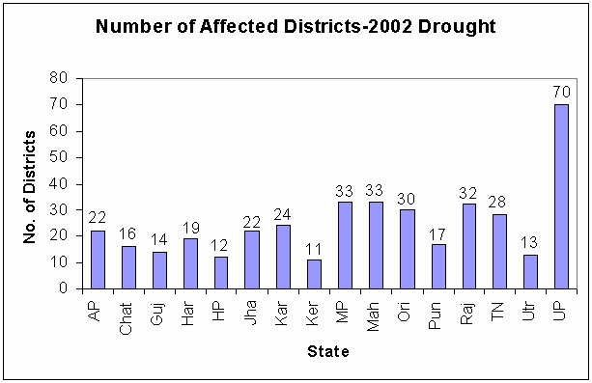
Figure 2: India 2002 Drought-Number of Affected Districts

Sub-sector

Water Management
The availability of water is highly uneven geographically and in time. Precipitation is mainly confined to the southwest monsoon months of June-September in the year varying from 100 mm in Rajasthan to over 10000 mm at Cherrapunji in Meghalaya. Rainwater and water in rivers, ponds and lakes and ground water are all part of one hydrological system.

Water is an essential natural resource and to emphasize the serious consideration it deserves, it is often said that the Fourth World War will be fought for water. It is therefore important that the nation endeavours to develop, conserve, utilize and manage water guided by national perspectives. An effective water management system can greatly reduce the probability of occurrence of drought and help mitigate the adverse effects in the event of its occurrence.

Policy/ Area – Drought Management
Though there is no separate policy on drought, individual ministries/sectors such as agriculture, water, forestry, livestock management, etc., have addressed the issue of drought management in their respective sectors.

Experience in fighting 12 major drought years between 1951 to 2002 has resulted in developing a system of drought monitoring, declaration and response to minimize its adverse effects.
Figure 3: An innovative way of drought proofing
Figure 2 presents states and number of districts affected by 2002 drought.

Case/ Initiative – Drought Management System in India

What is drought?
Drought is the single most important weather-related natural disaster. Drought is an extended period–a season, a year, or several years–of deficient rainfall relative to the statistical multi-year (usually 30 year) average for a region. Deficiencies in soil moisture and surface and subsurface water supplies are other indicators of drought
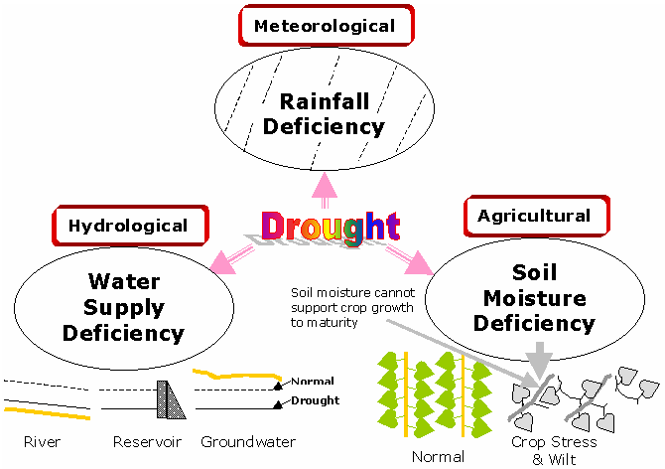
Figure 4: Classification of Drought
Drought may be meteorological, hydrological or agricultural as shown in Figure 4.
Figure 5 shows examples of hydrological drought.
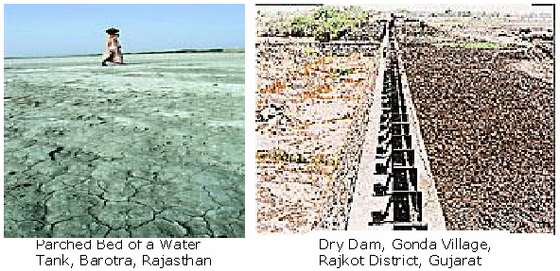
Source: http://www.frontlineonnet.com/fl1712/17121080.htm
Figure 5: Examples of Hydrological Drought

Drought & Aridity
Drought is a natural, recurring feature of climate which stems from the lack of rainfall over an extended period of time (e.g. a season or several years); it occurs in virtually all-climatic regions. Drought occurs in high as well as low rainfall areas and is a temporary anomaly, in contrast to aridity, which is a permanent feature of the climate and is restricted to low rainfall areas.

Drought differs from other natural disasters in three ways.
- It’s beginning and end is usually unknown.
- Varying definitions and interpretations make it difficult for decision-makers.
- Its impacts are spread over a larger area than from other natural hazards.

16% of the country's total area is drought prone and approximately 50 million people are annually affected by droughts. A total of 68% of sown area is subject to drought in varying degrees - 33% of area receiving less than 750-mm rainfall is chronically drought-prone. 35% of area that receives between 750-mm and 1125-mm rainfall is drought-prone. Most of the drought prone areas lie in the arid, semi arid and sub-humid areas of the country that occupy 77.6 percent of its total land area of 329 m ha.

- Arid Zone (19.6 percent) Mean Annual Precipitation (MAP) of 100-400 mm (water deficit throughout the year)-Rajasthan, Parts of Haryana and Gujarat. Droughts are severe in this zone.
- Semi-arid Zone (37.0 percent) with MAP of 400-600 mm (Water surplus in some months and deficit in other months)- Parts of Haryana, Punjab, West UP, West MP and also most entire peninsular parts of the Western Ghats. Drought can be moderate to severe in this zone.
- Dry Sub-humid Zone (21.0 percent) with MAP of 600-900mm in India- Parts of Northern Plains, Central Highlands, Eastern Plateau, Parts of Eastern Ghats and Plains and Parts of Western Himalayas. Droughts are moderate in this zone.
- The humid and per-humid regions such as Assam & NE States rarely face drought.

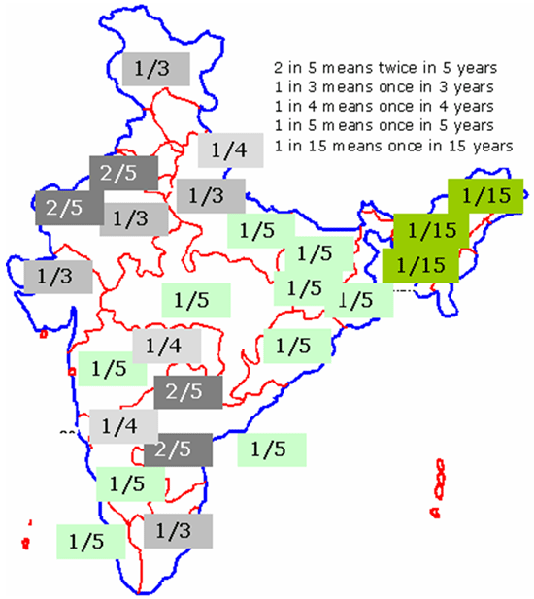
Figure 6: Frequency of Occurrence of Drought in India
The frequency of occurrence of droughts in different parts of India is presented in Figure 6.

Causes & Effects of Drought in India
Drought is a complex phenomenon, the causes for which are both natural factors (variations in large-scale atmospheric circulation patterns and the locations of anticyclones, or high-pressure systems, climatic variability, sea surface temperature changes such as El Nino) and manmade factors (deforestation, poor land and water management, green house effect). The common causes of drought in India and its effects are shown in Figure 7.

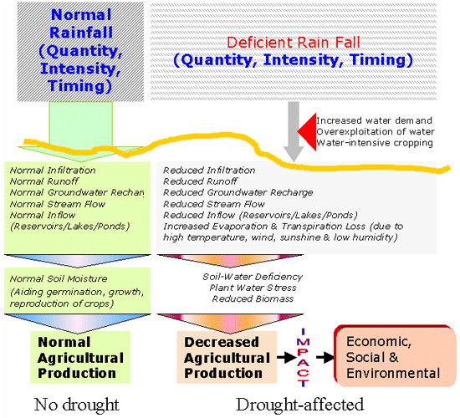
Figure 7: Causes of drought

Measuring/ Quantifying Drought

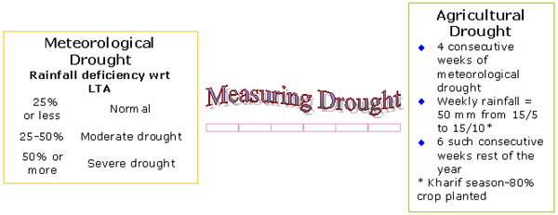
Figure 8: Measuring Meteorological & Agricultural Drought
Operational definitions identify the beginning, end, spatial extent and severity of a drought. They are often region specific and are based on scientific reasoning based on the analysis of hydro-meteorological data. They are beneficial in developing drought policies, monitoring systems, mitigation strategies and preparedness plans. Figure 8 explains the measurement of meteorological and agricultural drought.

Table 1: Drought Indices
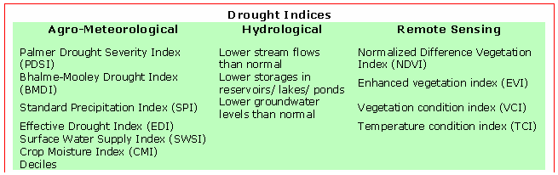
Drought indices are measures of drought, which are useful in giving an operational definition for drought. Table 1 presents some drought indices in use.

Drought Management
Intensity, duration and spatial extent are the three main features of drought.
To reduce drought consequences, India has evolved a drought management system.
Its main components are shown in Figure 9. Since agriculture is the most affected activity, which in turn affects the livelihood of the majority of population in India (as seen in Figure 10), drought management’s major thrust is on agriculture.
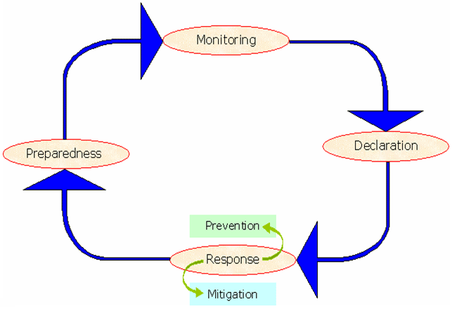
Figure 9: Elements of Drought Management System in India
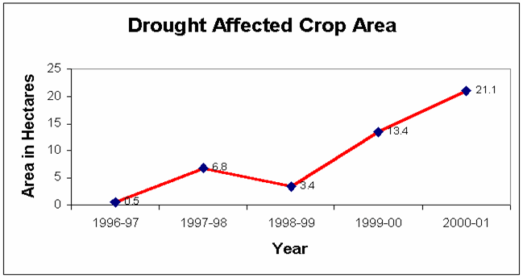
Figure 10: Crop Area affected by drought in India 1996-2001

Contributors and References

Key Architects
- Ministry of Agriculture and Cooperation, Government of India
- India Meteorological Department

Implementers/ Stakeholders
Government of India
- Department of Agriculture & Cooperation (CWWG, NCFC)
- Department of Science & Technology (IMD, NCMRWF)
- Department of Water Resources (CWC)
- Crop & Agricultural Extension Specialists
- Department of Space (NRSI, NADAMS)
- Indian Council of Agricultural Research and its Research Institutes

State Governments
- State Agricultural Department
- State, District, Tehsil and Village Level Administration
- Agricultural Universities

Non-Government Organizations

Documenting Authors
- Review and Analysis of Drought Monitoring, Declaration and Management in India, J.S.Samra, Deputy Director, ICAR, New Delhi, Working Paper No.84, Drought Series Paper 2, International Water Management I n s t i t u t e
- Address of Mrs. Radha Singh, Secretary, Department of Agriculture & Cooperation, Government of India, at the Inauguration of "International Workshop on Drought Assessment and Mitigation in South - West Asia" 7 - 8 October, 2004
- Role of Drought Early Warning Systems for Sustainable Agricultural Research in India, K.C. Sinha Ray, India Meteorological Department, Pune, India
- Contribution of Remote Sensing to Drought Early Warning, Felix N. Kogan, National Oceanic and Atmospheric Administration (NOAA), National Environmental Satellite Data and Information Services (NESDIS), Washington DC, U.S.A.
- The following web sites of UNCCD deal with drought problem.
- http://envfor.nic.in/unccd/chap-3.pdf
- http://envfor.nic.in/unccd/chap-4.pdf
- http://envfor.nic.in/unccd/chap-6-i.pdf
- http://envfor.nic.in/unccd/chap-6-ii.pdf
- http://envfor.nic.in/unccd/chap-6-iii.pdf
- http://envfor.nic.in/unccd/chap-7.pdf
- http://envfor.nic.in/unccd/chap-8.pdf
- http://envfor.nic.in/unccd/chap-9.pdf

References
- http://www.imd.ernet.in/services/agromet/services-to-agriculture-and-farmers.htm
- http://ndmindia.nic.in/
- http://agricoop.nic.in/
- http://agricoop.nic.in/drought/drought22.htm
- http://www.iwmi.cgiar.org/pubs/working/WOR84.pdf
- http://www.gisdevelopment.net/aars/acrs/2000/ts8/hami0001.shtml
- http://www.saciwaters.org/nwp_india.htm
- http://www.ceos.org/pages/DMSG/2001Ceos/Annexes/annex1.html
- http://www.geospatialtoday.com/articles/article_10.asp
- http://www.drought.unl.edu/monitor/EWS/ch10_Sinha-Ray.pdf
- http://www.undp.org.in/UNDMT/dpm/ Day%20Three/Session%20VII/reddy1.ppt
- http://www.jsai.or.jp/afita/afita-conf/2002/part6/p478.pdf
- http://www.frontlineonnet.com/fl1712/17121080.htm
- http://www.undp.org.in/UNDMT/dpm/Day%20One/Theme%20I%20Presentation/SKS.ppt
- http://www.unccd.int/cop/reports/asia/national/2000/india-eng.pdf
- http://www.oosa.unvienna.org/unisp-3/docs/backgroundpapers/bp2.pdf
- http://disaster.ceos.org/2001Ceos/Reports/WordDocs/drought.doc
- http://taylorandfrancis.metapress.com/app/home/contribution.asp?wasp=fc22ht5quq5vthfant2l&referrer=parent&backto=issue,3,17;journal,145,158;linkingpublicationresults,1:100669,1
- http://www.dailyexcelsior.com/99dec06/edit.htm
- http://www.dailyexcelsior.com/02sep01/edit.htm#5
- http://www.isprs.org/istanbul2004/comm7/papers/249.pdf
- http://rspas.anu.edu.au/papers/narayanan/1995oration.html
- http://www.oosa.unvienna.org/Reports/AC105_753E.pdf
- http://earthobservatory.nasa.gov/Library/MeasuringVegetation/
- http://www.iwmi.cgiar.org/droughtassessment/index.asp?nc=8552&id=843&msid=138
- http://www.iwmi.cgiar.org/droughtassessment/index.asp?nc=1191&id=1274&msid=138
- http://www.iwmi.cgiar.org/droughtassessment/index.asp?nc=5842&id=843&msid=138
- http://www.iwmi.cgiar.org/droughtassessment/index.asp?nc=3175&id=1277&msid=139
- http://www.iwmi.cgiar.org/droughtassessment/index.asp?nc=3289&id=850&msid=139
- http://www.csre.iitb.ac.in/rn/resume/drought/indices.html
- http://www.csre.iitb.ac.in/rn/resume/drought/subcontinent.html
- http://www.drought.unl.edu/whatis/concept.htm
- http://www.mapsofindia.com/maps/mapinnews/03052000.htm
- http://dmc.kar.nic.in/graph_more.htm
- http://www.gisdevelopment.net/application/natural_hazards/overview/nho0003pf.htm
- http://www.gisdevelopment.net/application/natural_hazards/drought/pdf/ma03204.pdf
- http://www.atmosphere.mpg.de/enid/1wb.html
- http://www.cidi.org/disaster/02b/ixl55.html (OCHA Drought India Report)
- http://www.reliefweb.int/rw/rwb.nsf/AllDocsByUNID/5a0eac26cfd01d27c1256c09003c2a92
- http://www.worldisgreen.com/2004/07/29/drought-proofing-agriculture/
- http://www.winrockindia.org/reportnrm_s.htm
- http://www.waterconserve.info/articles/reader.asp?linkid=34050
- http://www.ifrc.org/docs/appeals/rpts02/In-drought1.pdf
- http://agricoop.nic.in/ncfcweather/ncfc14-02-2004.htm
- http://agrolink.moa.my/nahrim/Papers/Drought%20Management.pdf
- http://www.ndmindia.nic.in/management/nccfscheme.html
- http://www.drought.unl.edu/monitor/EWS/ch7_Kogan.pdf
- http://www.adpc.net/infores/newsletter/2002/07-09/theme5.html
- http://envfor.nic.in/unccd/desert1.html
- http://envfor.nic.in/unccd/chap-4.pdf
- http://envfor.nic.in/unccd/chap-6-i.pdf
- http://envfor.nic.in/unccd/chap-6-ii.pdf
- http://envfor.nic.in/unccd/chap-6-iii.pdf
- http://envfor.nic.in/unccd/chap-7.pdf
- http://envfor.nic.in/unccd/chap-8.pdf
- http://envfor.nic.in/unccd/chap-9.pdf
- http://envfor.nic.in/unccd/chap-3.pdf
- http://www.rainwaterharvesting.org/
- http://www.indiatogether.org/photo/2004/env-rwhsaree.htm
- http://www.imd.ernet.in/section/satmet/dynamic/sector-vis.htm
- http://www.imd.ernet.in/section/satmet/dynamic/sector-ir.htm
- http://www.ncmrwf.gov.in/secure_test.htm
- http://www.ncmrwf.gov.in/dist_jpeg_files/Jaisalmer.jpeg (District Level Forecast)
- http://www.ncmrwf.gov.in/NCMRWF_bulletin.pdf
- http://www.ncmrwf.gov.in/kisan_bulletin.pdf
- http://www.iwmi.cgiar.org/droughtassessment/files/pdf/workshop%20docs/Address-India.pdf
- http://dmc.kar.nic.in/graph_more.htm

Organization
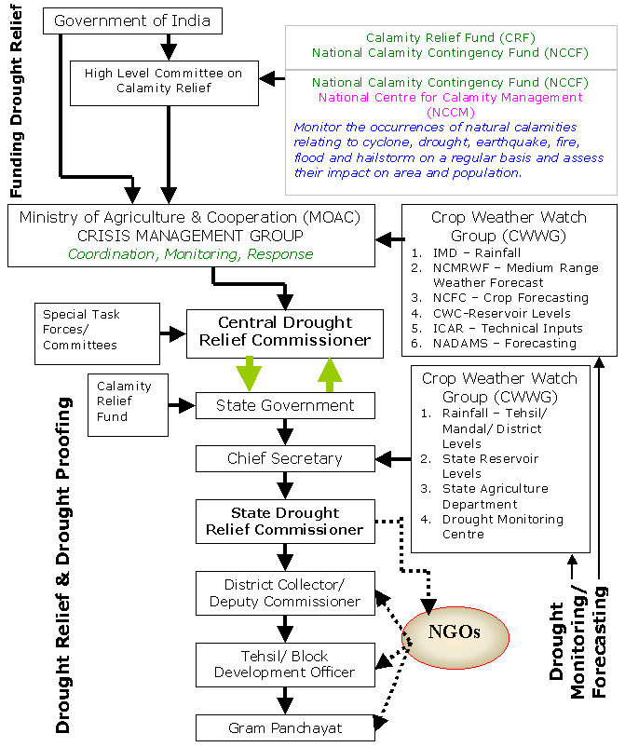
Figure 11: Organization for Drought Management
Monitoring of and responding to drought are the two major functions of the Crisis Management Group. Based on the information provided by the National Crop Forecasting Centre (NCFC) of the MOAC, the Crop Weather Watch Group (CWWG) meets every week to monitor weather and drought. Annex 1 gives the list of information discussed and provided by CWWG. Annex 2 is a sample rainfall distribution map issued by IMD. Annex 3 shows a sample NCMRWF forecast.

The Central Relief Commissioner is responsible for providing relief measures. Some states have set up Drought Monitoring Cells of their own to monitor/forecast drought. State governments are responsible for carrying out the drought relief operations at district, tehsil and village levels.

Project Design

Key Objectives
- Predicting drought using scientific methods and tools and data to prevent its occurrence
- Responding timely and effectively to mitigate the effects of drought through drought relief and drought proofing measures

Outcomes
- A multilevel institutionalized drought monitoring and early warning system during normal and drought periods is in place. Monitoring, prevention, mitigation, preparedness, vulnerability mapping, declaration, funding, relief and impact analysis are the elements of this system.
- Ground-based data and data obtained from space technologies (Remote Sensing, Vegetation Mapping) are being analyzed to monitor/ predict drought and estimation of losses. ICT is being increasingly used in drought management.
- Improved drought management system has resulted in reducing poverty levels in drought-affected states as compared to those in least drought-affected states.
- Weather forecasting by IMD and deliberations of CWWG has enabled states in declaring drought.
- During very severe droughts, special task forces at the central level and additional mechanisms at the states level reinforce the regular drought monitoring system.
- Some states like Karnataka have set up a Drought Monitoring Cell with state –of-the art technologies providing rainfall information.
- Socioeconomic impact of drought (on crops, water & power availability, livestock, fodder availability, market responses and employment) is being monitored by the Central/ State Relief Commissioners and Special Task Forces.
- The Relative Drought Vulnerability Index (Persons killed per million exposed) is 0.58 for India which is very low compared to 6 for China and 16847 for DPR Korea.
- A National Disaster Management Authority is soon to be set up by the Government of India under the proposed Disaster Management Bill to be tabled in the parliament in the 2005 Budget Session and install an early warning system for taking precautionary measures in the event of natural disasters.

Strategy/ Approach
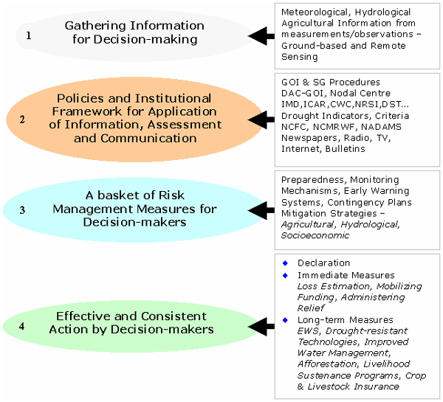
Figure 12: Drought Management Strategy
The traditional approach to drought management has been reactive, relying largely on crisis management. This approach has been ineffective because response is untimely, poorly coordinated, and poorly targeted to drought stricken groups or areas. In addition, drought response is post-impact and relief tends to reinforce existing resource management methods that quite often have increased societal vulnerability to drought.

The new strategy emphasizes a shift from Crisis Management to Risk Management. It is a holistic approach to drought management involving forecasting, prevention, mitigation and preparedness in pre-drought phase along with the policy practiced so far of post-drought measures of relief and rehabilitation under crisis management. This strategy involves extensive scientific and technological inputs for data collection, analysis, modeling and forecasting drought.

Critical Success Factors
- Institutional and operational readiness (administrative, financial, logistical) and contingency plans in Central and State Governments to combat drought in the event of its occurrence
- Effectiveness of monitoring, forecasting and Centre-State coordination
- State government’s readiness to declare drought based on drought monitoring data and prediction
- Rapidity of responding and mitigating
- Community participation

Methodology
The drought management methodology is presented in Figure 13.
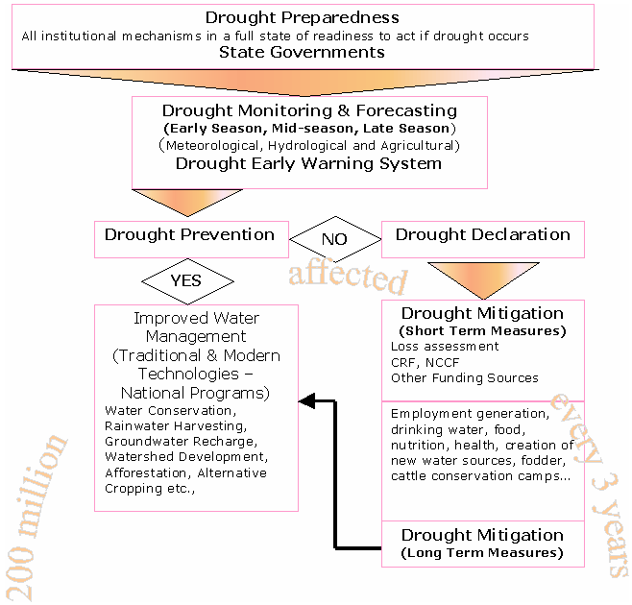
Figure 13: Drought Management Methodology

Conceptual Framework
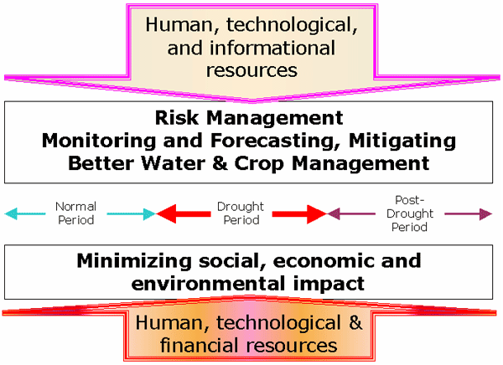
Figure 14: Drought Management-a conceptual framework
Conceptually, there are two ways of fighting drought. Replacing/ reducing rain-fed agriculture and animal husbandry by industry and services as contributors to our economy. This almost an impossible task as 75% of India’s population is dependent on agriculture-related occupations for their livelihood. The other alternative is to manage drought by improved water management and crop management by monitoring and mitigating its effects by creating livelihood/ income generation alternatives.

Presumptions & Risk Assessment
Drought onset and end and its severity are often difficult to predict. As the majority of people in India are dependent on agriculture and animal husbandry for their sustenance, drought has serious social and economic consequences.

Unless drought-proofing measures are undertaken and water management is improved, India may face increasing drought-proneness in coming years.
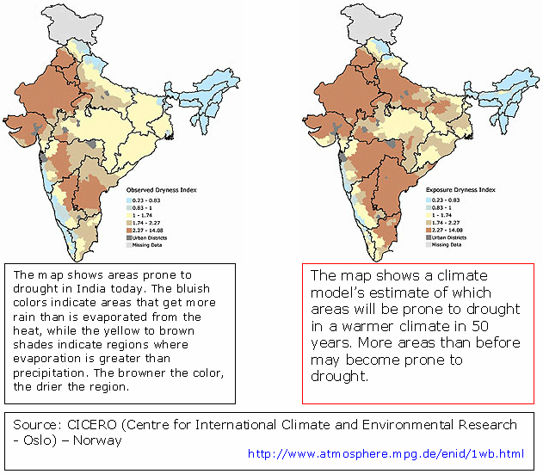
Figure 15: India's Drought-proneness - a prediction
Figure 15 is a prediction of India’s drought-proneness after 50 years.
Drought Risk = An area’s exposure to drought x Vulnerability
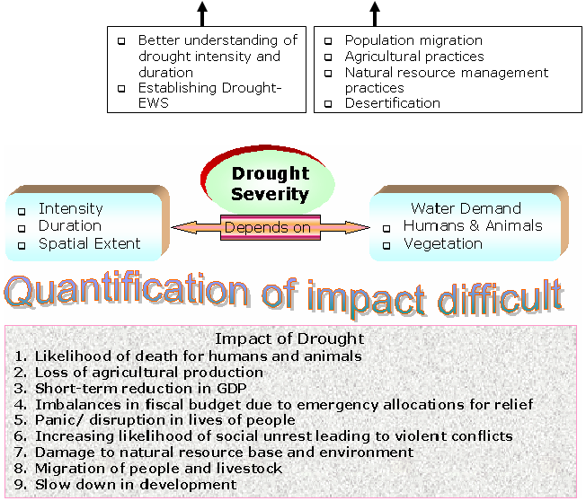

The impact of 2002 drought is summarized below.
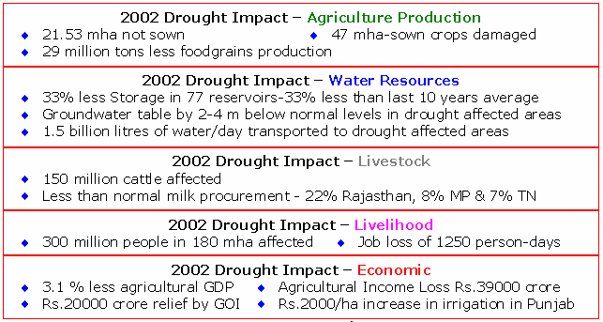

The risk management approach aims at ensuring food production, relying on leading drought indicators (rainfall, water level in reservoirs and progress of cropping pattern), and detect early signs of a developing drought situation.
Figure 16 shows the impact of 2002 drought on sown area, which in turn affected agricultural production.
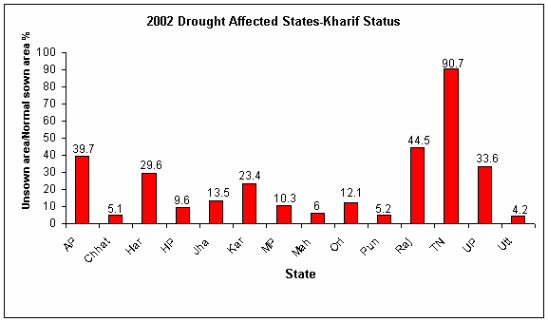
Figure 16: 2002 Drought Impact on Sown Area
CWWG monitors and forecasts drought assesses the impact of the monsoon on crop conditions and suggests corrective measures to minimize crop losses. It meets during the monsoon period from June to September. In case the CWWG anticipates widespread adverse seasonal conditions, it sends out a warning. This triggers the implementation of a contingency action plan for drought management.

Early Warning System plays an important role in risk management of drought.

The IMD and the Department of Agriculture & Cooperation (GOI) issue warnings. Many of the State Governments have their own early warning systems. Figure 17 is a summary of Drought EWS in India.

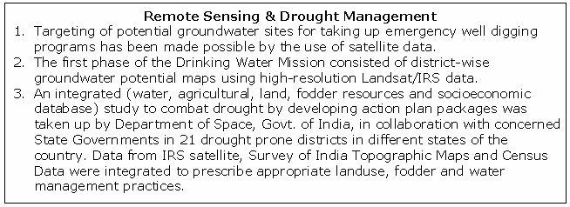

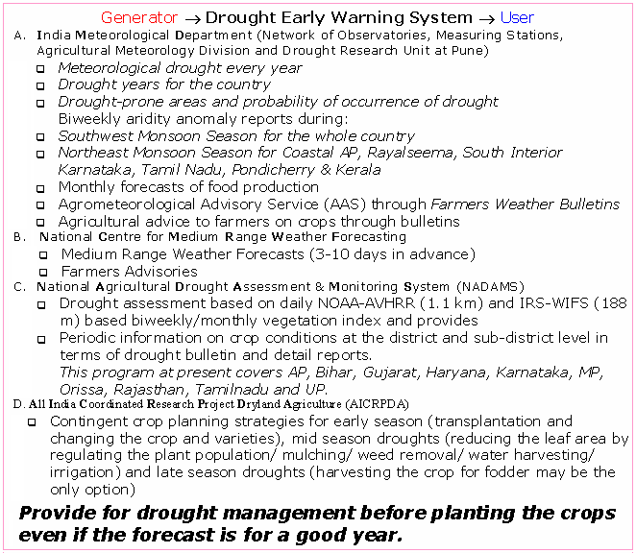
Figure 17: Summary of Features of EWS in India

Using Technology
Several new technologies like the remote sensing, geographical information system and the information & communication are being employed for forecasting, mitigation and governance of drought relief measures. Figure 18, Figure 19, and Figure 20 show the application of space technology in drought monitoring & forecasting.

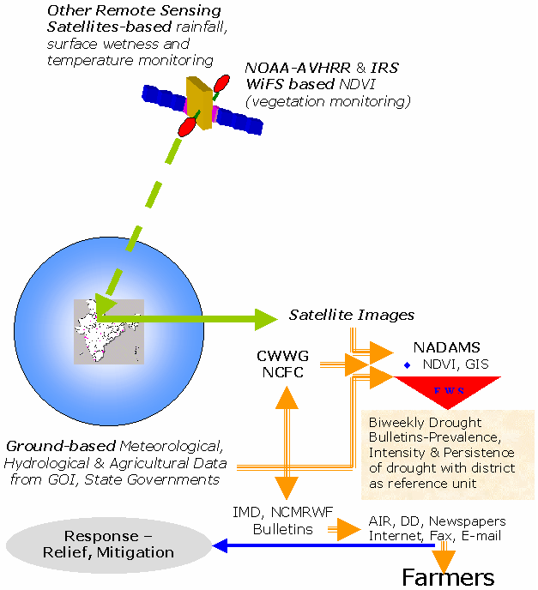
Figure 18: Space to Farms-Technology in Drought Management
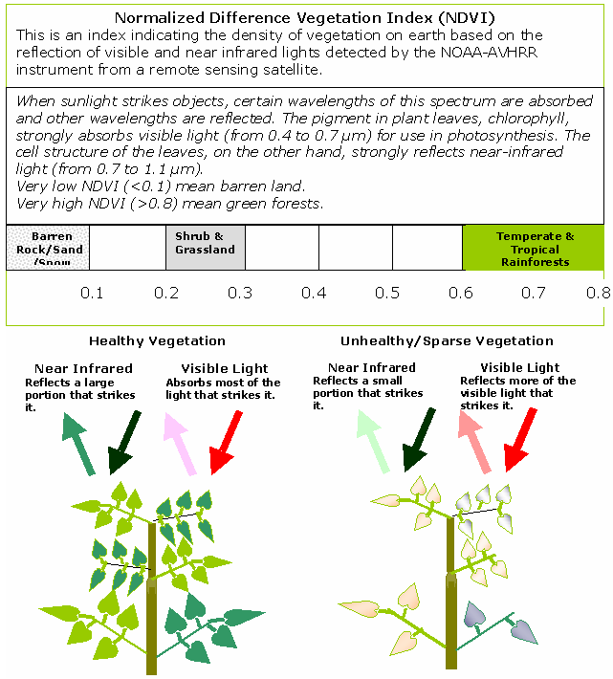
Figure 19: NADAMS Drought Monitoring using NDVI
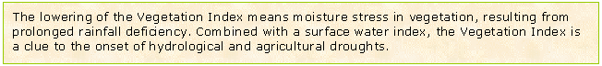
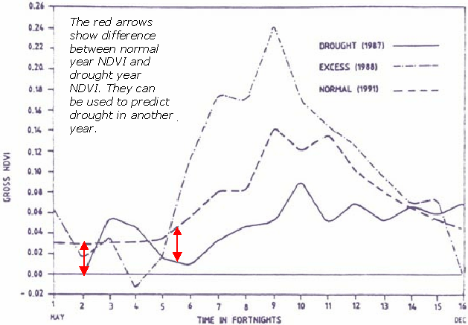
Figure 20: NDVI indicating seasonal vegetation conditions
(Bhiwani Dist.India)

