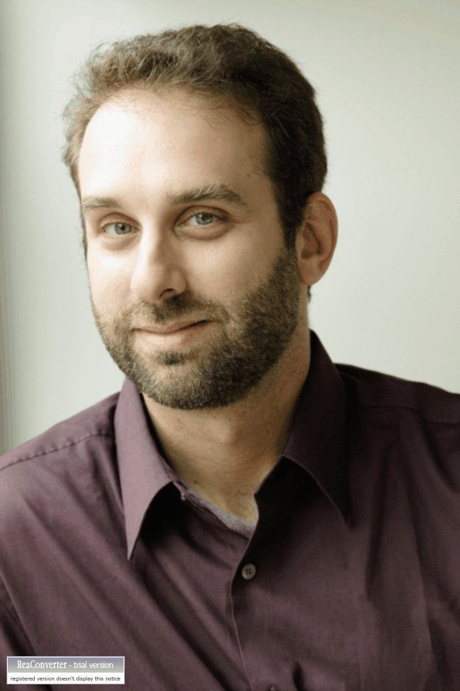
Eric Roston is a science writer in Washington, DC, and author of the critically acclaimed book THE CARBON AGE: How Life's Core Element Has Become Civilization's Greatest Threat. The book, based on three years of research, argues that "carbon" is the most important word that many people understand the least. The book traces the dynamic, fundamental science that unifies seemingly disparate parts of our experience: Climate, energy, health, industry--the fastest way to learn the most about the world is through the carbon atom.

The book has received endorsements from many prominent thinkers. Writing in the journal Nature, Sir John Meurig Thomas compared The Carbon Age to Michael Faraday's historic public lectures. The book met an exuberant reception at TIME, Newsweek, NPR, Discover, New Scientist, the publishing journals, and the blogosphere. Library Journal included it in its "Best of 2008" list, and Choice called it "a winner and a keeper."

Roston is Senior Associate in the Washington, DC, office of The Nicholas Institute for Environmental Policy Solutions at Duke University. He is a member of Monitor Talent, the speaker's bureau and advisory based in Cambridge, Mass.

Previously, Roston wrote for TIME, in its Washington bureau, where he covered economics, politics and technology. Roston joined the magazine in 2000 as a business reporter in the New York bureau, covering stories such as the collapse of Enron, China's emergence as a force in global trade, and how advanced computing technologies are reshaping the economy. An eyewitness to the collapse of the World Trade Center on Sept. 11, 2001, Roston was a part of the reporting team that won a National Magazine Award for best single-issue coverage.

In September 2002, Roston became a part of TIME's Washington bureau. He traveled extensively with President George W. Bush and Senators John Kerry and John Edwards during the 2004 election campaign, providing analysis and reporting to the magazine's seasoned political team. He was also a frequent contributor to the magazine's work on energy, environmental and health issues. He has penned a monthly column on technology and society for TIME Inside Business. In the spring of 2004, he became Time.com's first blogger, writing a daily commentary on "the technology that will carry us through tomorrow -- and the stuff that keeps us stuck in yesterday."

Roston has been a guest on Comedy Central's "The Colbert Report," CleanSkies.tv, CNN, MSNBC, ABC, CBC, National Public Radio and various radio stations nationwide and abroad. Prior to TIME, he wrote for LIFE magazine and contributed to Slate.com, where he wrote the "Today's Papers" column. Roston, who is fluent in Russian, holds an M.A. in Russian history, and a B.A. in modern European history, both from Columbia University. He lives in Washington, DC, with his wife, Karen, and daughter.

