Polysensor
A Sensor System for Water Quality Monitoring
Indian Institute of Technology – Bombay / Media Lab Asia

Presently the purity of water in our increasingly polluted environment can only be tested in laboratories using expensive equipment and highly trained technicians. This project aims at providing a low-cost and easy method of testing the impurities in water, with low-cost, rugged and tropicalized sensors.

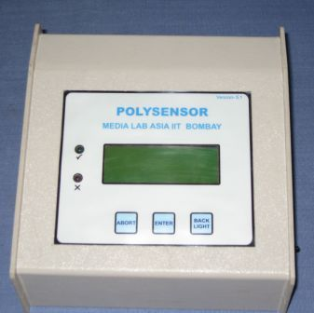

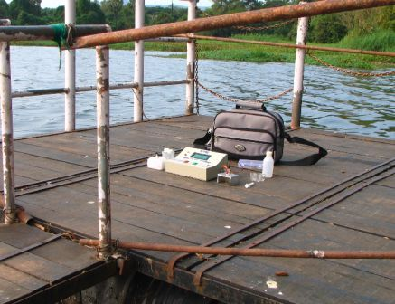

Features of Instrument:

- Basic Operating Principle – Potentiometry
- Lower limit as specified by WHO, no other instrument can go till that limit without pre-concentration
- Direct readout after automatic comparison with WHO specified limits
- Small size ; can be easily taken to site
- Convenient for application in rural areas, particularly un-electrified areas
- One instrument, one cartridge, many parameters together
- Easily repairable, Fully indigenous
- Any other parameter can be added theoretically. Only suitable sensor designing required
- Highly cost effective compared to existing technologies

Technical Features:

- The instrument works on +/- 3.6 Volts battery
- In-built battery charging facility
- 20 char X 4 line LCD
- Green and Red LED indicator for illiterate users
- User-friendly 2 key(enter and abort) interface
- Serial data upload
- MSP430F449 micro-controller ; with 64KB flash memory
- Backlight to the display
- Provision for storing the calibration and last measured data in flash memory automatically
- 8 channel 12 bit ADC for 8 different parameters

Current instrument can measure:
pH
Electrical Conductance(EC)
Total Dissolved Solids (TDS)
Nitrate Ion
Chloride Ion
Salinity
Fluoride ion (to be added soon).

Measurement Window of Polysensor & WHO limits:

Parameter | WHO Limit | Polysensor Window Lower | Polysensor Window Higher
pH | 6.5 to 8.5 | 5 | 9
Chloride | < 600 ppm | 5 ppm | 1000 ppm
Nitrate | < 45 ppm | 1 ppm | 100 ppm
EC | < 2500 μS/cm | 10 μS/cm | 3000 μS/cm
Salinity | < 987 ppm | 8.5 ppm | 1640 ppm
TDS | < 1600 ppm | 6.5 ppm | 1920 ppm

Target Users:
General household applications ; complimentary to the purification technologies
People in potentially hazardous areas
Water quality & Pollution monitoring agencies
Medical practitioners & patients in economically backward areas
Food processing, Beverages
Fisheries

Possible Extensions of the technology:
Healthcare
Agriculture
Diary

Contact Information:
Prof. A Q Contractor
Department of Chemistry
Indian Institute of Technology - Bombay,
Powai, Mumbai - 400 076
Maharastra, INDIA
E-mail: aqcontractor@iitb.ac.in
URL: http://www.dil.iitb.ac.in/poly/index.htm
References: http://www.medialabasia.org/
Tel: +91-22-25764193

