Ground Water Quality Assessment in Rural Districts of Karnataka-A GIS Approach
by
Dr.H.K.Ramaraju*

Abstract:

Water is life. It is the foundation for health, hygiene, progress and prosperity. Therefore efficient water management is essential to civil society for betterment of quality of life. Of all types of pollution that are steadily degrading community physical environment, probably the least recognized is the hidden groundwater. Magnitude of the drinking water quality problem depends on geo-environment and anthropogenic activities.
Rural Development Engineering Department, Government of Karnataka, carried out an analysis of water sources for its quality in rural villages (during 2000-2001). The GIS database has been used (2003-2004) to develop maps showing spatial variation of specific water quality parameters. The overall information on ground water quality in the state is presented in the form of tables for each taluk of each district and a composite table for the entire state. The villagewise databases have been generated and analytical data have been grouped into two classes viz., permissible limit and above permissible limit categories. For generating the Iso-concentration maps, surfer, Arc/Info and Arc/View software’s were used to establish water quality relationship with the influencing factors like geology, drainage, soil and habitations. It is clear that Water Quality problems in the state are due to Fluoride, Total dissolved salts, Total hardness, Nitrate, Iron and Bacterial contamination. The GIS database helps in decision-making process by identifying the most sensitive zones that need immediate attention.

- Water Quality Consciousness :

This is the age of quality consciousness. We insist on quality for many things that we use or own. Let us ask ourselves how conscious are we about the quality of water that we drink and use everyday for domestic purposes. Have we ever bothered to know the source and system of supply and the type of treatment given and the quality of water that reaches our tap? Have we ever checked storage system on water use practices? Do we know the health risks associated with inferior quality of drinking water?

We kNo.w well that there is No. problem of water because there are ample water sources on the earth and surrounding. But the real problem is of shortage and management of fresh water. Fresh water means water to acceptable quality for intended use. How often we inquire about the quality of water?

As many as two billion people do not have ready access to clean water. Six thousand children die every week from water related diseases. The United Nation had declared 2003 as the “International year of freshwater”. It will be in the fitness of things if the attention is focused on assurance of quality of drinking water and also establishing the facilities to check the quality of water and make it a regular public information system. At the same time let us also understand, that the people have the right to kNo.w the quality of water they get from public water supply.

*Professor, Department of Civil Engineering, Dayananda Sagar College of Engineering, Kumaraswamy layout,
Bangalore-78, Email- ramarajudr@yahoo.com
Former Water Quality and R&D expert, Jal Nirmal- KRWSSA, RD & PR Dept., Govt. of Karnataka

2. The Quality Standards:

Water that is clear and colourless gives an impression that it is safe for human consumption. This may not be always true as many of the bacteria and objectionable matter may be present in visible form. These may be added to water either naturally or due to certain activities and therefore it is important to understand their environmental significance. Water quality attributes are classified as physical, chemical and biological nature. The quality of water is judged by authentic standards. There are standards of drinking water quality but needing review under following reasons. World Health Organisation (WHO) has recommended guideline values for drinking water for developing countries, which are taken as base for formulating the local values. The department of rural water supply of GOI (Rajeev Gandhi National Drinking Water Mission) has recommended water quality standards in its publication “Operational Guidelines for Rural Water Quality Surveillance” (AIWH-Kolkata). Similarly the Ministry of Urban development (CPHEEO) has published water quality standards in its manual of water supply. The Ministry of health (ICMR) has also published water quality standards. The Bureau of Indian Standards (BIS) has published drinking water standards under IS : 10500 (1991). There appears to be No. uniformity in these standards. They differ for some of the parameters like TDS, Fluoride and Nitrate. How can there be different standards for different departments? Can we request the authorities to review and update the quality standards wherever necessary and implement uniform standards?

The need of the hour is to establish regular surveillance and monitoring of the water quality supplied to the community. This is required both for rural as well as urban areas.

3. Ground water quality – A GIS approach:

Since groundwater has a geographical context, study of its quality, quantity and variation of both over a large region is important, particularly in the context of rural water supply programs.

Any natural resource possessing multidimensional aspects is well understood if represented in spatial format. The natural resources particularly, the water – surface water and groundwater and the related landscape elements that control the distribution of particular resource, if represented in the from of proper maps, are amenable to better insight so that development and management strategies could be derived.

Since groundwater is available on the landscape and the community uses it for their sustenance, each habitation has particular history related to the quality attached with it. The conventional method of preparation of maps, keeping the records of chemical analysis and trying to relate to the analytical procedures like multi-layer integration, tabular / attribute data linkage needed for planning becomes laborious and time consuming. At the same time, the multidimensions of information if linked properly and provided with a synoptic view, creates a knowledge base that is essential for development oriented planning. In this regard, the KRWSSA (Karnataka Rural Water Supply & Sanitation Agency) decided to adopt a Geographic Information System (GIS) approach to develop a Spatial Information and Knowledge Base on the groundwater quality of Karnataka to establish its relationship with the influencing factors like geology, drainage, soil and the habitations. Based on the exercise achieved groundwater quality variation in Karnataka has been established.

The villagewise database has been generated and analytical data have been grouped into two classes viz., permissible limit and above permissible limit categories. The highest number of samples falling in any one category have been considered for average calculations and tabulated in XLS format. For generating the concentration (water quality contour maps) maps, surfer, Arc/Info and Arc/View software’s were used.

Salient features of the present study are:

- Villagewise, sourcewise groundwater quality characterized and compared with standard Norms and data organized around Arc/ Info and presented using Arc/View
- Talukwise, districtwise water quality variation maps prepared
- Water quality hot spots developed for the State, District and Taluks, individual quality analysis linked to the database.
- Villagewise census data linked at appropriate level
- Districtwise, talukwise water quality profiles – Including geology and drainage developed indicating problems.
- Water quality profile for the entire state prepared.

Groundwater Variation in Karnataka:

With a view to understand the broader quality criteria affecting the groundwater source in Karnataka, Rural Development Engineering Department, RD, & PR, Govt. of Karnataka, has collected 1,54,491 water samples, covering 33,667 villages/ habitations and analyzed the water samples, for 14 major apartments during the summer of year 2000. A large quantum of data accumulation, assimilation, analysis and standardization of The secondary data have resulted in the preparation of 175 taluk and 27 district profiles of Karnataka state spatial variation maps(Fig. 1 and 2) were prepared on GIS platform by INRIMT, Ban galore. The quality concerns become important as the groundwater depletion is worsening rapidly. The water quality data ( Table 1) from the sampled villages in the entire Karnataka State have reflected the contamination of groundwater with bacteria(23%) and presence of excess fluoride (17%), total dissolved salts (4%), total hardness (25%), iron (28%) and nitrate (10%) beyond permissible limits.

TABLE 1

Comprehensive analysis of water quality of Karnataka state

Sl No. | Name of Districts | Number of villages / habitations | Number of sampled villages | Number of samples analyzed | Water quality scenario | Bact (c/100  ml) | TDS  (2000)  ppm | TH (600  ppm | F(1.5)  ppm | NO₃ (100)  ppm | Fe (1) ppm
1 | Bagalkot | 705 | 596 | 2979 | No. of Samples beyond permissible limit | 256 | 257 | 783 | 275 | 84 | 304
 |  |  |  |  | No. of Villages affected | 173 | 132 | 288 | 134 | 56 | 198
 |  |  |  |  | Range | 1-17 | 2001-8870 | 602-9720 | 1.6-11.1 | 104-1056 | 1.1-12
2 | Bangalore (R) | 3067 | 2866 | 9528 | No. of Samples beyond permissible limit | 2357 | 42 | 434 | 660 | 144 | 464
 |  |  |  |  | No. of Villages affected | 1140 | 29 | 276 | 401 | 82 | 267
 |  |  |  |  | Range | 1-10444 | 2010-5220 | 601-2920 | 1.51-10.05 | 103-222 | 1.01-32
3 | Bangalore (U) | 1308 | 890 | 3904 | No. of Samples beyond permissible limit | 1199 | 154 | 95 | 485 | 0 | 1490
 |  |  |  |  | No. of Villages affected | 630 | 142 | 67 | 251 | 0 | 651
 |  |  |  |  | Range | 1-900 | 2007-15120 | 604-5200 | 1.51-115 | 177-806 | 1.2-17.1
4 | Belgaum | 1473 | 1075 | 6909 | No. of Samples beyond permissible limit | 1368 | 281 | 1639 | 289 | 11 | 1689
 |  |  |  |  | No. of Villages affected | 574 | 122 | 489 | 132 | 8 | 636
 |  |  |  |  | Range | 1-20 | 2004-10008 | 601-5200 | 1.51-115 | 177-806 | 1.2-17.1
5 | Bellary | 1026 | 763 | 3756 | No. of Samples beyond permissible limit | 1034 | 440 | 700 | 1412 | 503 | 335
 |  |  |  |  | No. of Villages affected | 372 | 202 | 294 | 460 | 207 | 185
 |  |  |  |  | Range | 1-300 | 2004-10300 | 602-2400 | 1.51-31.14 | 101-1275 | 1.01-18
6 | Bidar | 779 | 683 | 2653 | No. of Samples beyond permissible limit | 892 | 20 | 4 | 56 | 80 | 1
 |  |  |  |  | No. of Villages affected | 560 | 16 | 3 | 37 | 57 | 1
 |  |  |  |  | Range | 1-18 | 2020-3180 | 660-2400 | 1.9-9 | 101-420 | 1.3
7 | Bijapur | 774 | 708 | 4545 | No. of Samples beyond permissible limit | 461 | 565 | 1115 | 528 | 81 | 389
 |  |  |  |  | No. of Villages affected | 231 | 220 | 381 | 193 | 46 | 229
 |  |  |  |  | Range | Present | 2002-12810 | 604-6000 | 1.57-31.14 | 101-1275 | 1.01-18
8 | Chamarajanagara | 882 | 670 | 5083 | No. of Samples beyond permissible limit | 612 | 0 | 0 | 16 | 183 | 200
 |  |  |  |  | No. of Villages affected | 331 | 0 | 0 | 16 | 94 | 171
 |  |  |  |  | Range | Present | 0 | 0 | 1.55-6.9 | 101-180 | 1.2-5
9 | Chimagulur | 2495 | 1955 | 7685 | No. of Samples beyond permissible limit | 1685 | 12 | 295 | 60 | 2 | 1136
 |  |  |  |  | No. of Villages affected | 988 | 347 | 735 | 511 | 195 | 283
 |  |  |  |  | Range | Present | 2001-10800 | 601-4861 | 1.51-5.2 | 101-270 | 1.1-55.8
10 | Chitradurga | 1597 | 1308 | 6340 | No. of Samples beyond permissible limit | 1072 | 885 | 2346 | 1249 | 409 | 611
 |  |  |  |  | No. of Villages affected | 563 | 347 | 738 | 511 | 195 | 283
 |  |  |  |  | Range | 2-321 | 2001-10800 | 101-4861 | 1.51-5.2 | 101-270 | 1.1-55.8
11 | Dakshina Kananda | 1696 | 591 | 6647 | No. of Samples beyond permissible limit | 248 | 2 | 8 | 3 | 0 | 786
 |  |  |  |  | No. of Villages affected | 200 | 1 | 5 | 3 | 0 | 277
 |  |  |  |  | Range | 1-6 | 2023-2039 | 692-1708 | 1.78 | 0 | 1.01-9.46
12 | Davangere | 1220 | 890 | 5148 | No. of Samples beyond permissible limit | 152 | 268 | 1654 | 1045 | 635 | 6
 |  |  |  |  | No. of Villages affected | 142 | 159 | 569 | 363 | 133 | 5
 |  |  |  |  | Range | 1-4 | 2002-7467 | 604-4812 | 1.851-7.04 | 101-2490 | 1.1-4.3
13 | Dharwad | 441 | 312 | 1874 | No. of Samples beyond permissible limit | 101 | 40 | 247 | 128 | 22 | 430
 |  |  |  |  | No. of Villages affected | 90 | 25 | 103 | 71 | 14 | 142
 |  |  |  |  | Range | Present | 2001-8020 | 602-3169 | 1.51-21.3 | 128.9-1306 | 1.02-16
14 | Gadag | 367 | 336 | 1461 | No. of Samples beyond permissible limit | 291 | 161 | 293 | 276 | 1 | 0
 |  |  |  |  | No. of Villages affected | 159 | 83 | 139 | 130 | 1 | 0
 |  |  |  |  | Range | 4-140 | 2010-8351 | 600.1-5395 | 1.55-4.2 | 517 | 0
15 | Gulbarga | 1562 | 885 | 5709 | No. of Samples beyond permissible limit | 1919 | 50 | 1194 | 1929 | 4 | 872
 |  |  |  |  | No. of Villages affected | 564 | 48 | 551 | 450 | 4 | 409
 |  |  |  |  | Range | 1-59 | 2010-8667 | 602-2990 | 1.6-16.3 | 261-520 | 1.2-3.5
16 | Hassan | 3458 | 2648 | 10804 | No. of Samples beyond permissible limit | 577 | 88 | 773 | 309 | 24 | 457
 |  |  |  |  | No. of Villages affected | 539 | 64 | 456 | 161 | 12 | 353
 |  |  |  |  | Range | 2-12 | 2001-15950 | 601-3000 | 1.51-6.3 | 105-1740 | 1.01-8.24
17 | Haveri | 771 | 728 | 3519 | No. of Samples beyond permissible limit | 339 | 58 | 661 | 145 | 36 | 478
 |  |  |  |  | No. of Villages affected | 212 | 41 | 265 | 77 | 13 | 198
 |  |  |  |  | Range | Present | 2017-5430 | 604-4320 | 1.52-15 | 101-2104 | 1.2-5
18 | Kodagu | 852 | 215 | 1185 | No. of Samples beyond permissible limit | 622 | -- | 23 | -- | -- | 126
 |  |  |  |  | No. of Villages affected | 191 | -- | 15 | -- | -- | 63
 |  |  |  |  | Range | Present | -- | 684-1068 | -- | -- | 1.2-5
19 | Kolar | 4161 | 3211 | 7510 | No. of Samples beyond permissible limit | 1789 | 175 | 497 | 828 | 975 | 211
 |  |  |  |  | No. of Villages affected | 1518 | 147 | 386 | 505 | 672 | 148
 |  |  |  |  | Range | 1-965 | 2001-8622 | 604-2032 | 1.51-10.3 | 101-1942 | 1.02-30
20 | Koppal | 675 | 657 | 4509 | No. of Samples beyond permissible limit | 1749 | 438 | 905 | 1778 | 0 | 13
 |  |  |  |  | No. of Villages affected | 574 | 153 | 275 | 477 | 0 | 13
 |  |  |  |  | Range | 1-26 | 2002-6820 | 601-4193 | 1.51-16.6 | 0 | 1.1-4.6
21 | Mandya | 2048 | 1794 | 8467 | No. of Samples beyond permissible limit | 5249 | 466 | 2508 | 326 | 153 | 3530
 |  |  |  |  | No. of Villages affected | 1607 | 256 | 987 | 170 | 89 | 1176
 |  |  |  |  | Range | 1-624 | 2001-12425 | 604-8600 | 1.51-21.93 | 101-987 | 1.01-1221.6
22 | Mysore | 2028 | 1668 | 8069 | No. of Samples beyond permissible limit | 895 | 325 | 1387 | 1773 | 890 | 875
 |  |  |  |  | No. of Villages affected | 689 | 200 | 632 | 105 | 334 | 493
 |  |  |  |  | Range | 1-400 | 2004-6278 | 601-3178 | 1.51-4.52 | 101-650 | 1.0038-7.4
23 | Raichur | 955 | 1003 | 3666 | No. of Samples beyond permissible limit | 3372 | 400 | 228 | 575 | 137 | 171
 |  |  |  |  | No. of Villages affected | 994 | 225 | 154 | 298 | 99 | 146
 |  |  |  |  | Range | 1-82 | 2010-26660 | 610-4970 | 1.6-8.9 | 101-370 | 1.1-17
24 | Shimoga | 3545 | 1042 | 10010 | No. of Samples beyond permissible limit | 1786 | 51 | 43 | 138 | -- | 1158
 |  |  |  |  | No. of Villages affected | 709 | 35 | 33 | 91 | -- | 442
 |  |  |  |  | Range | 1-10 | 2010-3110 | 610-1050 | 1.6-9.3 | -- | 1.1-6.5
25 | Tumkur | 4063 | 3777 | 11752 | No. of Samples beyond permissible limit | 1976 | 623 | 1983 | 1564 | 2577 | 3690
 |  |  |  |  | No. of Villages affected | 1155 | 375 | 1154 | 633 | 1312 | 2015
 |  |  |  |  | Range | 1-300 | 2003-8090 | 602-4462 | 1.51-33.2 | 101-866 | 1.1-101
26 | Udupi | 1489 | 445 | 4913 | No. of Samples beyond permissible limit | 468 | 3 | 4 | 16 | 0 | 857
 |  |  |  |  | No. of Villages affected | 167 | 2 | 3 | 14 | 0 | 226
 |  |  |  |  | Range | 1-9 | 2398-4659 | 728-1476 | 1.6-7 | 0 | 1.01-8
27 | Uttara Kannada | 3872 | 1951 | 5866 | No. of Samples beyond permissible limit | 2561 | 38 | 15 | 53 | 26 | 204
 |  |  |  |  | No. of Villages affected | 1132 | 35 | 15 | 29 | 8 | 154
 |  |  |  |  | Range | 1-46 | 2050-8900 | 620-960 | 1.52-40 | 110-251 | 1.1-17
 | Total | 47309 | 33667 | 154491 | No. of Samples beyond permissible limit | 35030 | 5842 | 19834 | 14320 | 6977 | 20483
 | Total |  |  |  | No. of Villages affected | 16204 | 3067 | 8408 | 5766 | 3438 | 9453
 | Total |  |  |  | Range | 1-10444 | 2001-26660 | 601-8600 | 1.51-40 | 101-6064 | 1.0038-1221.6

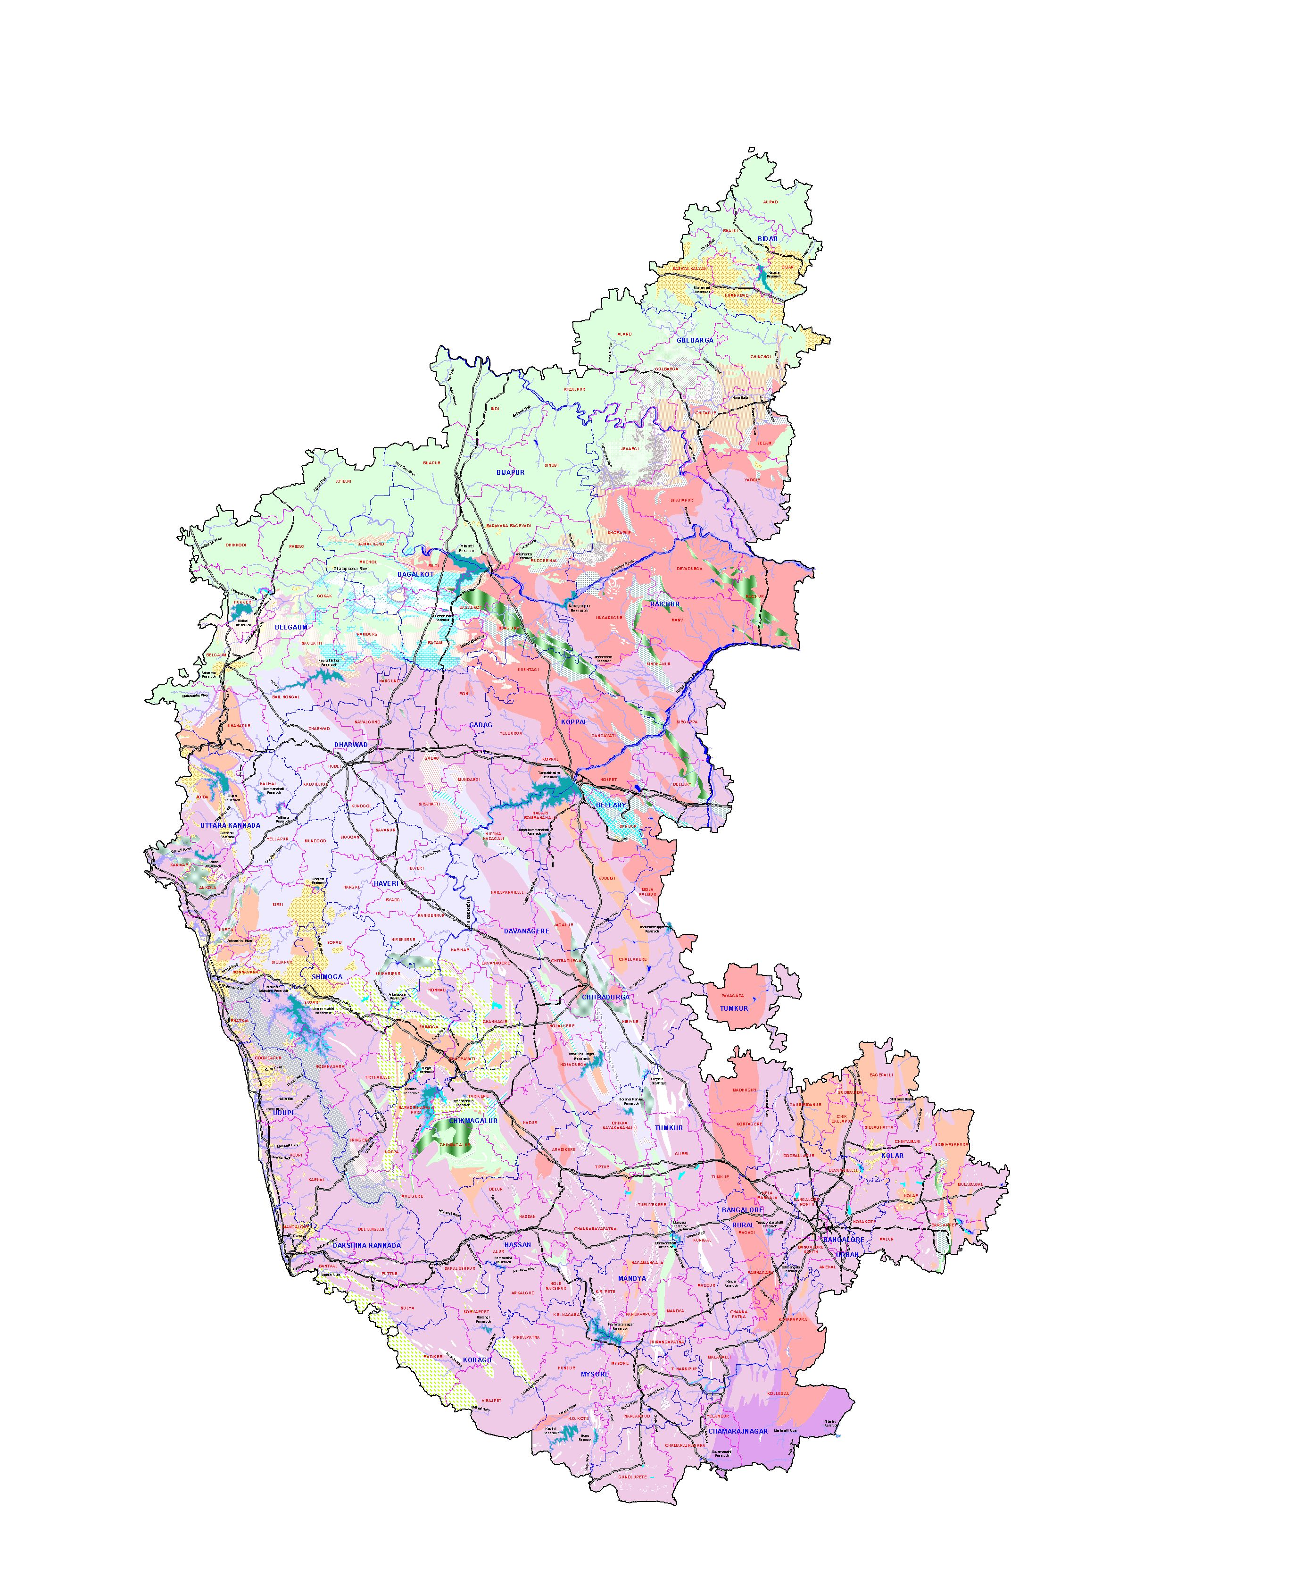
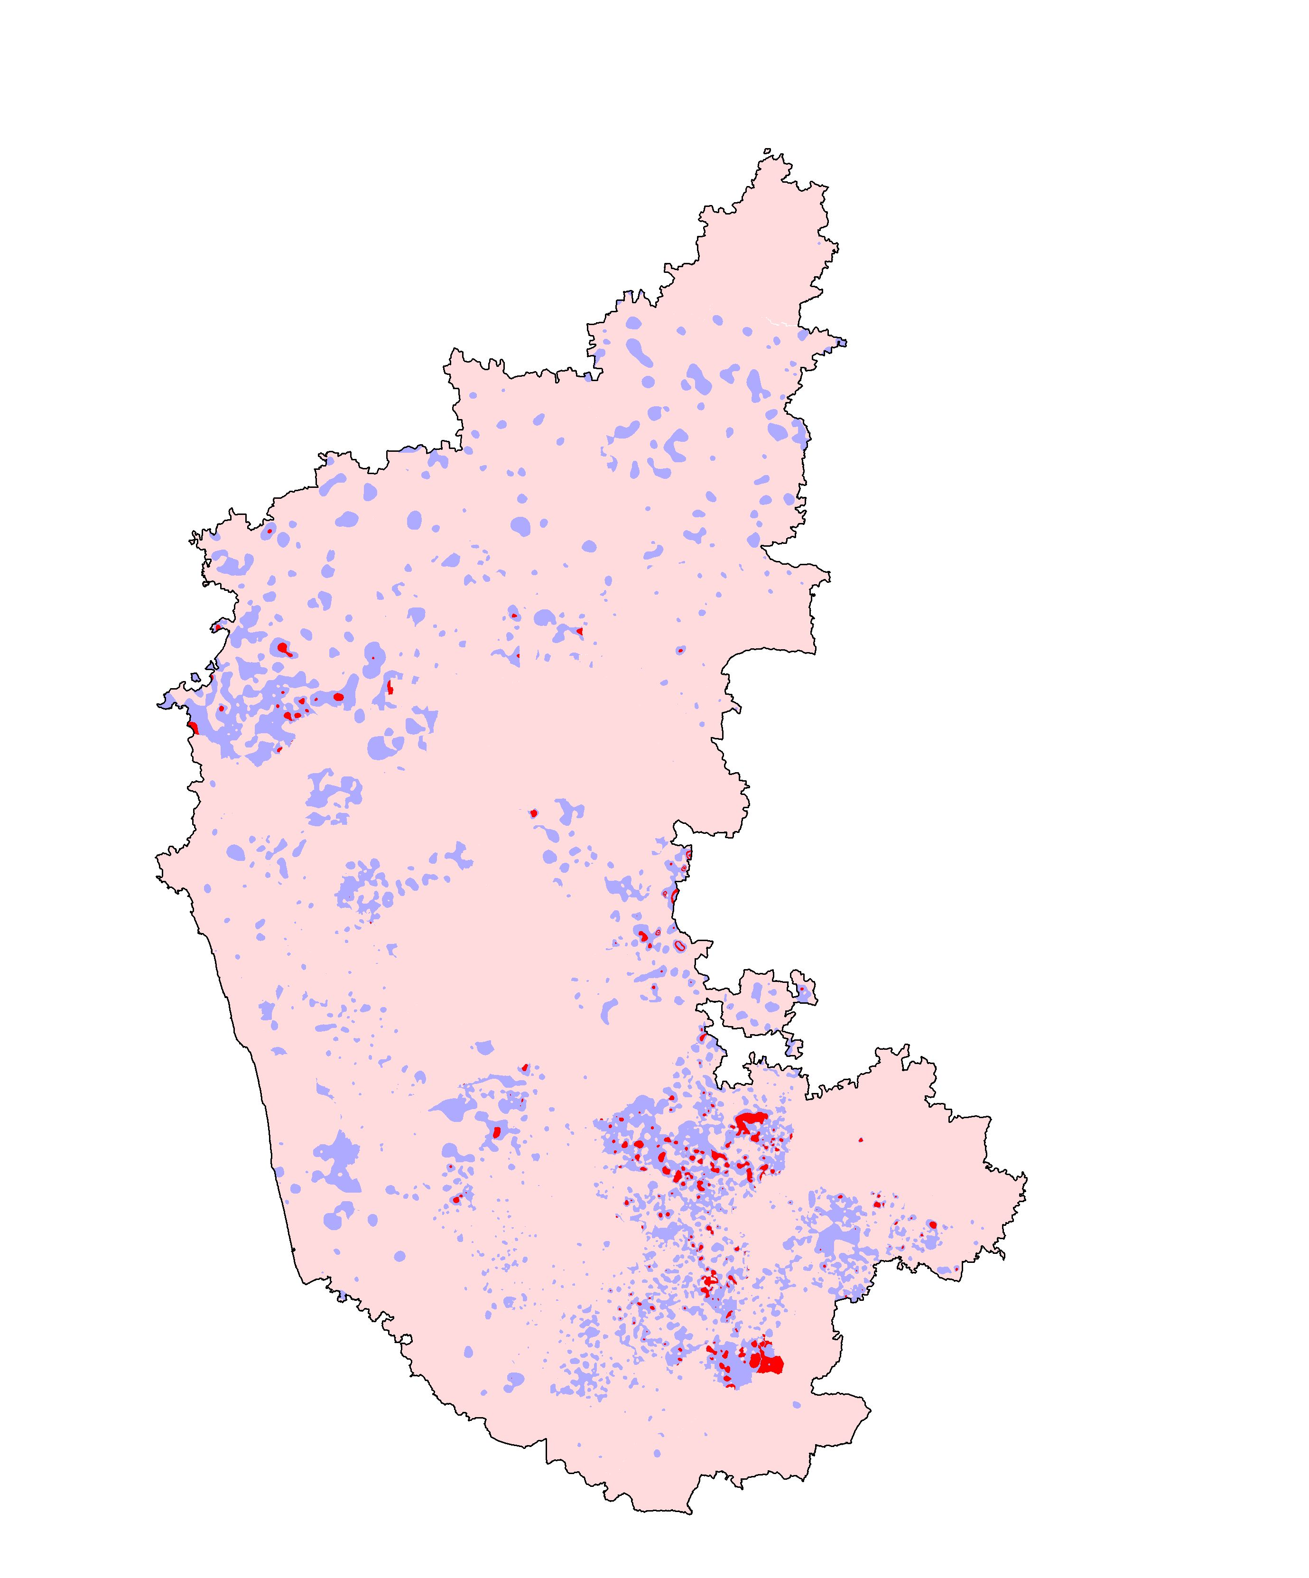
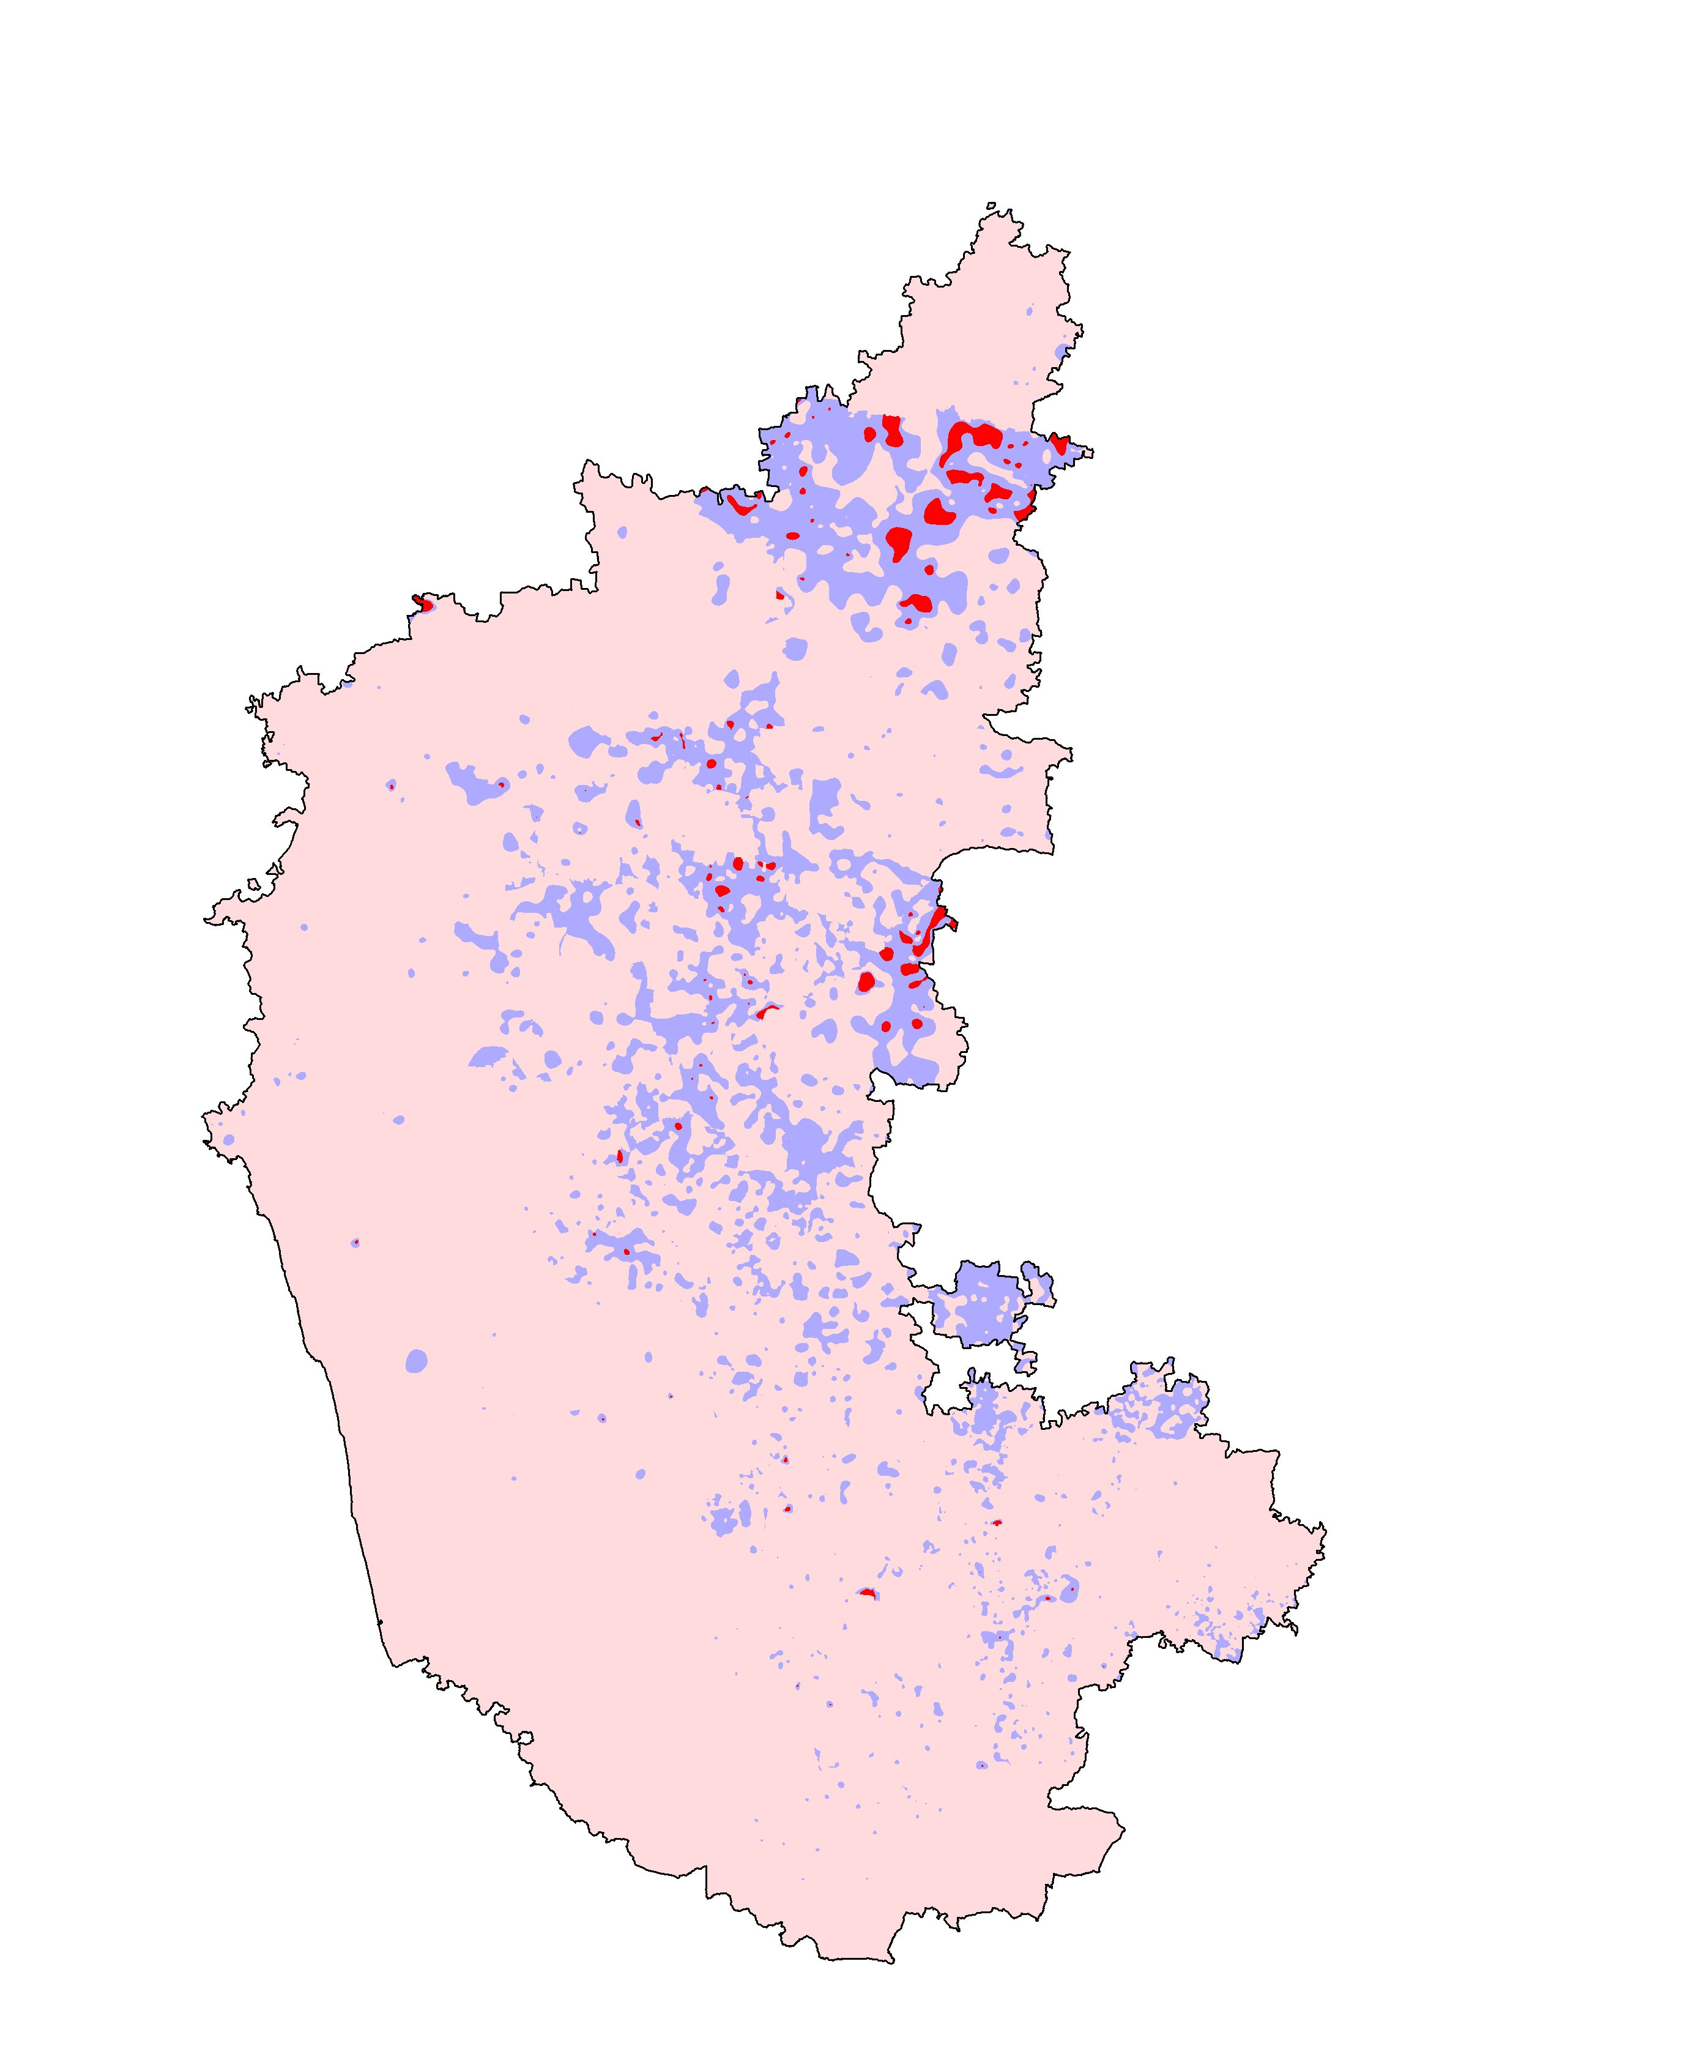
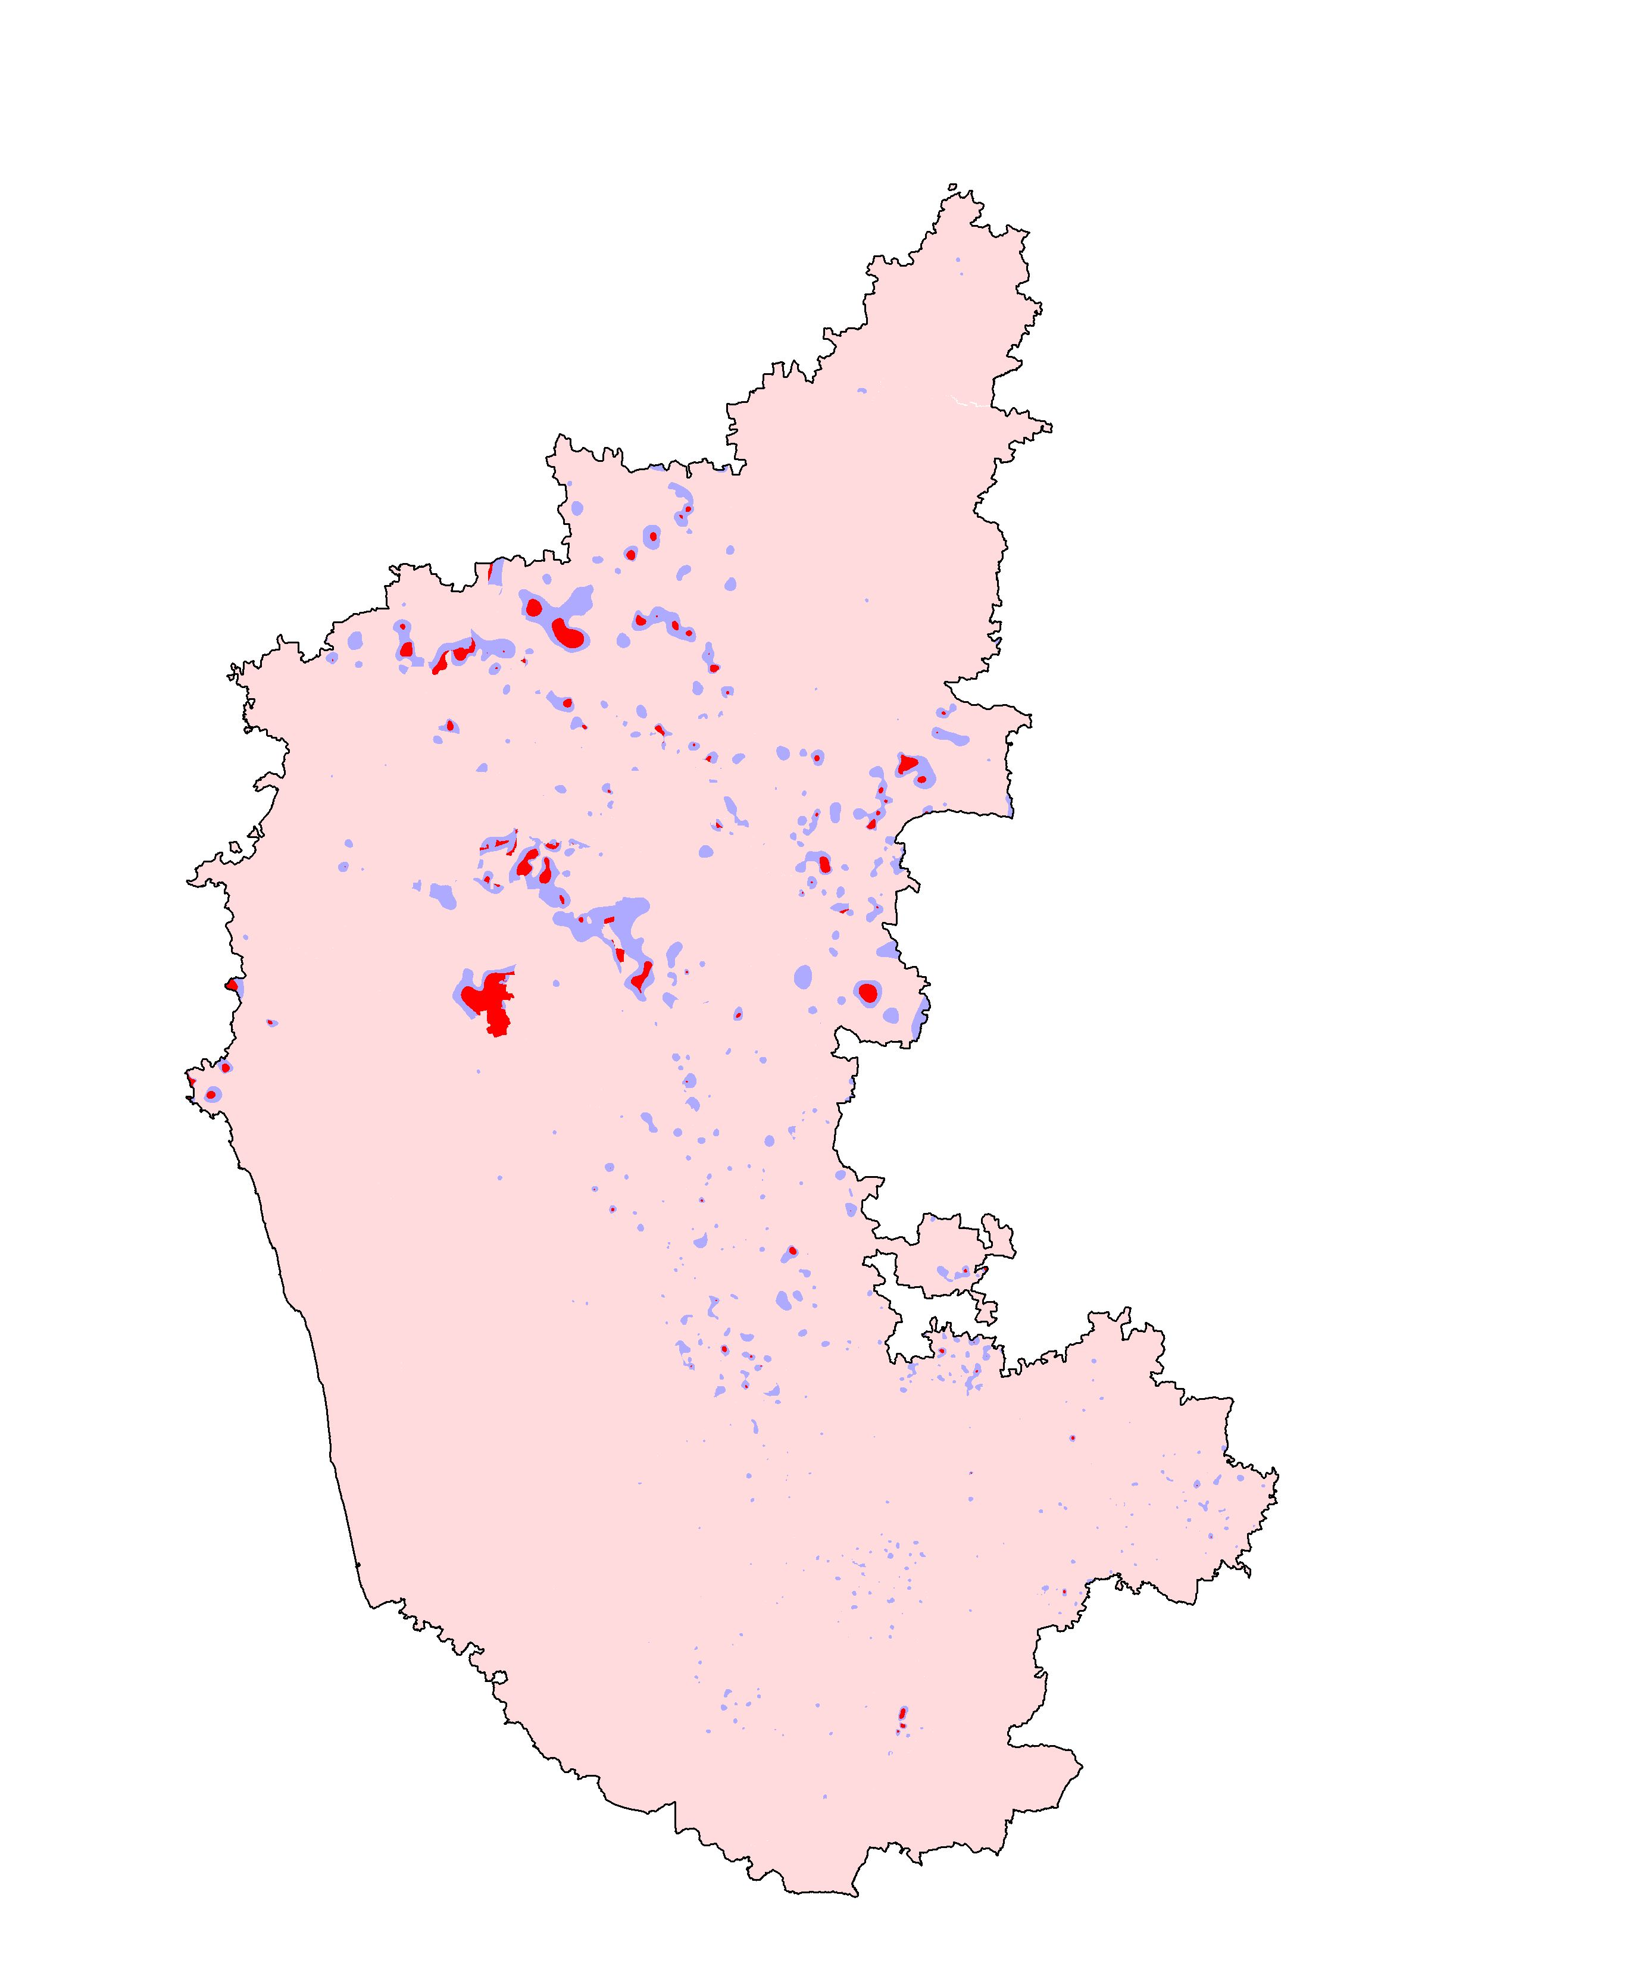
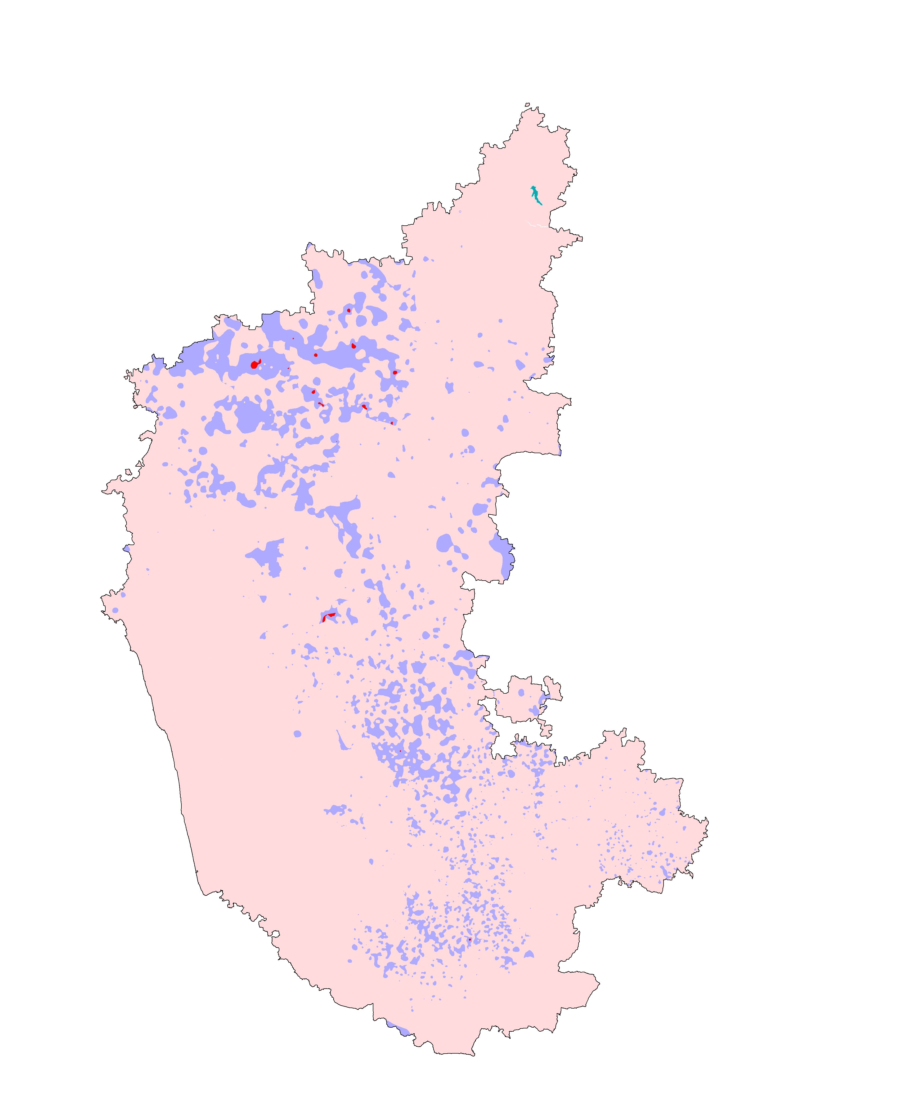
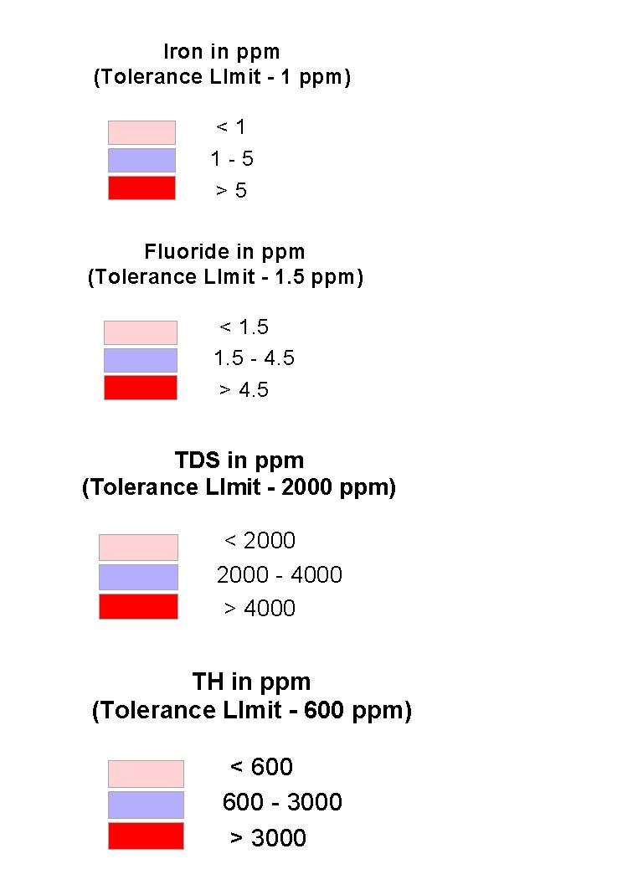
KARNATAKA
TOTAL DISSOLOVED SOLIDS
FLUORIDE
IRON
TOTAL HARDNESS

Fig. 1

Groundwater quality scenario for major parameters in Karnataka (2000-2001)

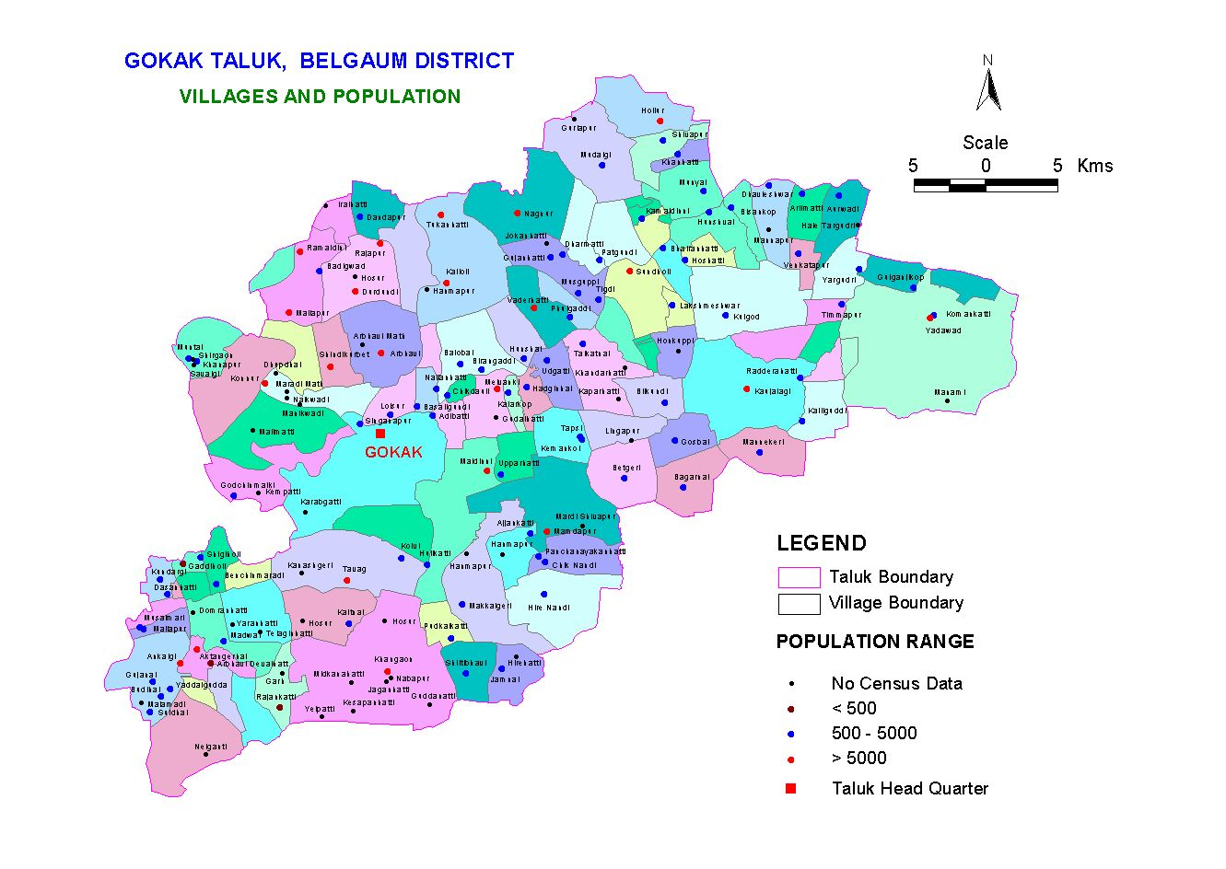
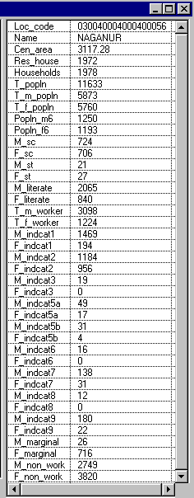
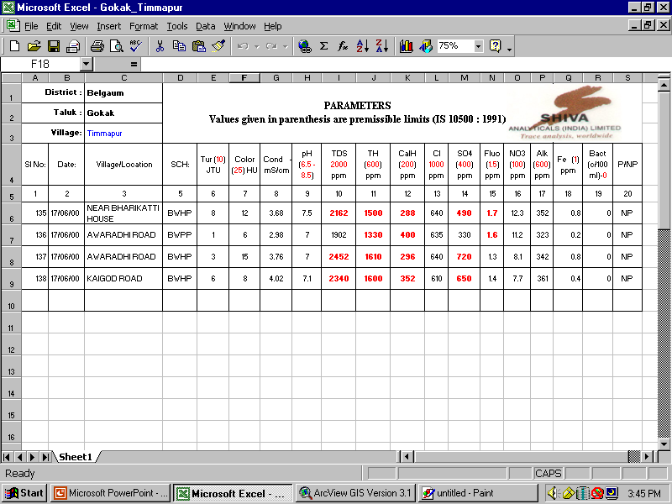
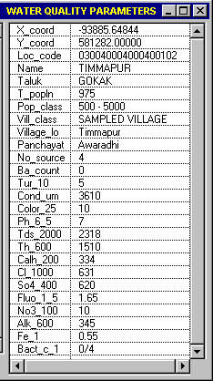
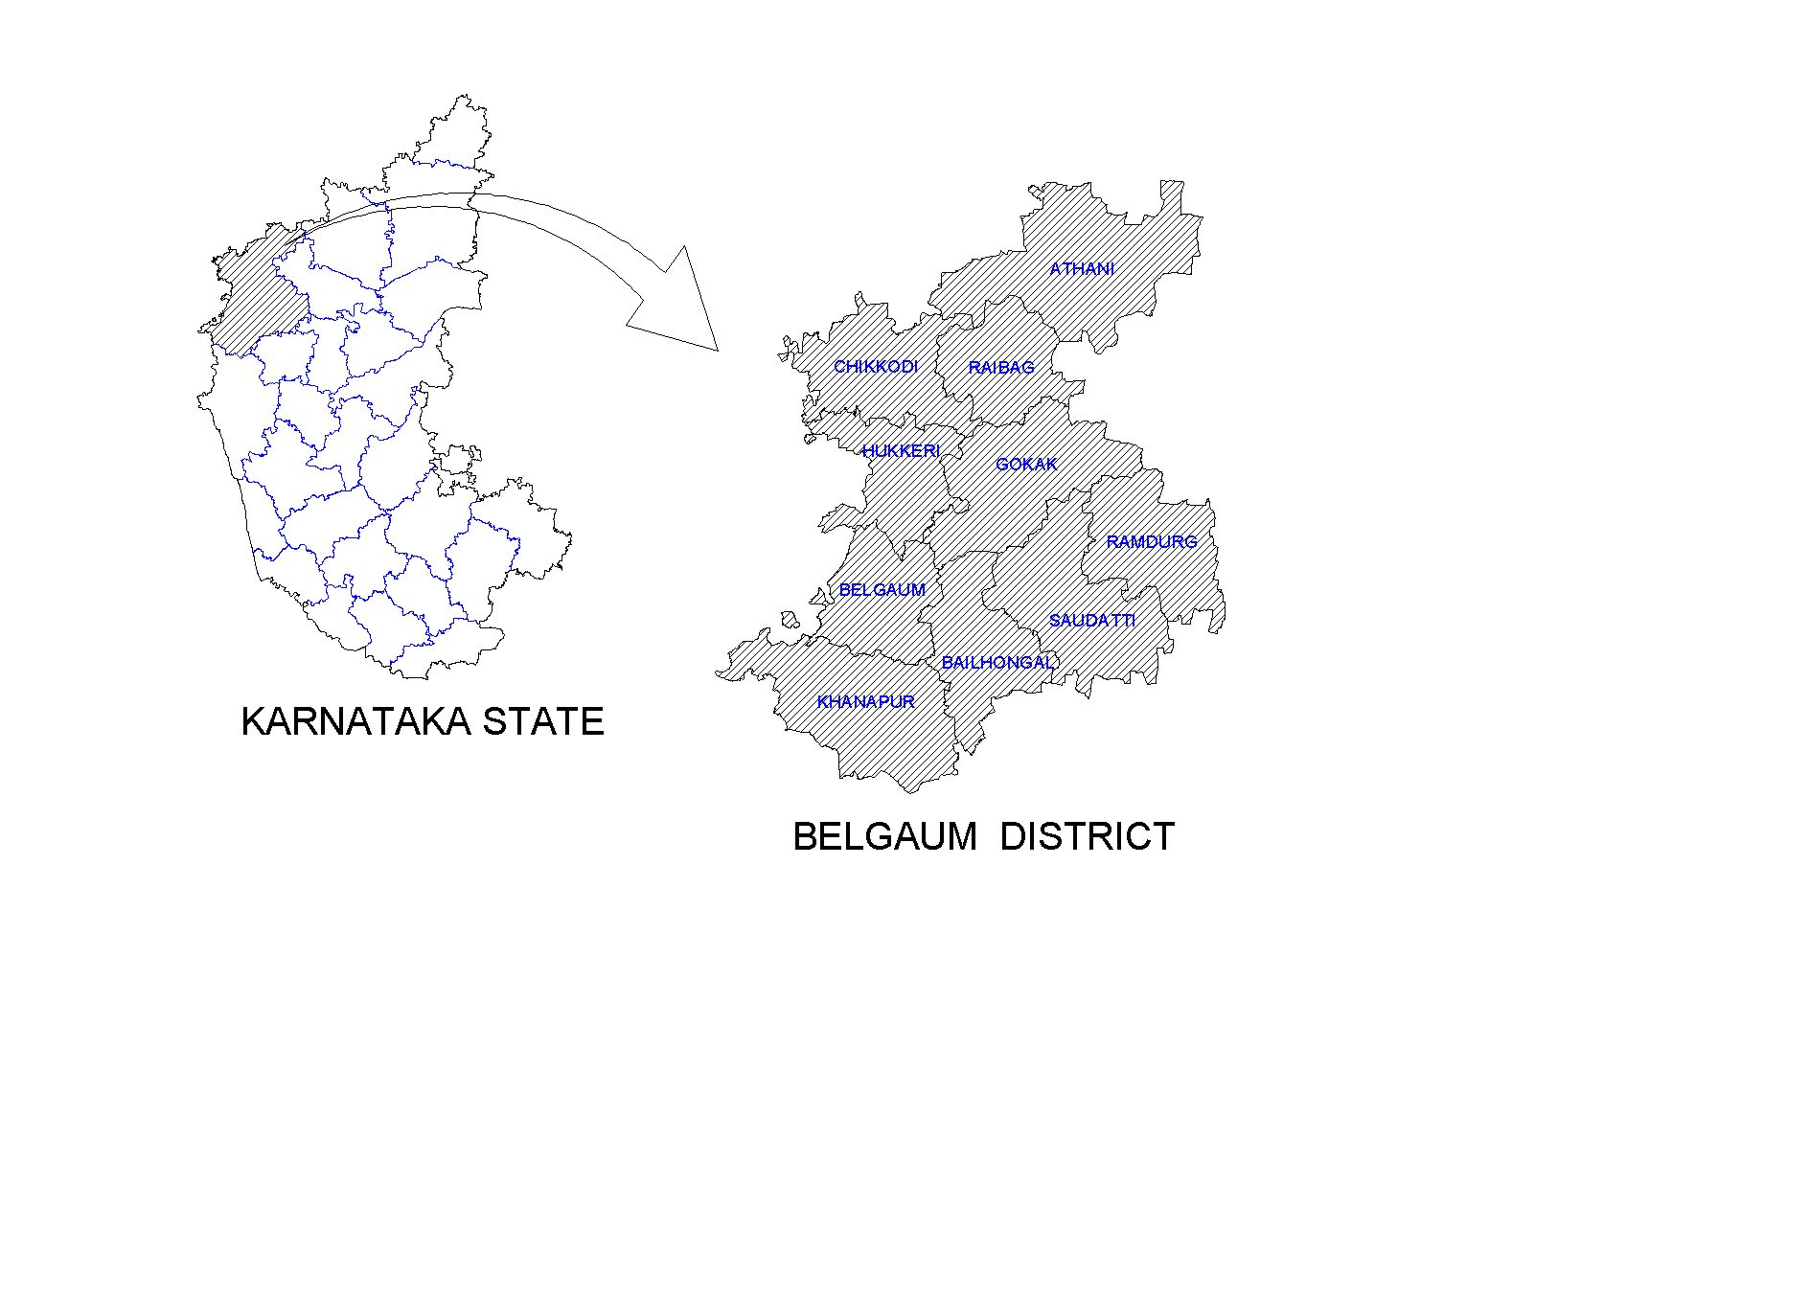
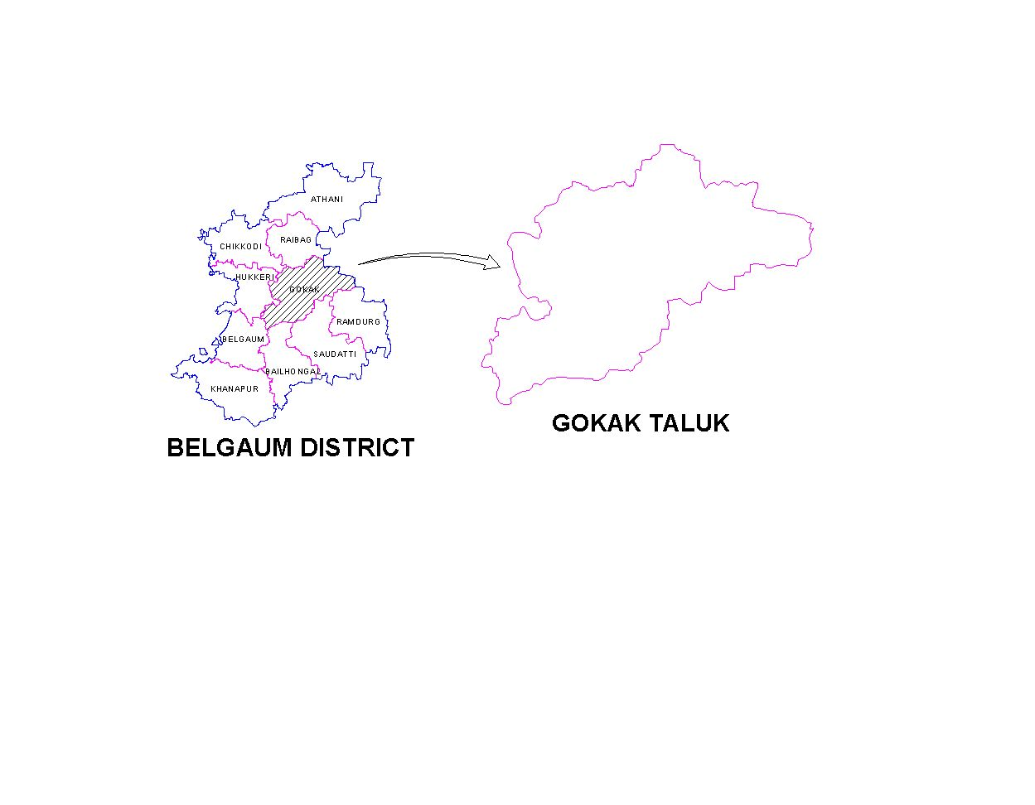
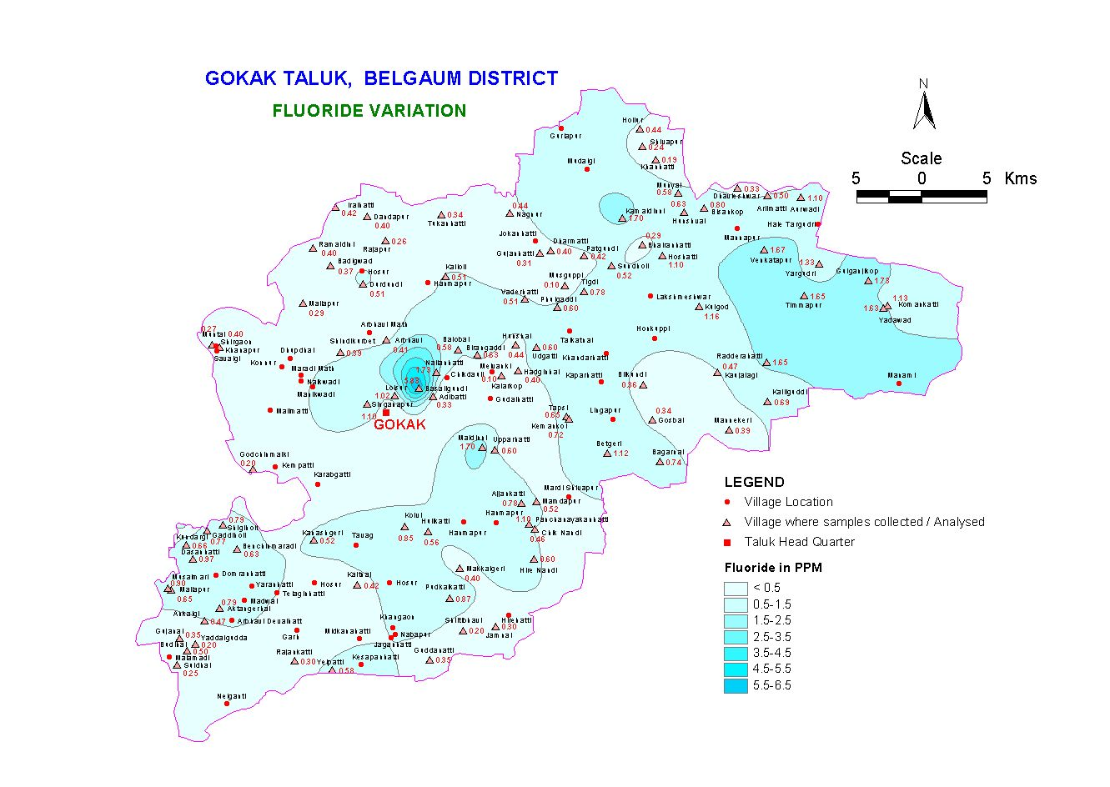
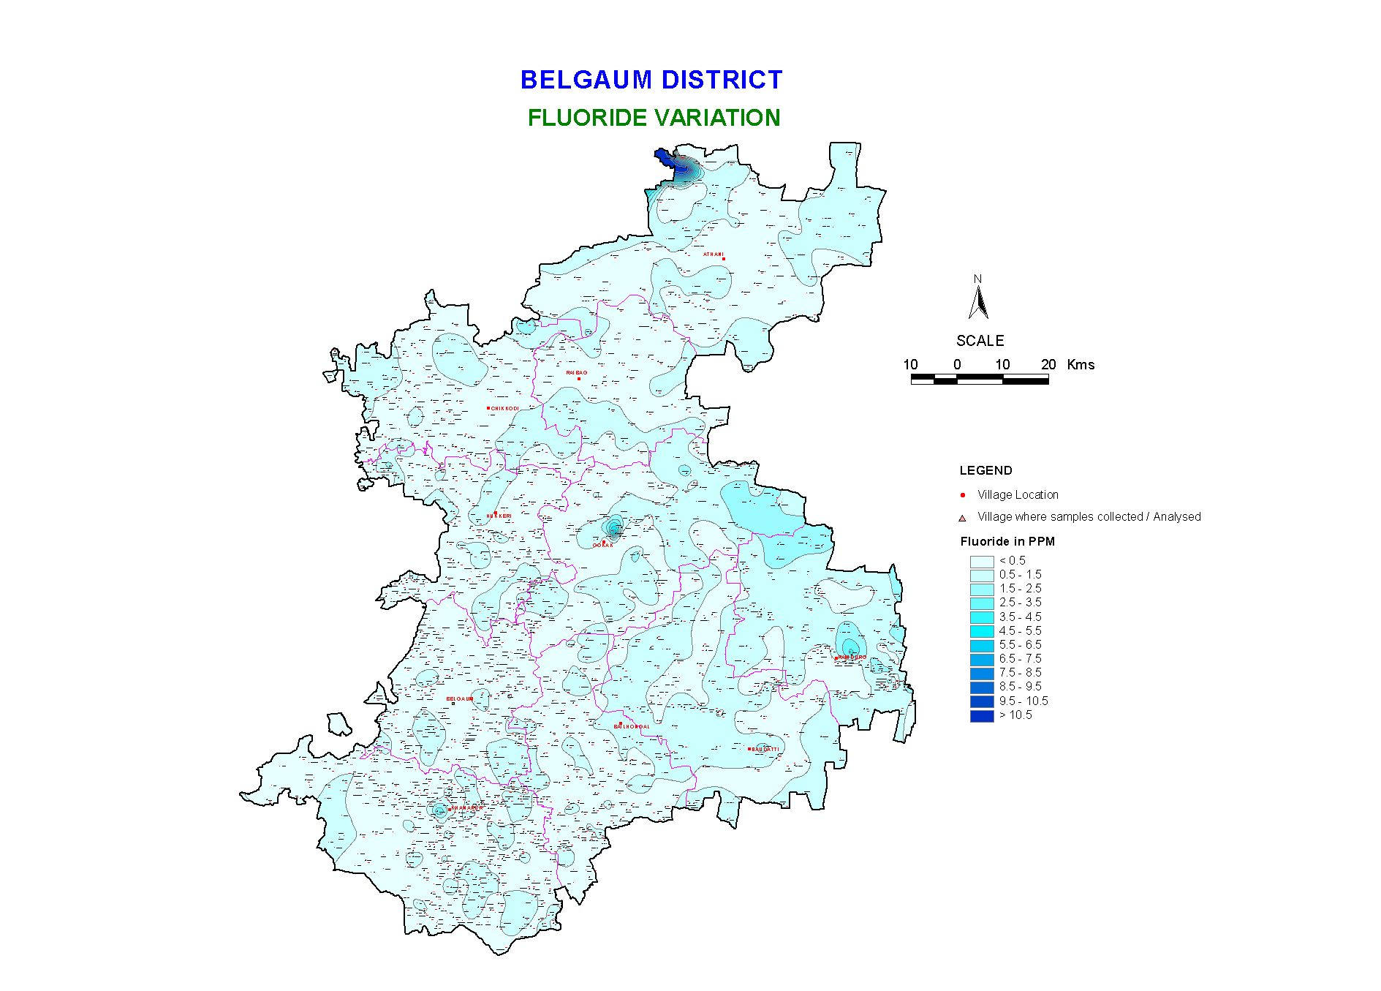

Fig. 2

Villagewise census data linked with water quality

- Priority levels of technical options for ground water quality:

Sl No | Parameter | Available options | Accepted / Recommended options in the order of priority
1 | Fluoride | - Alternate local distant ground water source (with appropriate groundwater recharge arrangements)  - Local / distant surface source  - Blending with Non-fluoride water wherever feasible  - Dual supply with different service level (drinking, cooking and other purposes)  - Household dufluoridation units  - Nalagonda Techniques (using Alum) Ion exchange process (using activated Alumina) | - Where isolated small number of habitations are affected.  - Where large number of continuous villages are affected  - Where fluoride concentration is marginally higher (1.5-2 mg/l) and fluoride free water is available  - Where community is aware, able to distinguish the difference (on pilot basis)  - Can be tried on an experimental basis  - Can be tried on an experimental basis
2 | Nitrate | - In areas affected with Nitrates, open well sources shall be avoided.  - Alternatively, borewell with at least 10 meters casing is recommended. Flushing is to be done. | - In areas affected with nitrate, open well sources shall be avoided  - Alternatively, borewell with at least 10 meters casing is recommended
3 | TDS | - Alternate distant source /ground water  - Alternate local/distant surface source  - Blending, if possible | - Alternate distant source / ground water  - Alternate local / distant surface source  - Blending, if possible
4 | Iron | - Treatment for iron removal  - Regular use of borewells to avoid accumulation of corrosion products from iron pipes | - Creating awareness to avoid long idling of borewells  - Store water longer and strain through cloth  - Change the GI pipe of PVC casing  - Use PVC pipe for new borewells  - Install iron removal plant
5 | Bacteria | a. Disinfection | a. Continuous chlorination of water supply to maintain a minimum residual concentration of 0.2 mg/lit

6. Conclusions:

In this regard, the initiatives taken by the KRWSSA to adopt a Geographic Information System (GIS) approach to develop spatial information and knowledge based on the ground water quality of Karnataka has been found to be very useful. Keeping in tune with the initiatives at the national level, the action agenda of Karnataka State is being accomplished with the commitment to provide rural community with safe drinking water. The GIS database of the entire state, created for the first time in the country would go a long way in water quality monitoring also. The Government authorities should concentrate on water quality monitoring and surveillance strategies for Rural Karnataka.

The outputs of water quality mapping exercise provide a synoptic view of the taluk / district / state and would form a powerful tool for monitoring water quality across the state. The GIS database also helps in decision-making process by identifying the most sensitive zones that need immediate attention. The planning process can also foresee the quality fluctuations and decide upon the priority, schedule, corrective measures and protection aspects with finer details.

Acknowledgements:

Sincere thanks are due to Jal Nirmal Team, RD & PR Department, Government of Karnataka, Prof.Srinivasa Varadan, Principal & Dr.W.P.Prema Kumar, Head of Civil Engineering Department, Dayananda Sagar College of Engineering for their constant encouragement, guidance and support extended in producing this paper.

References:

Manual on Water Supply and Treatment, (3rd Edition), CPHEEO, New Delhi

Water and Waste water treatment: Fair and Geyer.

- How safe is our drinking water? Sounier, 36th Annual Convention of IWWA, 2004.

