
Direct Seeding Of Paddy –

Even if 25% of paddy fields adopt direct seeding, water saved is equal to total water consumed by industry

For further information, please contact corporate.communications@intl.pepsico.com

Agriculture uses over 85% of India’s water resources, with the rest used by industry and domestic consumers. In a year of low rain fall the water table gets further depleted due to large water withdrawal by agriculture. Amongst the various crops, paddy alone uses about half the water used in Indian agriculture. Hence, in order to reduce rapid depletion of the water table, it is critical to reduce water consumption in paddy cultivation. Direct seeding helps reduce water consumption by about 0.9 million liters / acre as it eliminates raising of saplings in a nursery, puddling, manual transplanting and 4 – 5 inches of water at the base of the crop. The farmer saves about Rs 1400 / acre in cultivation cost. Paddy cultivation causes Methane emission due to presence of biomass and water at the base of the crop. Direct seeding significantly reduces Methane emission, and offers an opportunity for farmers to earn from Carbon Credits. Direct seeding offers a very exciting opportunity to improve water and environmental sustainability in Indian agriculture. After carrying out thorough trials over 5 years, and developing a paddy seeding machine, PepsiCo has taken this initiative to farmer fields in 5 states. During 2009 this initiative has already saved over 5000 million liters of water. PepsiCo is working with IRRI and IARI on various aspects of the direct seeding initiative.
PepsiCo has been working with the farmers since 1989 and pioneered the concept of contract farming in India. In line with PepsiCo’s commitment to improve agricultural sustainability and farmer earnings, a new initiative was taken up to promote direct seeding of paddy.
India grows about 130 million tons of paddy over about 108 million acres and is amongst the largest rice growers in the world. In the northern part of the country paddy is mostly grown during the monsoon season (July to October) while in the southern and eastern parts of the country it is grown throughout the year and there are usually two paddy crops annually.
Traditionally, India paddy is cultivated by sowing seeds in a small nursery, where the seeds germinate into saplings. The saplings are then transferred manually into the main field and then grown with 4 - 5 inches of water at the base of the crop for the first 6 - 8 weeks, mainly to prevent weed growth. Direct seeding avoids three basic operations, namely, puddling ( a process where soil is compacted to reduce water seepage), transplanting and standing water, thereby saving about 30% water (0.9 million liters of water / acre). Even if 25% of the Indian paddy cultivation can be shifted to direct seeding, water saving will be equal to the total water consumed by the Indian Industry. PepsiCo is working with International Rice Research Institute to carry out water measurements in direct seeded and traditionally irrigated farmer fields to validate the reduction in water consumption achieved through direct seeding.
After a successful demonstration of direct seeding at PepsiCo’s R&D fields in Punjab during 2004 and 2005, this technology was taken to farmers’ fields in years 2006 and 2007 by planting 20 and 100 acres respectively. During 2008, PepsiCo carried out direct seeding over 1100 acres.
This innovative process is now becoming extremely popular with the farmers and during 2009 PepsiCo has already carried out direct seeding over 5700 acres across 5 states having different agro-climatic and soil conditions and with various varieties of paddy. The saving in water during 2009 through this PepsiCo initiative will be over 5000 million liters.
Apart from resulting in substantial reductions in water consumption, direct seeding also results in significant cost saving of Rs 1400 / acre for the farmer. This happens primarily as the following three processes are eliminated in direct seeding.
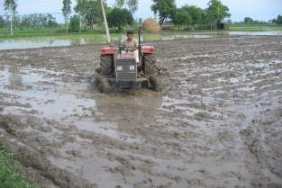
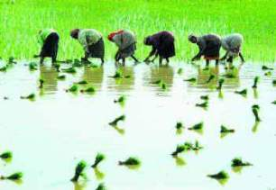
Puddling
Manual Transplanting
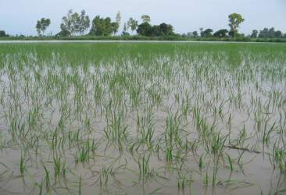
Standing water for first one and a half months

The critical success factors for direct seeding are:
- Proper seed germination, plant population and its geometry
- Nutrition & management of micronutrient deficiency
- Management and control of weeds
The various developments made during PepsiCo’s R&D trials to manage above said factors are as follows:

Proper seed germination, plant population and its geometry

- Development of Direct seeder: PepsiCo has developed a tractor driven direct seeding machine locally with a specific seed-metering device used for sowing the paddy seeds.
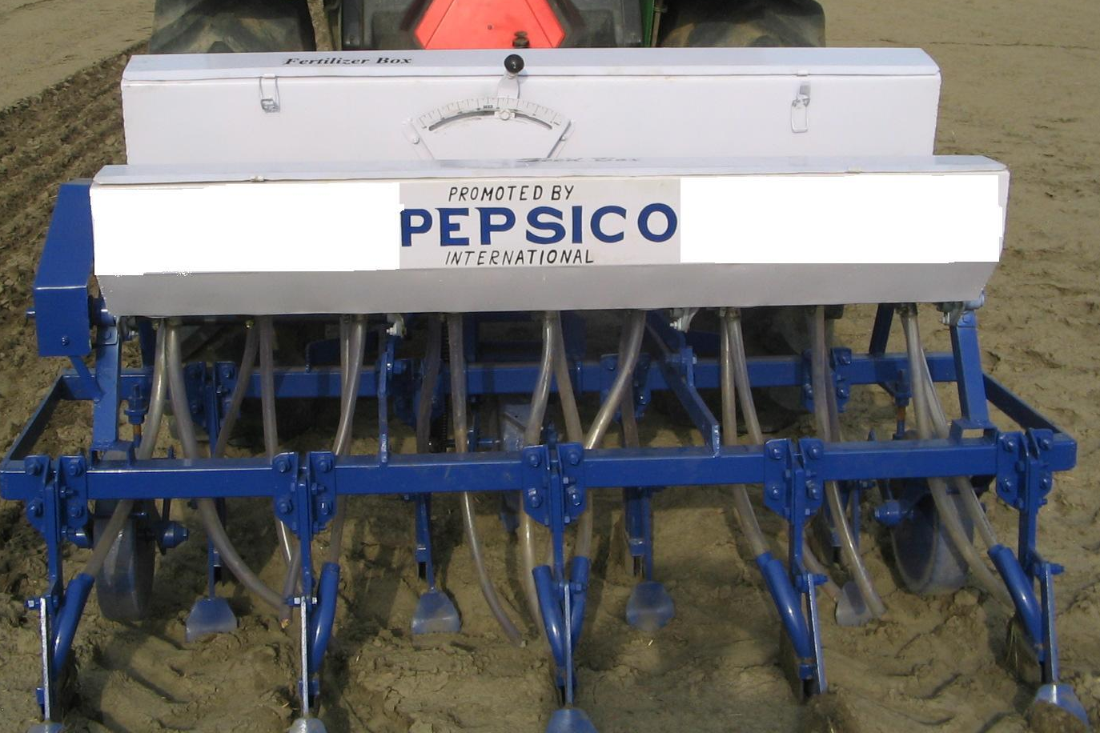

Direct seeding Machine

In direct seeding, depth of sowing is very important as it affects the seed germination efficiency. In order to have good germination, the machine has been designed to sow the seeds at a depth of 1-1.5 inches.

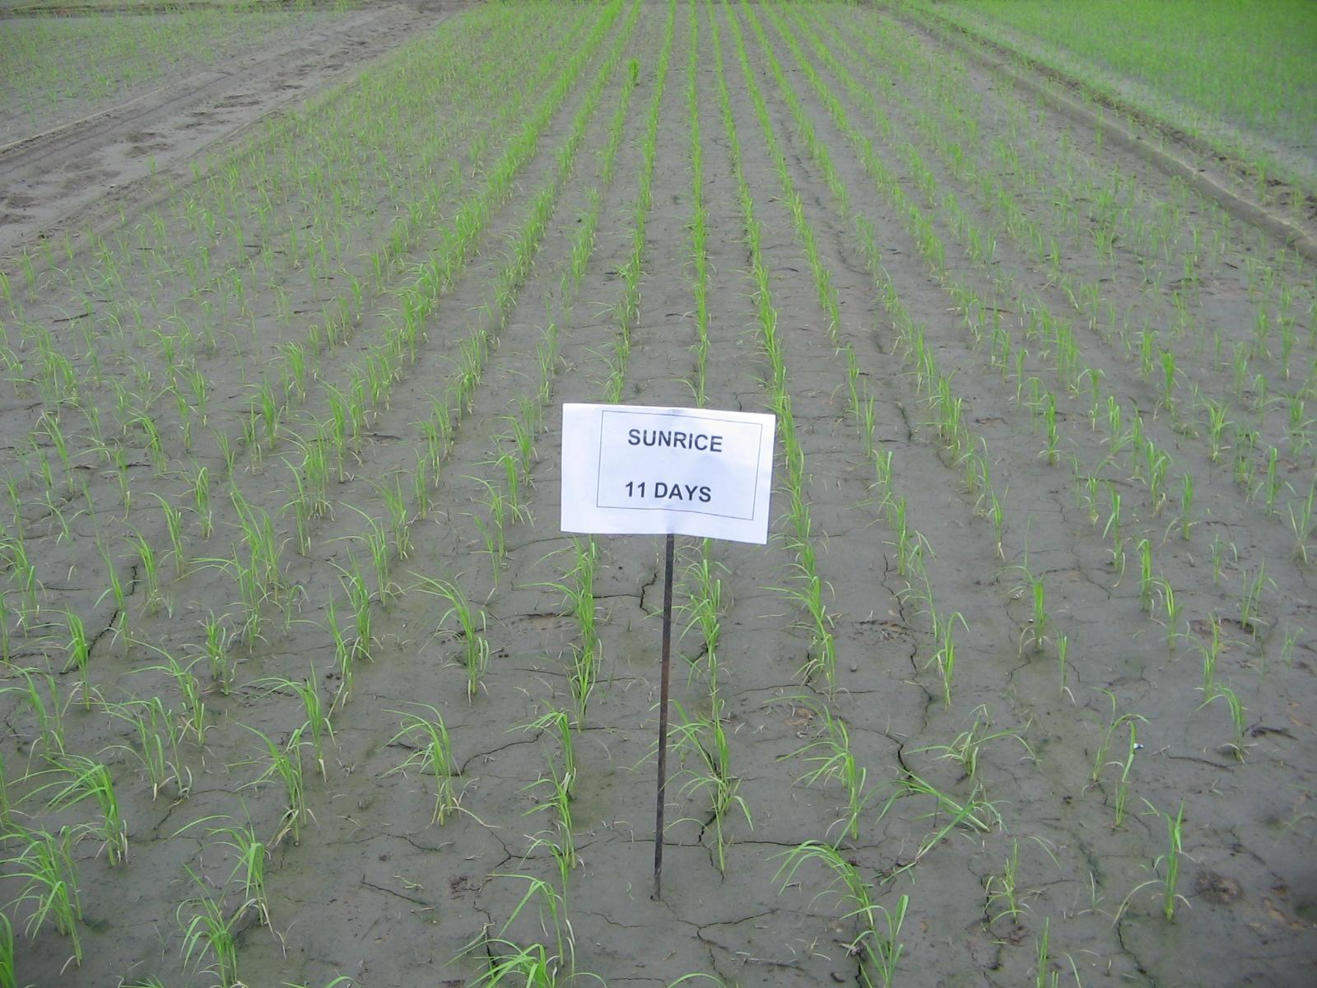
The direct seeder developed by PepsiCo has a unique seed-metering device which ensures planting of the seeds 8-9 inches apart (4-5 seeds falling at this distance) and also maintains a row to row distance of 9 inches. This machine ensures about 30-32 plants / sq meter. PepsiCo has bought many direct seeding machines and offers to the farmer free access to these machines to carry out direct seeding in their fields.

- Seed Priming: Seed priming is soaking and treatment of seeds before actual seeding through the machine. This is a very important operation which helps to improve germination and control of seed borne diseases. The seed is soaked in solution having fungicide and antibiotics (Emisan and Streptomycin) for 15-20 hours. The seed thus treated is dried for 1-2 hours in shade so that it can be dispensed efficiently from the machine.

Nutrition & management of micronutrients deficiencies

Since direct seeding follows aerobic cultivation of paddy, it usually results in certain micronutrient deficiencies, namely Zn, Fe & Sulfur and also P among macronutrients. These deficiencies are corrected by application of Cheated Zinc and Ferrous fertilizers. To meet this demand and to avoid nutritional deficiencies, fertilization schedule as mentioned below has been followed:
Time of Fertilization | Fertilizer (in Kgs / acre)
 | Urea | DAP | MOP | Librel Zinc | Librel Fe
At the time of sowing | 15 | 25 | 20 | 0.5 | 0.5
20 days after sowing | 15-20 | 0 | 0 | 0 | 0
35 days after sowing | 10-15 | 0 | 0 | 0 | 0

At the time of sowing, 25 kg of DAP, 0.5 kg of Librel Zinc and 0.5 kg of Librel Fe are drilled and the remaining fertilizers are broadcast. After 30 - 35 days of sowing, Libmix @ 2 gm per liter of water is sprayed. This helps overcome the deficiencies of Zinc and Iron. To overcome Sulfur deficiency, ground application of 2 kg acre of Librel Sulfur needs to be done.
Management and Control of weeds Management of weeds with pre & post emergence herbicides plays a critical role for success of direct seeding technology. Application of pre-emergence herbicide is important as it reduces the competition between germinating paddy and weeds by stopping the growth of weeds for first few days, hence improving paddy seed germination. Among pre-emergence herbicides, Top Star (Oxadiargyl) has performed well during field trials.
Few of the post emergence herbicides which have done well in farmer fields are Sunrice (Ethoxy Sulfuron), Nominee Gold (Dispyribac-sodium), Whip Super (Fenoxa-prop-p-ethyl) and Almix (Metsulfuron+ Chlorimuron Ethyl). Selection and application of post-emergence herbicides depends upon the weed flora in the field. Timely application of post emergence herbicide is extremely critical to get good management of weeds.
The harvesting of direct seeded paddy fields sown during 2008 has shown that output from direct seeded paddy fields is comparable to traditionally irrigated paddy fields. With lower cost of cultivation, direct seeding results in higher income to the farmers.

Methane emission reduction through direct seeding of paddy
Paddy cultivation with traditional flooded irrigation is one of the main reasons for Methane (a gas which damages the ozone layer 23 times more adversely than CO₂) emission in the country. The presence of biomass immersed in water over an extended period leads to about 4.5 million tons of Methane being emitted from the paddy crop in India annually. Since in direct seeding there is no water at the base of the crop, there is a substantial reduction in Methane emissions. PepsiCo is partnering Indian Agricultural Research Institute and International Rice Research Institute to establish the reduction in Methane emissions. PepsiCo will work to get clearance from United Nations Framework Convention on Climate Change (UNFCCC) for direct seeding of paddy to be included as an approved means to earn Carbon Credits. As the land holdings in India are fragmented, once the UNFCCC approvals are received, PepsiCo will look at consolidating Carbon Credits for all direct seeded fields and pass these on to the individual farmers, after recovering its own costs.
Few photographs of direct seeded paddy crop at different stages in farmer fields are attached. It should be noticed that there is no water at the base of the crop. Also, all the saplings are in a geometric pattern due to machine seeding.

Different stages of direct seeding crop
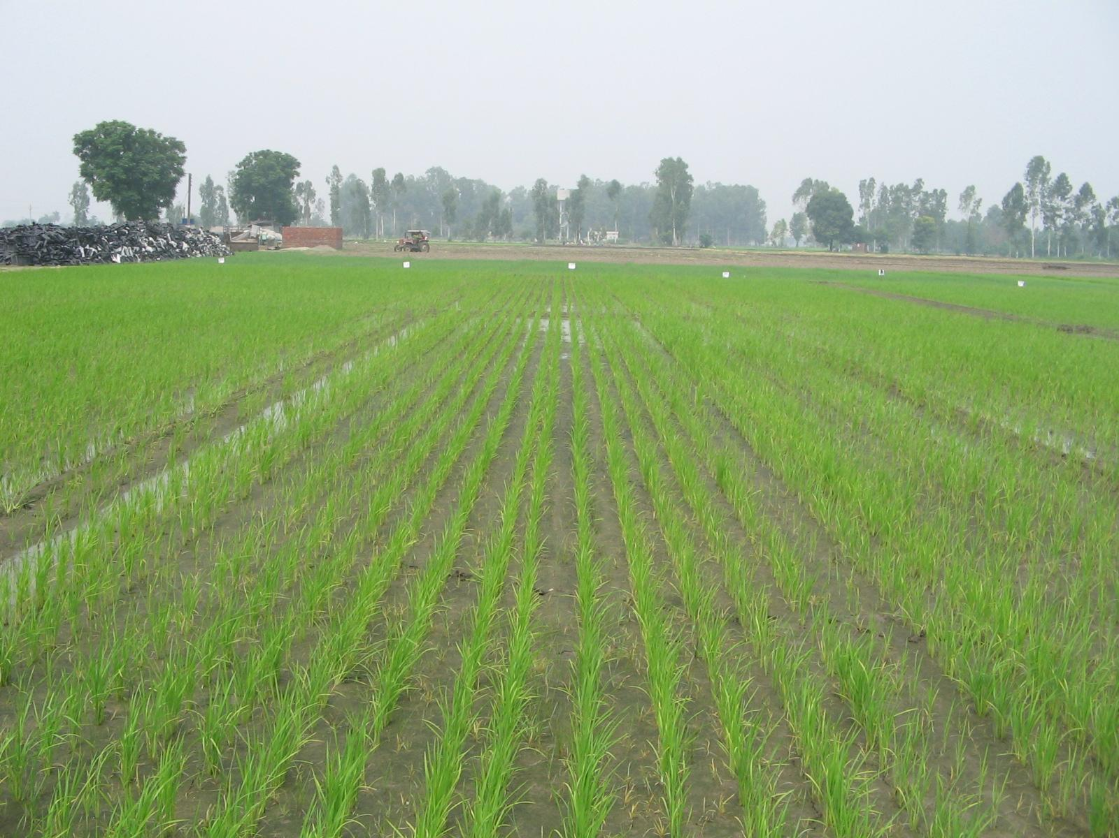
Variety-170
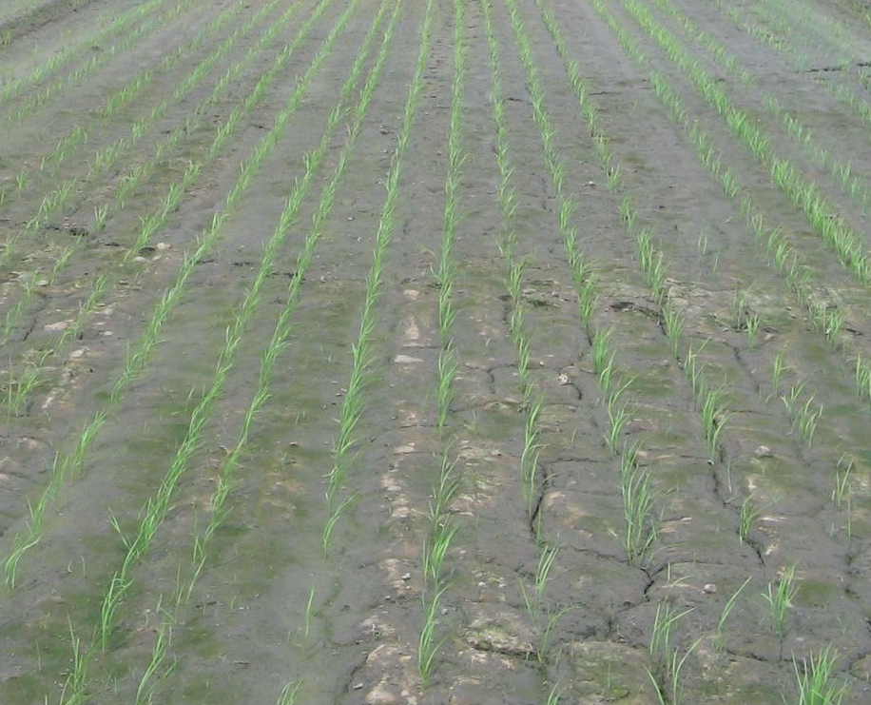
15 days old direct seeding crop
30 days old direct seeding crop
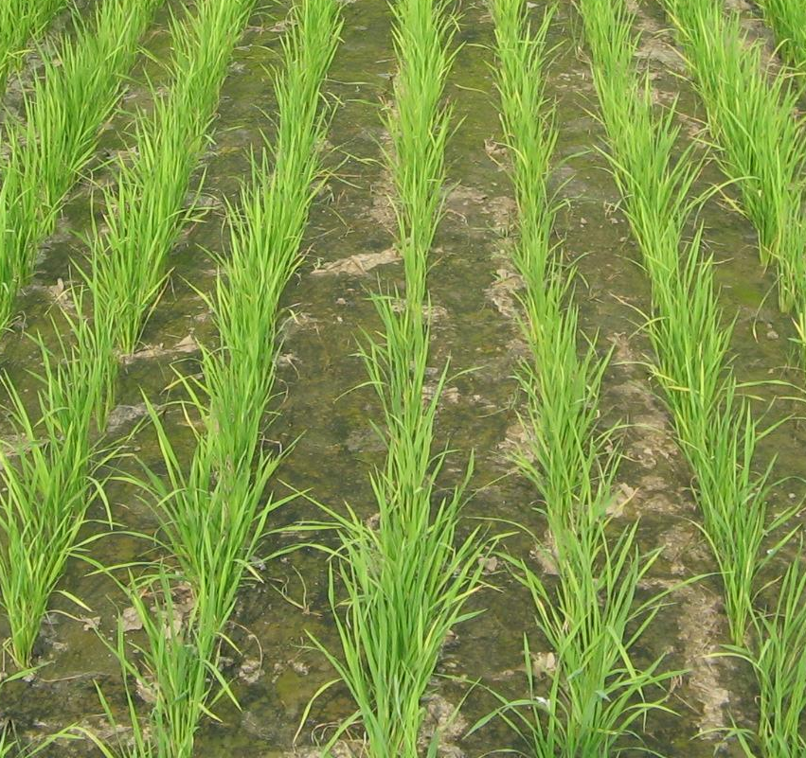
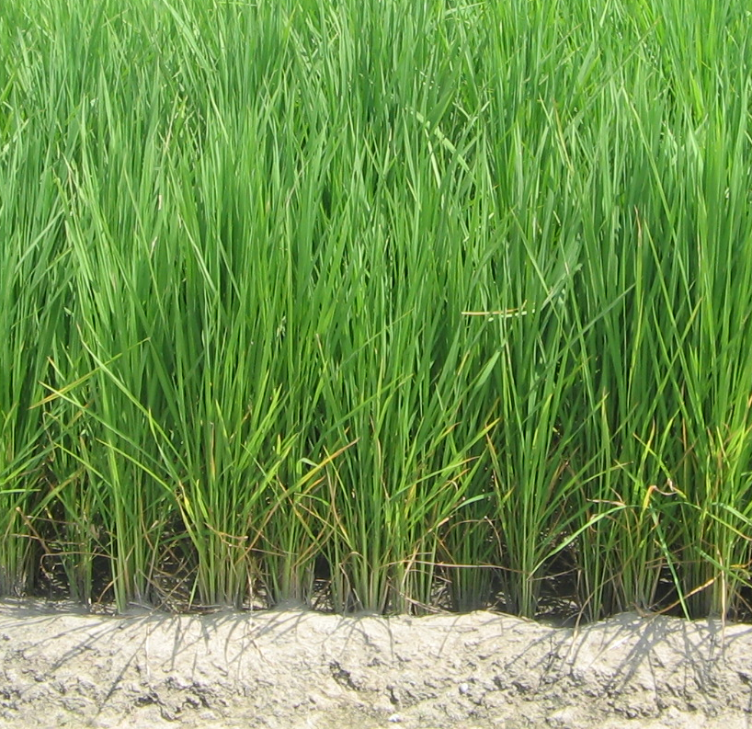
85 days old direct seeding crop
40 days old direct seeding crop
Direct seeding crop at
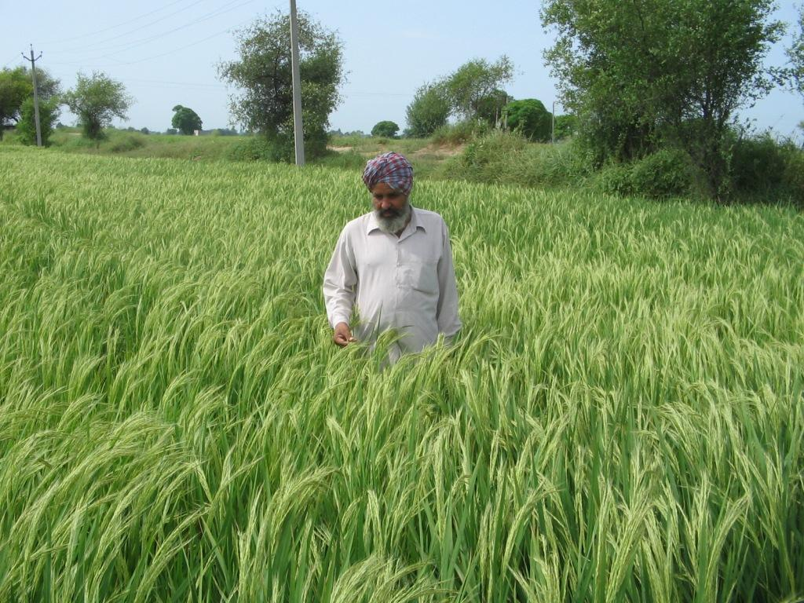

120 days old crop

