Experts expected to deliver lecture

Dr A K Singh, DDG (NRM), Indian Council for Agricultural Research (ICAR), New Delhi

Er Rupert Talbot, Chief of Water & Sanitation, UNICEF

Dr Deepak Kashyap, Professor of Civil Engineering, Indian Institute of Technology (IITR), Roorkee

Dr. P P Mujumdar, Prof & Chairman, Department of Civil Engineering, Indian Institute of Science (IISC), Bangalore

Dr P D Porey, Director, S V National Institute of Technology,(SVNIT) Surat, Gujarat State

Dr K V Jayakumar, Executive Director, Centre for Water Resources Development and Management, (CWRDM), Kozhikode, Kerala

Dr V R Desai, Department of Civil Engineering, Indian Institute of Technology (IITKgp), Kharaghpur

Dr. L M S Palni, Director, G B Pant Himalayan Institute of Environment and Development (GBPHIED), Kosi Kataramal, Almora

Dr. Anil Joshi, Chairman, Himalayan Environmental Studies and Conservation Organization, (HESCO) Dehradun

Er. T C Gupta, General Manager, NHPC Limited, Tanakpur Hydel Power Station, Banbasa

ACCOMMODATION
Moderate Accommodation will be provided to participants in International Guest House of the University free of charges on availability with prior information only.
Technical Visit Details
A technical visit to Nainital, Bhimtal, Sattal lakes and Gola Barrage has been arranged on 21st Feb 2009.

Optional: Depending upon the response of interested participants, a field trip to Jim Corbett Park / Tanakpur Hydel Power Station is proposed on 22nd Feb 2009, self financed by the participants on a nominal amount of Rs. 500/- only submitted on the spot in addition to the registration fee.
Important Date

Last Date of Registration: 10th Feb 2009

Registration Fees Details

Participants from Acad. / NGO Institutions: Nil
Participants from Industry/Govt. Organisations Rs. 500 / - (US$10)

Address for Correspondence

Asso. Prof. Jyothi Prasad
Department of Civil Engineering
College of Technology,
G B Pant University of Agri. & Tech.
Pantnagar-263145
Email: prasad_jyothi@lycos.com
jptce@gbpuat-tech.ac.in
Contact No. +91-9410119571
Fax: 05944-233338/233473
Tel: 05944-233731 / 235682 (R)
or
Asso. Prof. H J Shiva Prasad
Department of Civil Engineering
College of Technology
G B Pant University of Agri. & Tech.
Pantnagar-263145
Email: hjs_prasad@yahoo.com
sptce@gbpuat-tech.ac.in
Contact No. +91- 9719245303

Website: www.gbpuat.ac.in
www.gbpuat-tech.ac.in

WATER SUMMIT
February 19-21, 2009
Under
Technical Education Quality Improvement Programme (TEQIP))
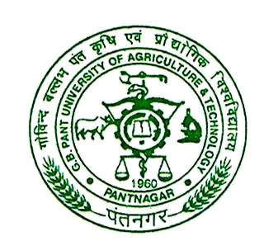

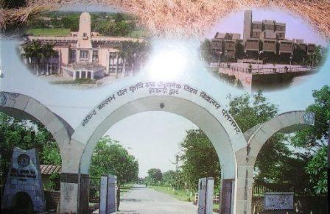
Organized by
College of Technology
G B Pant University of Agriculture & Technology
Pantnagar-263145 Distt. US Nagar (Uttarakhand.), India

Supported by

ISTE, Pantnagar Chapter

OBJECTIVES

Uttarakhand state with an area of approximately 53,483 sq. kms., encompasses both hilly as well as plain terrains. The state has vast natural resources of water. To unveil the recent developments in the areas of water and bring together the scientists, researchers and engineers from academia, field and industries of the nation to interact among themselves for exchange of knowledge, ideas and views for enhancing mutual co-operation and also to provide a platform to disseminate the latest technologies in the field of water to the faculty, scientists, engineers etc.
ABOUT THE UNIVERSITY

Pt. Jawaharlal Nehru, the first Prime Minister of India, laid the foundation stone of the UP Agricultural University on 17th November 1960 rechristened later as Govind Ballabh Pant University of Agriculture and Technology. It is the first Agriculture University of the country established on the land grant pattern of U.S.A. and better known as the “Harbinger of Green Revolution” in India. The university is located at Pantnagar, Uttarakhand. Nainital, the city of lakes is about 60 kms. from Pantnagar. The weather is cool and pleasant at Pantnagar during mid February and stay will be very much enjoyable in this location, which is rich in flora and fauna.

COLLEGE OF TECHNOLOGY

The College of Technology, one of the constituent colleges of the University, was established in 1966 and presently offers eight Bachelor degree and Twenty-two Post-Graduate degree programs. The College has ten departments. It has well established infrastructures with modern facilities.

TOPICS OF THE TRAINING

- Water Resources
- Water Supply
- Soft Computing Applications
- Irrigation Water Management
- Social, Environmental, Ecological Aspects
- Resettlement and Rehabilitation aspects
- Surface / Ground Water Management
- Water Power Development
- Water Quality Aspects
- Urban Water Management
TEQIP PROJECT:
The Technical Education Quality Improvement Program (TEQIP) a World Bank funded project is in operation in 128 institutions of the country to enhance the quality of Technical Education by strengthening facilities. The College of Technology is the lead institute of Uttarakhand under this project. The major components of this project are Academic Excellence, Net Working, Service to Community and Economy. The College has got appreciation on the basis of its performance in TEQIP at the National level.

Leaflet can be downloaded from university website at http://www.gbpuat.ac.in
WATER SUMMIT-2009
February 19-21, 2009

Registration Proforma

1. Name :
2. Organization name with address:

3. Address for communication:

4. Phone No. with STD code:
Office: Residence:
Mobile: Email:

5. Registration Category:
Academician/Government Organizations/Delegate from Industry/ Research Scholars/ Faculty/NGOs

6. Accommodation required: Yes/ No

7. Tentative Travel Plan:

Arrival:

Departure:

- a) Technical Site Lakes Visit: Yes/No
b) Optional visit (Tick option):
Jim Corbett Park / Tanakpur Hydel Power Station

Date: Signature of the Participant
Place:

Signature & Seal of the Head of the Institution

