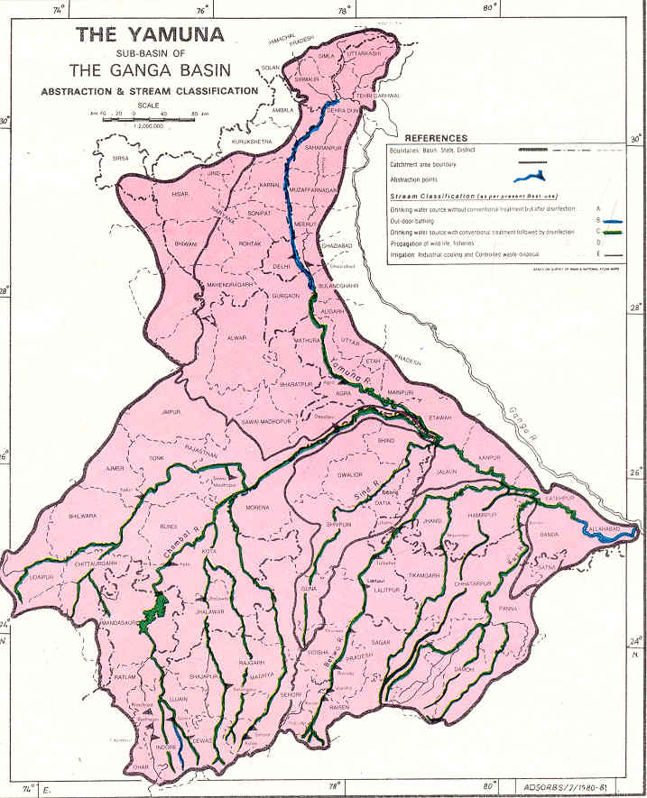
Yamuna Mathura-Agra Conference 2009

Sponsored by: Yamuna Foundation for Blue Water,
(http://www.rowfoundation.org/row/)
Rivers of the World Foundation
(http://www.rowfoundation.org )

Techknow Environmental & Sustainable Solutions
Pvt., Ltd. Delhi,, India( http://www.techknow-eng.com/ )

Location: Goverdhan Hotel, Opp. Delhi Gate
Agra, U.P. 282002; Ph: 0562 4000867,

Date/Time: Sunday, January 4, 2009/ 3:00 – 7:00 PM

Purpose and Objective:

The primary Objective of this conference is to develop plans to control the discharges to the Yamuna such that – “The quality of water that flows through the Yamuna River prior to entering Agra area must be the same or better when it leaves the Agra area” .

The purpose of the proposed conference is to explore possible ways to clean up the drains discharging to the Yamuna River near Agra and causing massive pollution to the River. This will also provide a forum for the locales, Municipalities, Government organizations, and NGOs to come forward with their ideas and views on what they can possibly do to accomplish that.

Background:

This conference is planned as a forum for NGOs, Governmental Agencies, State, Local, Central, other Stakeholders/concerned Citizens, and above all the direct users of Yamuna Water to voice their views and step forward to join hands in this massive effort. The remedial technology options befitting the local conditions of the stretches of Yamuna river close to Agra, Mathura, and Vrindaban will be the focal point of discussion amongst participants involved in this discussion/forum. All of the participants are expected to take an active role and come forward in a cohesive manner to review and share their experience on the various efforts that they have undertaken so far and their “lessons learnt”. This will also be a forum for the State, Local, or Central Governmental Agencies to discuss any of their current or impending actions involving the water quality protection of rivers and streams.

The main objective of this conference is to yield a plan identifying viable remedial options and strategies for the Yamuna river and to draw a parallel for any other Rivers in India or the World. Based on the feasibility of various remediation options it is hoped that the Conference will generate valuable feeds and fresh inputs into the Yamuna cleanup effort. The outcome of the conference is expected to have conspicuous options, which should lead us to expeditious implementation steps. The strategies budding out of this conference should lead us to a short- and long-term cleanup plan. Efforts will be made to resort to a bottom-up approach rather than a top-down one to help this highly polluted river, which is the major life-supporting artery of Agra, Mathura, Vrindaban and many other cities in India.

We invite you to participate in the conference and to join hands in developing a viable and multifaceted plan involving cleanup, awareness, education, and improved watershed management that will turn the waters of this great and holy rivers blue someday.

Tentative program/Topics

Opening Remarks - CM, UP or Mayor, Agra (Invited)

Yamuna remediation effort- status a - Subijoy Dutta, Yamuna Foundation for Blue Water
and Plans
Discussions:

Plans for Yamuna River near Agra - Lead by CPCB, Agra;
- Cleanup Alternatives - Ram Koduri

Yamuna River – Issues, Problems & Awareness - Lead by Brij Khandelwal & Dr. Venkatesh Dutta

Mathura – Vrindaban Issues & Problems - Lead by Rep. from Mathura-Vrindaban Area

Health and Sanitation - Toilet Project – Subijoy Dutta will present
Views/suggestions from Dr. Ronald Parker,
Wash. DC, &. World Bank, New Delhi
Summary of Plans and Options a - Ram Koduri and Brij Khandelwal

Break:

Management of Municipal Solid Waste - Lead by Agra Municipal Corporation and Subijoy Dutta,

Action Items – - Yamuna Trash Cleanup, Sponsored by Alice F. Foundation,
in March 2009 (Ms. Tracey Bowen, planning to visit
in March for conducting the cleanup)
- Steps to be taken within next 12 months in Agra.

Refreshments:

For further information please contact Mr. Brij Khandelwal, email: agrabrij@gmail.com or by phone at 0562-400-2937 or Mr. D.K. Mital, Ph: 2274-2512 in New Delhi.

Please Complete and Mail the Registration Form below to:
Mr. Brij Khandelwal  e-mail: agrabrij@gmail.com  or to Subijoy Dutta  e-mail: blueyamuna@yahoo.com | Or send by Postal Mail to:  Mr. Brij Khandelwal  Attn: Yamuna Registration  BRIJ KHANDELWAL  21/22. Free Ganj, AGRA-282004  India  Phones: 0562 4002937;
:

Cut Here

REGISTRATION FOR THE YAMUNA MATHURA-AGRA CONFERENCE, January 4, 2008

Name: ___________________________; Position___________________________________________

Company/Organization__________________________________________________________________

Address______________________________________________________________________________

Phone:______________________________; E-mail: __________________________________________

Registration Fees/Contribution: Active Participation - No Fee

Contributions/Donations Welcome.
It will help to provide active support for moving the projects forward

Donation can be provided to Brij Khandelwal at the meeting or by mail to the above address.

