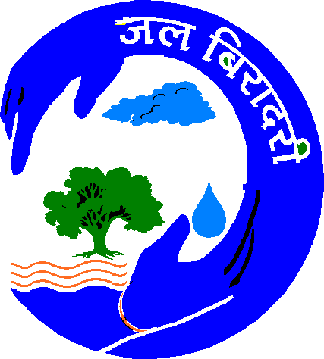
JALBIRADARI
34/46, KIRAN PATH, MANSAROVAR JAIPUR -302020 (RAJ.)

Rajendra Singh (Ramon Magsaysay Awardee)
Chairperson Phone- 9414066765
Email: watermantbs@yahoo.com
jalpurushtbs@gmail.com

Invitation for ‘Jal Kumbh’

We at the Jal Biradari and Tarun Bharat Sangh are organizing a very important Kumbh on 6th and 7th of September in an interior village called Khajura in the Tehsil of Sappotara in Karoli district, Rajasthan. For those water lovers who are fed up with seeing the polluting nature of normal Kumbhs, this Kumbh would be a refreshing and an unforgettable experience. Friends, we just want to make our people understand that the true meaning of Kumbh is not to destroy the rivers but to conserve them. We also want to show you how beautifully any river can be rejuvenated.

Let us understand, first of all how the tradition of gathering for Kumbh started. Once there was a king called Bagiratha who was a farmers’ leader. Those farmers faced a severe water crisis then, which made him to take a pledge of bringing down the Ganga who had been dwelling on the mountains. Along with his 60000 farmers, he worked day in and day out to realize his dream. Finally, Ganga came down to the plains. The farmers on both the side of her started practicing agriculture; their homes became prosperous and their souls were liberated.

Till the time of Bagiratha, there were no big issues on sharing her water among the farmers. But the next generation did not kept quiet; the farmers started fighting with each other. The climax came to settle down these issues. Farmers met the Rishis. The then king was also present. Wise Rishis said, “See Ganga is not ours, not even yours; everybody has the right to use her waters but also we have the duty to conserve our Ganga for her unobstructed flow, for generations! Importantly, the king has higher responsibility of implementing this understanding”. Every one nodded and the tradition of Kumbh started at that very moment. For generations, common people, saints and even the kings gathered for Kumbh to show their solidarity in conserving the purity of Ganga. But friends, today Kumbh is just a ritual. It is polluting Ganga like anything.

In this regard, any river in this country is getting polluted, severely; is being encroached and exploited unmindfully! It seems that the darkness is enfolding the country from every direction. It seems that there is no way out for escaping from this darkness. If this situation continues, it is sure that we are going to face a severe water crisis in the near future. Will we survive out of this crisis? Will we rejuvenate the rivers? Will we understand the importance of harvesting the rain water where ever it is possible?

Yes, we know that it is a Himalayan task to bring sustainable water prosperity in this country; but it is not impossible, more over it is very necessary. If an isolated, deserted village like Khajura could spring up with full of life by using time tested, traditional water conservation methods, why couldn’t other parts of our country? If the villagers of Khajura could rise from their painful past, why couldn’t all of us? We are not going to say what was the condition prevailed here or how they have succeeded in rejuvenating their ‘Maheshwari River’. We only invite you to see by yourself; hear the story from the villagers!

Friends, “From struggle comes strength and the strength is retained through solidarity”. Let us show our solidarity to keep our earth green, rivers alive; to pass on, pure waters to our next generations! Come and conquer the evils which destroy the very life of our planet!

Expecting your presence and participation,

With Regards,

Rajendra Singh,
Tarun Bharat Sangh.

Note:

Simple lodging and boarding facilities are arranged in the villages.

Routes:
By bus
- New Delhi(ISBT)-(NH8)-Dharuheda(70Km) to Biwadi(3 Km) to Alwar(40Km) to Mandawar(55 Km) to Mahowa(23 Km) to Hindon(30 Km) to Karoli(25 Km) to Kailadevi(21 Km) to Khajura Village(17 Km)=284 Km.
- Jaipur-Karoli-Kailadevi-Khajura
- Agra-NH11-Mahowa-Karoli-Kailadevi-Khajura
By train
- From South India
Gangapur Railway Station. After getting down here, catch a bus to Karoli(24 Km). Then follow the Karoli-kailadevi-Khajura route.
- From North
Hindon Railway Station. After getting down here, catch a bus to Karoli(25 Km). Then follow the Karoli-kailadevi-Khajura route.

