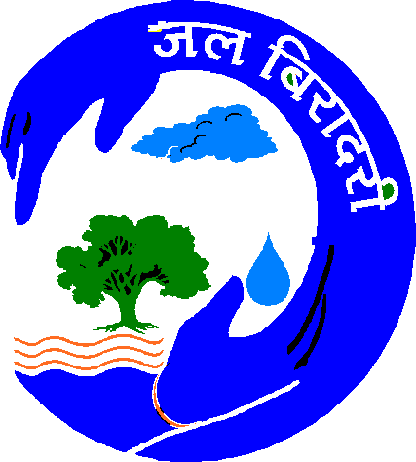
JALBIRADARI
34/46, KIRAN PATH, MANSAROVAR JAIPUR -302020 (RAJ.)

Rajendra Singh (Ramon Magsaysay Awardee)
Chairperson
Phone- 9414066765
Email: watermantbs@yahoo.com
jalpurushtbs@gmail.com

Jal Kumbh

Aims:
- Reflecting upon the necessity of rejuvenating the rivers of India
- Rethinking and reviving the true tradition of Kumbh
Objectives:

- To show solidarity in protesting against pollution, encroachment and exploitation of rivers and creating a conducive environment for the same. So we need to rethink on the strategy of ‘National River Revival Satyagrah-2008’ at this juncture.
- Spreading awareness and leading by example to create Green Earth in which clean and perennial rivers can flow.
- Triggering the potential minds of saints of various religions to keep up the sanctity of Indian rivers intact.
- Giving direction for reviving the true tradition of Kumbh.
Venue: Khajura Village, Tehsil-Sappotara, Karoli district, Rajasthan.

Dates: 6th and 7th September, 2008.

The solidarity shown by the villagers of Khajura in rejuvenating their River Maheshwari has to be appreciated. That’s why the Kumbh is also going to be held on the banks of the first Talab they have built. Please be present and participate.

Note: Kindly see also the detailed invitation attached herewith.

