Strengthening Data and Monitoring in the Indian Water and Sanitation Sector

Aidan Cronin, Nisha Thompson

Name Aidan Cronin
Position Water, Sanitation and Hygiene (WASH) Specialist
Affiliation UNICEF India Country Office
Address UNICEF House, 73 Lodhi Estate, New Delhi, 110 003, India
Email address acronin@unicef.org

Name Nisha Thompson

Position Data Project Manager
Affiliation Arghyam
Address Bangalore, India
Email address nisha@arghyam.org

Acknowledgements:
The authors would like to thanks reviewers for comments including Sandhya Singh, Joint Director Stats (MDWS); Sue Coates, Arnold Cole and Frank Odhiambo (UNICEF, India) and Amrtha Kasturi Rangan (Arghyam, India).

Strengthening Data and Monitoring in the Indian Water and Sanitation Sector

Abstract
There are significant challenges in the Indian water and sanitation sector in terms of service provision. To this end, reliable data is extremely important to facilitate evidence-based decisions. This paper examines current approaches to data, monitoring and evaluation of water, sanitation and hygiene (WASH) programmes in India, focusing on the Government programs and the data collected as part of these programs. This examination allows the assessment of progress towards the planned results. We review these approaches and identify the current critical gaps. Key challenges include data quality, reliability, standardization, availability, reach to all social groups and scaling up for improved program management. Recent positive developments include the increasing efforts to make public data available on-line as well as efforts to improve visualization of data, use of technology and efforts to ground-truth data. However, much more needs to be done - potential recommendations for improvement are identified four critical levels: national, State, District & sub-District and citizen and include such measures as increased emphasis on data quality, disaggregation and standardization, auditing and benchmarking and above all corrective management via the linking monitoring to results.

Keywords
India, water, sanitation, data, monitoring, WASH

1 Introduction
India is at a critical time in terms of management of water resources, water supply and sanitation with unprecedented challenges from population growth, urbanization, agricultural and industrial demands (UNICEF, FAO, SACIWaters, 2013). The water and sanitation sector is a complex and inter-linked one, requiring solid data to facilitate evidence-based decisions (ADB, 2013). The Government of India (GoI) recognises this: “sustainable water management has become a far more complex task (technically, socially and politically) than can be handled by traditional cost– benefit analysis; It calls for reliable information on a wider range of aspects and comprehensive knowledge regarding the current and emerging situation” but is critical to India’s development (Planning Commission, 2011a,b). However, serious gaps and inadequacies exist in the scope, coverage and quality of data currently used for managing India’s water (Upali, 2008; Shah, 2013).
This paper examines current approaches to data, monitoring and evaluation of water, sanitation and hygiene (WASH) programmes in India, focusing on the National Rural Drinking Water Program (NRDWP) and Nirmal Bharat Abhiyan (NBA). The data collected as part of these programs helps to assess progress towards the planned outputs and, where required, should be used to improve, re-orient or discontinue the evaluated intervention or policy. We review these approaches and offer potential recommendations for improvement.
In India, water is overseen by two Central Ministries: the Ministry of Water Resources (MOWR) manages all water resource issues while rural drinking water supply and sanitation is handled by the Ministry of Drinking Water and Sanitation (MDWS) (Figure 1). These Ministries are, therefore, responsible for monitoring the entire water ecosystem from nature to services to people. The monitoring and data collection is the responsibility of the district level offices. Since water is constitutionally a state issue, Government of India provides guidelines and funding while the State Governments implement the schemes. Crucially, most monitoring happens at State level. Therefore, the State and Districts collect data from the sub district levels and feed this into a comprehensive National on-line system, the Integrated Management Information System, IMIS. The other major source of data on drinking water and sanitation progress in India are national household surveys (from Census to National Family Household Survey and National Sampling Survey Organisation surveys) and are used in the Joint Monitoring Program assessing progress towards the water and sanitation targets of MDG 7 (WHO / UNICEF, 2013).
Water data in India is consistently collected by Government and a great amount of it is also shared online. For instance, water supply schemes are monitored right up to habitation level in relation to physical targets including number of households to be covered in a particular habitation along with the expenditure planned and incurred and this is all available on the MDWS website. Also the MDWS IMIS system contains information regarding water quality tests conducted at various laboratories of samples drawn from villages throughout the country. The IMIS also contains habitation-wise information on number of schemes handed over to the Gram Panchayats, local Government bodies. Information on financial progress and achievement for Operation and Maintenance (O&M) is also provided.

Figure 1 Ministries with oversight of water, sanitation and their sub-components, in Government of India.
However, issues with methodology of data collection, timely availability, and quality of local level data have been found across the sector. This makes it difficult to undertake large scale analysis that can be drilled down to habitation level for intervention; for example it is not possible to determine the number of villages fully covered by water supply schemes that have slipped back to using unsafe water. Data also is not consistent across government bodies. Data collected by one agency may be at odds with other agencies; the 2011 Census had a very different result for toilet numbers than the NBA, which may indicate poor or corrupt data collection practices (Mohanty, 2012).
In summary, the water problems in India require detailed data collection and analysis to determine appropriate interventions and allow for proper evaluation of those interventions. As water is a State issue, it is currently difficult for a central body to rigorously monitor and standardize methodology for various parameters. This has resulted in a gap in the availability of consistent quality data across States.

2 Overview of the Sector
Significant differences are observed between the coverage values for sanitation obtained in various sources such as National Sampling Survey (NSS), National Family Health Survey (NFHS), District Level Health Survey (DLHS) and Census (Table 1). The District-wise status of water and sanitation has been mapped (Fig. 2, 3), despite inconsistencies encountered when new Districts are created.

Table 1- Current Status of water and sanitation provision in India; values in % of Households
Source | Year | Water |  | Sanitation
Source | Year | Piped Water | Other Improved | Improved Sanitation | Open defecation
Census 2011 | 2011 | 43.5 | 53 | 45.8 | 53.1
JMP | 2011 | 25 | 67 | 35 | 50
NSS 65 | 2009 | 30.1 | 60.3 | 31.9 | 65.2
DLHS 3 | 2007-08 | 28 | 51.7 | 26.2 | 65.8
NFHS 3 | 2005-06 | 24.9 | 58.3 | 19 | 73

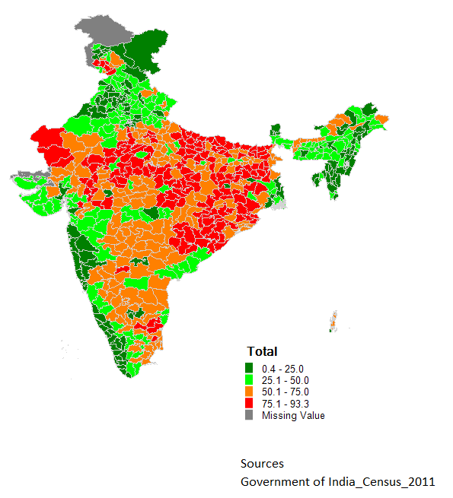

Figure 2 - Percentage of population open defecating in Districts of India, based on analysis of Census 2011

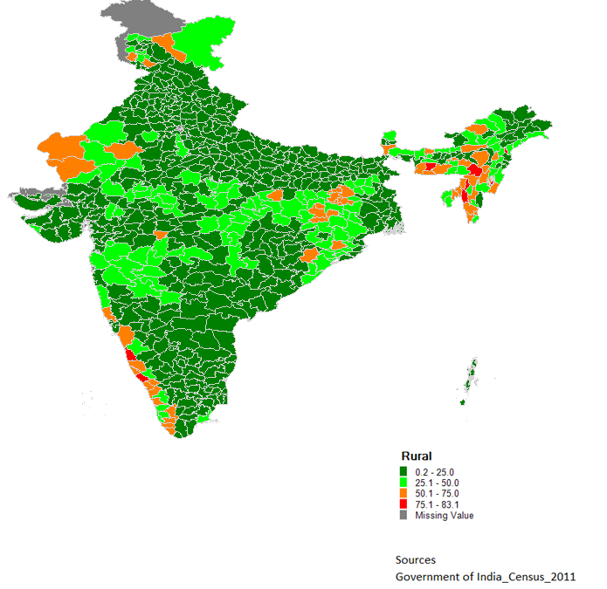
Figure 3 - Percentage of population using unimproved water sources in Districts of India, based on analysis of Census 2011

The MDWS IMIS states progress of 81% cumulative total on sanitation up to April 2011 against the 2001 Census population, which is of course much higher than the Census 2011 report of 53% of India with no latrine. Another issue is differences in methodologies undertaken by the various surveys. However, given the significant discrepancies, a new baseline survey for NBA is underway and will count the actual toilets in place. However, there is a possibility that this count will differ from the current NBA numbers and the Census due to methodology issues such as data inconsistencies, differences in below and above poverty line, double counting, non-functional toilets no longer being considered, etc.
While the household surveys collect data on usage, the IMIS data is based on assets created. Table 1 highlights differences in data reporting that suggests that a significant proportion of assets – toilets, drinking water facilities created are not used by households for various reasons but does not give reasons for this discrepancy. One of the reasons of discrepancy may be lack of use due to poor quality of assets. Therefore, with the NBA data it is not possible to determine the proportion of households practicing open defecation as the data pertains to toilets built over a period of time against the targets set without any consideration to their use: however the number of household not having toilets as per the target may be inferred. IMIS also does not capture the type of toilets built - flush or pit. It also does not allow combining water access and sanitation progress to highlight which districts are doing well in both areas.
The gap between reported and actual coverage and usage in toilets constructed is also seen from concurrent monitoring efforts of households in UP (GoUP and UNICEF, 2011) where actual coverage is 20-25% less than the reported coverage (as per NBA monitoring system), while the usage in turn is 20-25% less than actual coverage (Fig 4). It is clear that a mechanism, including concurrent monitoring or third party verification, to assess, verify and certify the assets being built are necessary.
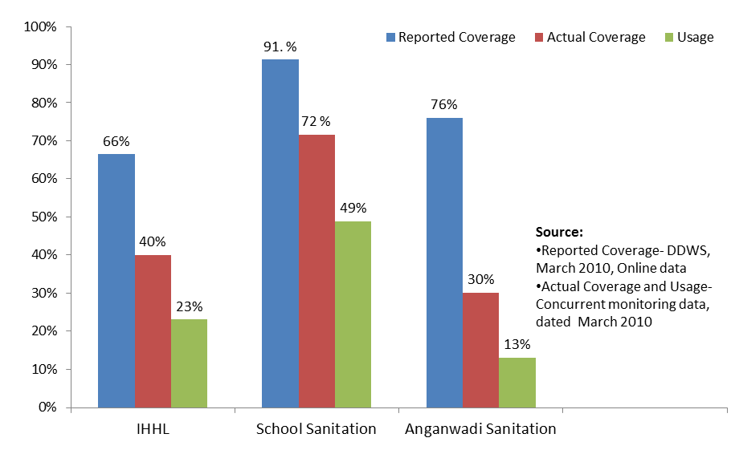
Figure 4 - Difference between IMIS and field verification in 5 GPs of UP, (GoUP and UNICEF, 2011)
Similarly, in the case of drinking water it is not possible to assess the access to improved drinking water sources throughout the year; multiple sources are routinely used by households across India particularly during summer, all of which are not improved. The IMIS does not capture other improved sources of drinking water like protected well which account for about 10% of all sources in rural areas or whether the source of drinking water is within or outside the premises. However, the IMIS does provide information on water quality tests done throughout the country on a periodic basis though here the critical information on bacteriological contamination is not provided. The IMIS though provides data on availability of field testing kits across districts throughout the country. On the other hand the Census and surveys do not capture any data on water quality at the moment except Census 2011 which has included question on proportion of treated / untreated tap water.
A key issue behind the service provision statistics is to determine who has access and the rate at which access is acquired. Based on these it is evident that 65% of the richest quintile of India have piped water on premises while it is only 2% of the poorest quintile; in rural areas 32% of the richest quintile have piped water on premises while it is 1% of the poorest quintile (NFHS, 2006). State wealth quintile analyses are also possible (Figure 5).
Scheduled Tribe (ST) household access to piped water is lower than the Indian average (24% as opposed to 44%); the corresponding value for Scheduled Castes (SCs) is 41%. STs and SCs are also disproportionally disadvantaged with lower access to sanitation than the Indian average with 75% and 63% respectively as compared to the national average of 50% (Census, 2011). Though surveys capture these at National and State level, more detailed disaggregation is often not possible. Indeed for gender very little if any disaggregated data exists (Lala et al., in review). Without such data or ability to better define inequitable access, corrective actions cannot be systematically initiated.

Figure 5 - Examples of drinking water sources across wealth quintiles - taking the State of a Rajasthan and Kerala as examples; based on NFHS-3 (2006)

3 Moving forward
3.1 National level
The India Water Portal (IWP) is a community of water sector actors which, over the past 5 years, has been largely concentrating on collating content, including case studies, reports, policy documents, manuals, news, opinions, and advice. The IWP Data Project aims to understand what water data exists and create a diverse and vibrant community who will use that data to enhance projects, advocacy, and impact around major water sector indicators. The website has had in excess of 34,000 hits over the past 3 years.
The IWP assessed the available datasets relating to water in India and found that over 300 datasets exist online but the water sector’s use and understanding of how to use data is limited and there is significant space to expand content and usage. There are issues in terms of the formats used and its presentation. For example, while MDWS data is extensive and updated frequently, it does not allow easy visualization. More open platforms would encourage more use and users of the data and help to ground truth the information. Figures 2 to 4 all used open data but required considerable reworking to allow analysis and visualization. Freely available data in easily workable formats will help move the discourse away from anecdotal to evidence-based decision making - for example, to what extent does lack of functioning toilets contribute to dropout rates among school children? More quality data that is easily available can begin to allow such correlations to influence policy and implementation.
Open government data (OGD) is gaining popularity. This relates to the concept that data collected using public funds and being used for development should be freely available to use it for projects and pursue policy change through evidence (OKFN). The Govt. of India recognizes the potential of OGD and has approved the National Data Sharing and Accessibility Policy (NDSAP) requiring all departments to share and categorize the data they have in one common platform such as Data.Gov.in (DST, 2012) which adopts a similar approach to data sharing platforms of the US and the UK. MDWS has also contributed rationalized datasets to this initiative.
The Planning Commission has also recognized the need to improve water data and its role in improved management and a series of recommendations made (Shah, 2013). The Central Water Commission (CWC) has developed a GIS-based water data portal, the Water Resource Information System (WRIS) and is presenting water data on a mapped interface. The recent draft policy on data dissemination which the CWC released underlines the clear importance of the WRIS as a dissemination platform for water data in India (MoWR, 2013).
National level efforts on data standardization and quality assurance are essential. Water quality data illustrates this point well. A large database of water quality data exists on the MDWS IMIS but it is not clear if States collected and analyzed data in the same way and so quality assurance is a very real issue. There is also a great deal of water quality data that sits in CGWB and CWC. It can be helpful to have a standard water quality testing procedures across Ministries and for the data to all be in place so that people can get a full idea of what the water quality is from various sources to allow for corrective action, as called for in the Uniform Drinking Water Quality Monitoring Protocol (MDWS, 2013). Provision for collection of data on water quality should be made in various household surveys to allow cross-correlation access and safety (see Bain et al. 2011).
Linking financial progress with usage and results, especially in disadvantaged communities, could help a variance analysis to be made and so would allow any discrepancies between the two to be spotted immediately. In addition, a district-wise analysis of year-wise slipped back habitations need to be done in order to identify prone districts and also assess the reasons for the same. It would be interesting to study, state-wise, the linkage between number of slipped back villages (as obtained from the IMIS) and NGPs from various concurrent monitoring initiatives and National Level Monitor reports (MoRD, 2012).

To address equity, a comparative analysis of coverage in areas with high concentrations of minority groups may be made. Indeed, in the IMIS, the use of GIS may be further strengthened to identify problem areas and also to map process variables, for instance number of Block resource centres operational / number of meetings of local committees etc. Furthermore, there is a need to look at water and sanitation programmes in an integrated manner as ease of access to water source is an important variable for sanitation (UNICEF, 2012a). Mehrotra et al., (2013) argue that MIS, including for MDWS, is still in its infancy in most GoI flagship programmes, and yet to become an evidence-based tool for management and argue for improvements in this respect.

In 2012 Arghyam initiated the State of Sanitation Program with the goal of simple pattern analyses of NBA data. The work has involved examining spending and coverage data in the IMIS system and creating dynamic visualizations along with clear terminologies for a non-technical audience. The current site offers table after table of data that can make it difficult to compare or do analysis. Figure 6 shows an example of how financial information is shown.
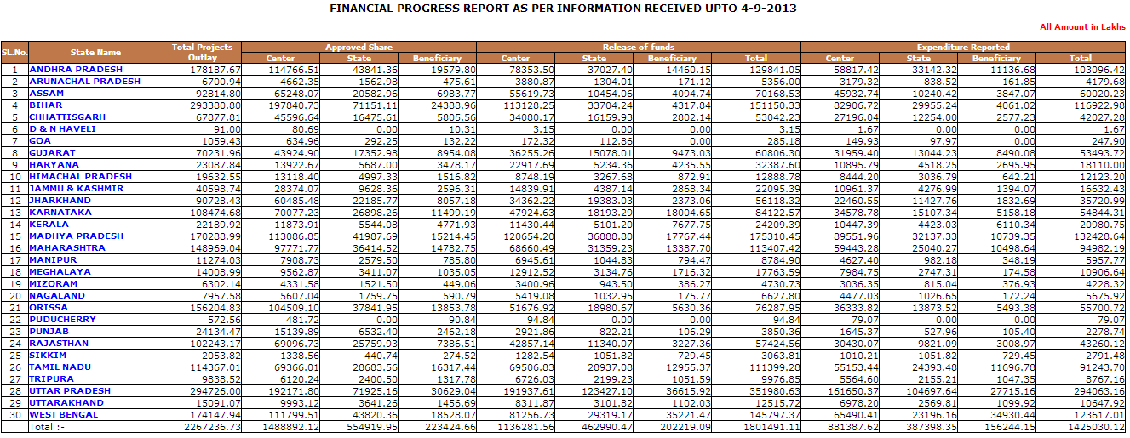
Figure 6 - Table of financial breakdown of Centre, State, and Beneficiary for all the states.

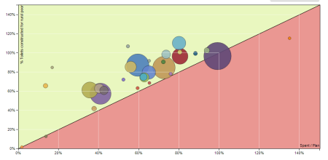

Figure 7 - Visualization of performance for NBA. Comparing percentage of financial budget (X-axis) spent to percentage of toilets built (Y-axis)
For instance, it is not easy to answer questions such as: how one state is doing with respect to another; or one district vs other similar ones in different state. Such simple visuals will aid in easy understanding of the state of rural sanitation. Figure 7 shows an example of an analysis done comparing financial progress and physical progress. On one graph you can compare the states and see how they are performing. Districts and states with best practices can be identified and lessons cross fertilized from these to areas that are struggling to achieve rural sanitation. Just by changing how the data is presented can improve monitoring and evaluation, in addition to, involving more audiences to interact with rural sanitation development.

3.2 State level
The ultimate goal is to move towards monitoring for results, i.e. the sustained usage of safe drinking water and hygienic sanitation facilities by all. This means a shift in traditional views of M&E from a reporting requirement to a management tool that can improve achieving results, including increased financial efficiency. Simple tools monitoring tools for effective management need to be available to decision makers at state level. Positive examples exist in the Sector of a strengthened evidence-based influencing decision making, e.g. a review of the initial NGP awardees highlighted slipping back of several NGPs in terms of their open defection free status (UNICEF/TARU, 2008). While this did expose limitations in the verification process, the findings were collaborated on a larger scale (MDWS, 2011) leading eventually to process strengthening via third party verification of NGP applications.
A clear understanding of the impediments to achieving results can be achieved through mapping of bottlenecks. Generally the focus of these approaches is on assessing inputs, processes, outputs and outcomes in order to be able to arrive at a situational analysis whereby key gaps, bottlenecks, become visible, along with the required interventions and finance to achieve the goals and from this an intervention priority mapping may be derived. These approaches may also take into account the inclusion aspects with particular indicators looking at the accessibility and affordability of marginalized sections. It has been used extensively in the Health Sector. The marginal budgeting for bottlenecks tool (MBB) is an analytical costing and budgeting tool that helps countries develop their health plans by taking into account the most effective interventions, cost and budget marginal allocations of their implementation to health services and assess their potential impact on health coverage and outcomes. Bottleneck analyses have taken place for WASH in India at District level, for example in Maharashtra (UNICEF, 2012b) and at State level, for example in MP, Orissa and Rajasthan (WSP, 2013) and further developed tools are now available for comprehensive bottleneck approaches at States level (UNICEF, 2012c); this will help identify what priority efforts can be made to unblock bottlenecks with the aid of strong monitoring.
Diarrhea among children is important indicator of quality of drinking water and sanitation provisioning. From an analysis of all India Coverage Evaluation Survey (CES, 2009) it has been found that odds of getting diarrhea are greater when unimproved sanitation is used than with improved sanitation. Linkage of drinking water and sanitation provisioning and diarrhea cases over time may provide one way of assessing the program outcomes. Appropriate linkage may be established with NRHM / ICDS programmes so that GP wise number of monthly diarrhea cases among children could also be put on the website of MDWS in order to ascertain the impact over time. Such an approach is not easy to immediately gauge impact due to methodological challenges, cost and capacity and the complex multiple routes of the faecal-oral transmission route as well as the key role played by personal hygiene. However, such an initiative would help to raise awareness on the importance of convergence of monitoring systems and linkages of WASH to health impacts. Longer term the key issue of improved nutritional outcomes and reduced stunting may prove a strong indication of improved WASH service delivery.

3.3 District and Sub-District levels
The District, Block and village bodies are the key institutions responsible for the implementation and upkeep of drinking water and sanitation programmes in rural India. Each level has both enabling as well as execution and reporting roles; each tier must act as an enabler for the tier below and also report on its own performance. Accordingly in order to arrive at fair evaluation of the workings of the system at micro-level it is important to capture process indicators (e.g. Table 2) at various levels in addition to the overall output indicators like number of latrines constructed, number of water supply schemes completed etc. It is of course essential that to have impact one must see the process of data collection and strengthen this (i.e. a system improvement plan) and then its analysis and usage to make mid-term implementation changes in the program (a performance improvement plan). Close inter-linkage of these plans is essential.

Table 2 - Examples of possible process indicators at District and sub-District level
Level / Institution | Potential process indicators
District (eg District Water & Sanitation Mission) | 1. No. of schemes for water supply and sanitation submitted by block panchayats/ GPs approved  2. No. of BRCs supported  3. No. of capacity development and campaign programmes organized  4. No. of O&M issues resolved at district level  5. No. of meetings held with convergence programmes like MGNREGA, NRHM, SSA, ICDS  6. No. of field visits conducted by officials
Block (eg Block Resource Centre) | 1. No of GPs assisted in formation of VWSC  2. No of IEC events conducted  3. Training courses conducted for GP and VWSC functionaries  4. No of GPs assisted in drawing up of Village Action Plan on water and sanitation  5. No. of GPs assisted in implementing Village Action Plan  6. No. of GPs assisted on O&M issues  7. No. of trained workers assisted in water quality testing  8. No of GPs assisted in conducting social audit
Village and Panchyat level (Village water and sanitation committees) | 1. No of VWSC meetings held in the month (with gender and social grouping participation monitored)  2. No. of households demanding sanitation facility identified  3. No. of households demanding sanitation facility approved / supported  4. No. of new water schemes proposed  5. No. of O&M issues addressed in existing water schemes  6. No. of water quality samples collected and sent for testing / tested

The extent of devolvement in terms of funds, functions and functionaries varies across States and must be better understood (e.g. one recent initiative in this respect is the MDWS Management Devolution Index initiative) and strengthened. Adequate provision must be made for monitoring planned versus actual progress, along with a provision for logging of alerts highlighting gaps in execution through websites which can be updated at local level. This will assist in putting in place an accountability mechanism with clear identification of bottlenecks and actions required. In terms of sustainability of structures built a record of expected life of assets would be kept and compared with actual life span. Turn-around time for O&M activities may be recorded and compared with benchmarks. Areas continuously missing targets may be prioritized for attention.

3.4 Citizen level
A strong two-way interface between the citizens and the service provider is necessary for real-time feedback on quality of service provision. The service provider must consult users on plans and progress and citizens should have the option of reporting their complaints, O&M issues, water quality problems etc. in an accessible manner. Technology can now plan a key role in facilitating this interaction. A web-based system could contain village-wise list of households planned for sanitation, water work with the list of completed households, slipped back sources and action planned; such a website can have two way access by users - for checking and updating e.g. through mobile phones. A call centre interface at district level could also be established in local language with interactive voice response system (IVRS). Such as website is possible to be updated also at GP level as the Common Service Centre Scheme of the Government of India, via the National e-Governance Plan, has established a network of about 100,000 ICT kiosks all across the country in rural areas. Thus, an enabling environment has been created for updating and monitoring the data on water and sanitation on on-line basis from village settings. In order to strengthen validation and monitoring, Android based mobile phones / low cost smart phones with GPS facility can be readily used - an image of the asset (water / sanitation) built may be put on a website with the GPS coordinates for verification and a date stamp (e.g. WSP, 2012). A summary of the various potential recommendations at National, State and District level is given in Table 3.

Table 3: Potential recommendations at National, State and District level for rural WASH M&E in India
National Level
 | Medium Priority |  | High Priority
Short-term | Standarisation of water quality testing and reporting procedures  Expand visualisation tools in IMIS |  | Link financial progress with outputs and impact evaluation  Standardised formats for data collection and dissemination
Medium-term | Service Level Benchmarking |  | Slip back of habitations - analysis of why and corrective action  Undertake local formatives, baselines, mid-line corrections and end-line evaluations, including hygiene
Long-term | Village level data and maps available on website for download and use at grass-roots level |  | Sharp focus on collection of data on monitoring / marginalised groups with emphasis on data disaggregation (including gender)
State Level
 |  | Medium Priority | High Priority
Short-term |  | New District integration into IMIS of all flagship programs | Bottleneck Analyses  Higher focus on hygiene  Link financial progress with outputs
Medium-term |  | District data validation  Technical Audits | Convergence of schemes and analysis  Capacity building on M&E issues
Long-term |  | Service level benchmarks – O&M, availability, accessibility, durability of assets; monitoring of sustainability | Clear Accountability: Personnel policy adopted to outcome measures, additional allocation of funds to better performing GPs/ districts
District Level
 | Medium Priority |  | High Priority
Short-term | Review of planned and actual implementation  Institutional WASH reviews (AWCs, PHCs, schools) |  | Review of current process indicators and actions on gaps
Medium-term | District validation of GP/community progress (and use of new technology via mobile, GPS etc.) |  | Capacity building of GPs and Communities  Engaging citizens and civil society for results-based monitoring and social audits
Long-term | Review of system sustainability and O&M v capital costs to take efficiency review |  | Outcome to Impact reporting

3.5 Audits
Financial auditing is in practice, overseen by the Auditor General, but alone it cannot comment on value for money or on quality of service delivery. It must be linked with a social audit to reflect on what has been delivered to the community and a technical audit for quality of service provided, a provision for social audit may be made as a built-in component in NRDWP and NBA programmes (MDWS, 2011). The social audit may be done by the community regularly and transparently and may consider some of the following activities:
- Recording the achievements made in number of toilets constructed and water supply issues resolved in previous month and who was reached / not reached
- Identifying individuals demanding sanitation facility and any need for O&M of water sources, need for new water source
- Projecting Month Plan for construction of toilets and water supply schemes in the GP
- Identifying slip back cases and working out strategy for addressing the same
- Verifying expenditure made on various activities in the previous month including disbursement of incentive amount, construction and other works and activities.
- Works undertaken under IEC, HRD and SLWM etc.
- Availability of human resources required for implementation e.g. adequate number of motivators for sanitation

Regular technical audits (internal and/or external) of both water and sanitation projects are essential to optimize the benefits of costs incurred and to ensure sustainability. For sanitation, this may involve evaluating the type of toilets constructed with reference to the geological condition, type of soil, water table and distance to nearby water bodies. For hand pumps / tube wells it should be ensured that it is at a safe distance (from contaminating bodies, it should not be shallow and regular O&M activities are done and can check if a cement apron and subsurface seal is provided. For the piped water supply schemes a technical audit should focus on capacity of the system to supply stipulated quantity of water, estimating losses in distribution pipe line network, assessing the downtime and O&M activities, study of power utilization to achieve savings in consumption of electricity etc.

Such a suite of auditing (Figure 8) would help to ensure efficiency of the systems and value for money. Indirectly, such a combination of financial, social and technical audits would help impact on corruption in the WASH Sector as it would impact on the three main types of corruption that can be found in the rural WASH sector. These are procurement irregularities (e.g. over-invoicing on officials tenders), leakages from development budgets (i.e. payments to senior bureaucrats and politicians) and unviable distortions of planned schemes (reworking of schemes due to political or other pressures that may be against technical best practices and will eventually compromise the scheme functionality (James, 2010). Some progress has been in this respect in the urban sector (e.g. MoUD, 2007).

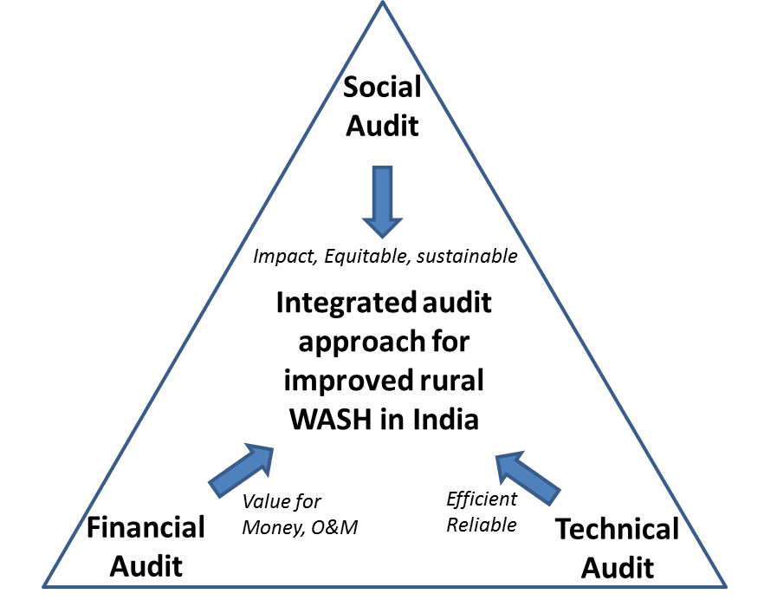
Figure 8 - Concept of combined auditing for improved

3.6 Good practices
The role of regulators is receiving increasing attention (Shah, 2013). As part of the Twelfth Plan, a model bill for state water regulatory system has been drafted based on a thorough study of latest international thinking on regulation and the experience of the Maharashtra Water Resources Regulatory Authority (MWRRA) (Planning Commission 2012). The draft bill proposes a separation of the authority to make “political” or ‘normative’ decisions and the authority to make “technical” or “predominantly non-normative” decisions. Thus, the State Water Regulatory and Development Council (SC) is expected to ensure accountability by providing the policy framework for the techno-economic regulatory decisions of the State Independent Water Expert Authority (SIWEA). The SIWEA will, in turn, be accountable to technical experts through a mechanism of regular review.
In terms of a large country-wide standardization of water data collection methodology, the United States Geological Survey is a good example. All data must be collected and analyzed according to strict protocols even though the actual data collection is done at the state level (USGS, 2013). By standardizing data collection methodology across the country the conflicting parties use the same high quality data sets instead of debating on differing data and their interpretation.
Benchmarking seeks to identify a minimum set of standard performance parameters that are commonly understood and used by all stakeholders. It seeks to define a common minimum framework for monitoring and reporting on these indicators. Service level benchmarks need to be developed for supply, availability and accessibility of water including O&M. Process benchmarking involves identifying and learning from the processes from those that are ‘best in class’, i.e. GPs/VWSCs can learn from other GPs/VWSCs that are doing well. Thus, processes in GPs already awarded Nirmal Gram status (now about 10% of all GPs) may be studied and compared with the prevalent practices and suitably adopted by other GPs. Here it may be mentioned that the linkage between processes and performance in the context of sanitation programme in India has been studied by WSP (2011) in 22 districts across 21 states of the country using process indicators like strategy for implementation, institutional structure and capacity, approach to creating demand, promotion and supply chain, financing and incentives etc and with performance indicators like % budget spent, % Individual Household Latrine target achieved, % sanitation target achieved, success rate of NGP applications, % of NGP Panchayats to total No. of PRIs etc. It is argued that performance indicators are highly correlated with process indicators (correlation coefficient = +0.635).

Bringing in non-State actors such as NGOs into monitoring and evaluation processes can help sharpen the impact focus and reduce irregularities also (Davis, 2004). Organisations such as Accountability Initiative and Centre for Budget and Governance Accountability (CBGA) examine budget allocation and expenditure around water and sanitation to ensure the budget allocated are getting spent in the ways it was intended and are being used effectively e.g. AI (2010). Such calls are also being made globally (e.g. Breslin, 2010) and initiatives like concurrent monitoring can help in this respect (Solutions Exchange, 2012).
Akvo is a non- profit that builds open source tools for monitoring and collecting data. It is specifically designed for WASH projects and has had extensive experience collecting data through mobile devices. They host the project Openaid which present aid-spend data online in easy to navigate ways so they can meet transparency obligations. This project has brought together a lot of information regarding foreign aid spending so that donors and individuals can track where money is going.
Transparent Chennai uses a data driven model (using volunteers, crowd sourcing techniques and the Right to Information Act) to assess service delivery. They have mapped public toilets in Chennai using government data along with volunteer validation and overlain criteria such as proximity to market places and slums to show the gaps in toilet locations in relation to needs.
India Governs is a Bangalore NGO that works on correlating Govt. scheme outcomes to electoral districts instead of along the usual administrative boundaries. They generate reports and share them with elected officials on how their parliamentary district is doing on public schemes and so with this evidence-based advocacy aim to make program delivery a part of the election conversation (Table 4); attracting media attention (Kundu, 2013; Navya, 2013).
Table 4 - Comparing water access in two Assembly Constituencies in Karnataka (India Governs, Last accessed May 2013); the State average in comparison is over 60 litres per person per day.
Parliamentary Constituency | Assembly Constituency | Year | Water Per Person Per Day (litres) | No of Piped Water Supply Schemes (In Use) | No of Latrines under Nirmala Grama Yojana
Bangalore Rural | Bangalore South | 2003- 04 | 27 | 59 | 1840
Bangalore Rural | Channapatna | 2006-07 | 24 | 179 | 3408

4 Conclusions
There are significant data and monitoring challenges in the Indian water and sanitation sector, including data quality, reliability, standardization, availability and reach to all social groups. One pertinent example is gender disaggregated data and data on WASH access in marginalized groups which is currently lacking and is a big gap. The active participation of women and monitory groups in different decision making bodies is crucial and inclusion of key process and impact indicators to capture this is essential.
Recent positive developments include the increasing efforts to make public data available on-line as well as efforts to improve visualization of data, use of technology and efforts to ground-truth data. However, much more needs to be done. Good management is cognizant of tacit knowledge and the importance of sharing information. The Indian water and sanitation sector requires to take stock of this and to strive towards a reliable ground-based impact methodology using data as a backbone to decision-making. Even with current systems, by collecting data in one place in usage formats and allowing for sharing of uniform methodologies more use can be deemed from the available sources. Other measures needed include increased emphasis on data quality, disaggregation, auditing and benchmarking and above all corrective management via the linking monitoring to results.
Significant efforts are required to put such recommendations in place in terms of orientation and approach, putting enabling systems in place including ICT tools at GP level, training and capacity building. This will have substantial cost implications, but it is argued that such systems are needed to facilitate in progress towards adoption of universal access to safe drinking water and sanitation for a vast population in rural areas of the country and safeguarding WASH investements.
It is ultimately important for all WASH actors to assess the cause of poor performance, including in terms of sustainability, quality and equity, and together share for learning and sharing; indeed learning from failure is very important. Acknowledgement of mistakes with lessons learnt can greatly help to accelerate the programs once a sharing system is open and used.

Disclaimer
The views expressed herein are those of the authors and do not necessarily reflect the views of UNICEF, or the United Nations or Arghyam. The views expressed in this paper are entirely personal.

References
AI (2010) Accountability Initiative, Budget Briefs - Rural drinking water and sanitation, GoI 2009/10; 6 pages.
Asian Development Bank (ADB). 2013. Asian Water Development Outlook 2013, Measuring Water Security in Asia and the Pacific, 128 pages. ISBN: 978-92-9092-988-8
Bain, R. Gundry, S.W., Wright, J.A., Yang, H., Pedley S. Bartram, J.K. (2012) Accounting for water quality in monitoring access to safe drinking-water as part of the Millennium Development Goals: lessons from five countries, Bulletin of the World Health Organization 2012; 90:228–235A
Breslin, E., (2010) Rethinking Hydro-Philanthropy - Smart Money for Transformative Impact; Water for People 9 pages.
Census (2011) - Census of India, 2011, Government of India
CES (2009) Coverage Evaluation Survey, All India Report, Govt of India Ministry of Health and Family Welfare and UNICEF, 252 pages
Davis, J. (2004) “Corruption in Public Service Delivery: Experience from South Asia’s Water and Sanitation Sector”, World Development Vol. 32, No. 1, pp. 53–71.
DST (2012) Department of Science and Technology, National Data Sharing and Accessibility Policy (NDSAP), Government of India. http://ogpl.gov.in/NDSAP/NDSAP-30Jan2012.pdf
GoUP and UNICEF, 2011 - Presentation by GoUP and UNICEF UP at National meeting on Monitoring and Evaluation in Water and Sanitation held October 4, 2011 by MDWS and UNICEF.
James, A.J. (2010) Challenging the ‘percentage system’, Improved transparency and accountability in rural water supply programmes in India, in International Symposium on ‘Pumps, Pipes and Promises’, 16-18 November 2010, IRC International Water and Sanitation Centre, the Hague, Netherlands
Kundu, R. (2013), “Karnataka sees a decline in its MNREGA expenditure” Times of India < http://articles.timesofindia.indiatimes.com/2013-04-26/bangalore/38842313_1_mnrega-rs-13-crore-finance-ministry>
Lala, S., Cronin, A.A., Basu, M., Jyotsna (in review) Collating field experiences to inform structured approaches for gender and equity in WASH in India
Mehrotra, S., Indrakumar, D., Saxena, V., (2013) Management Information System (MIS) of Indian Government’s Flagship Programmes: Are they an adequate monitoring tool?, IAMR Occasional Paper No. 5/2012, ISBN: 978-93-83133-04-8, 67 pages.
MDWS, 2011 - Strategic plan of Ministry of Drinking Water and Sanitation, Govt of India
MDWS (2013) Government of India, Ministry of Drinking Water and Sanitation (2013) Uniform Drinking Water Quality Monitoring Protocol, 72 pages.
Mohanty, B.K. (2012), “Toilet Scam Leaps Out of Closet” The Telegraph, < http://www.telegraphindia.com/1120418/jsp/frontpage/story_15387948.jsp#.UZFU1rWnxDN>
MoRD (2012) National Level Monitoring of Rural Development Programs, Regular monitoring by NLMs, Phase 1 2012-13; Ministry of Rural Development, Govt. of India. 106 pages.
MoUD (2007) Toolkit for Appointment of Independent Review and Monitoring Agencies for projects; JNNURM, Ministry of Urban Development, Sub-Mission for Urban Infrastructure and Governance, Govt. of India, 67 pages.
MOWR, (2013), Hydro-Meteorological Data Dissemination PoIicy, Ministry of Water Resources, Govt. of India http://wrmin.nic.in/writereaddata/linkimages/hddp4302748422.pdf
National Family Health Survey-3, 2005/06, Govt of India.
Navya, P.K., (2013) “Rajaji Nagar: Erratic development throws plans into disarray” Citizen Matters <http://bangalore.citizenmatters.in/articles/view/5234-rajaji-nagar-erratic-development-throws-plans-into-disarray>
Planning Commission, (2011a) Report of the working group on water database development and management for the 12th Year Plan (2012-2017), Planning Commission, Government of India
Planning Commission (2011b) Faster, Sustainable and More Inclusive Growth An Approach to the Twelfth Five Year Plan, (2012-17); Planning Commission, Govt of India, 148 pages.
Planning Commission (2012) Twelfth Five Year Plan Draft; Planning Commission, Govt of India, Vol I 174 pages. http://planningcommission.gov.in/plans/planrel/12thplan/pdf/vol_1.pdf
Shah, M. 2013. Water: Towards a Paradigm Shift in the Twelfth Plan, Economic & Political Weekly, January 19, 2013 Vol xlvii no 3
Solutions Exchange (2012) Improving concurrent monitoring process in water and sanitation; Solution Exchange for the Water Community - Consolidated Reply. 40 pages.
UNICEF/TARU 2008: Review of NGP villages
UNICEF (2012a) WASH Atlas - Unpacking the Census 2011 Data on Water & Sanitation, Maharashtra
UNICEF (2012b) Bottleneck analysis report of NBA and NRDWP Implementation Chandrapur
UNICEF (2012c) Water, Sanitation and Hygiene Bottleneck Analysis Tool (WASH-BAT), Technical Manual - Accompaniment to the WASH-BAT in Excel
UNICEF, FAO and SaciWATERs (2013) Water in India: Situation and Prospects. 105 pages. Available at http://www.unicef.org/india/media_8098.htm Accessed April, 2013
Upali A. Amarasinghe, Tushaar Shah and B. K. Anand, 20008 “India’s water supply and demand from 2025-2050: business-as-usual scenario and issues” page 49, IWMI <http://www.iwmi.cgiar.org/publications/Other/PDF/NRLP%20Proceeding-2%20Paper%202.pdf>
USGS (2013) United States Geological Survey, Information Quality Guidelines, http://www.usgs.gov/info_qual/> Accessed, May 15, 2013
WHO/UNICEF (2013) Joint Monitoring Programme for Water Supply and Sanitation. Available at: http://www.wssinfo.org/
WSP (2011) Presentation on TSC progress and Data validation, State Secretaries meeting Sept. 2011, Water and Sanitation Program, World Bank
WSP (2012) You manage what you measure - using mobile phones to strengthen outcome monitoring in rural sanitation, 10 pages, Water and Sanitation Program, World Bank
WSP (2013) Service Delivery Assessment Reports MP, Odisha, Rajasthan, Water and Sanitation Program, World Bank

www.mdws.nic.in
www.indiawaterportal.org
Open Knowledge Foundation, Definition of Open Government Data http://opengovernmentdata.org/
http://data.gov.in/catalogs/?filter=catalog_type%3Acatalog_type_raw_data%2Bagency%3A1926&sort=updated%20desc>
http://www.indiawaterportal.org/topics/rural-sanitation
http://negp.gov.in/
http://www.akvo.org/
http://www.transparentchennai.com/
http://www.transparentchennai.com/research/public-toilets-and-sanitation/
http://www.indiagoverns.org/

