Study of Pondhe Watershed Area, Purandar taluka, Pune district, Maharashtra Based on Rapid Hydrogeological Mapping through Field Studies

Large areas of India are covered by what are called “hard rocks” that are mostly of igneous and metamorphic origin. Many arid and semi-arid regions of India obtain water supplies from groundwater stored in these rocks. This is especially true for large rural tracts that obtain water for agriculture and domestic supplies entirely from the groundwater stored in these rocks.

It is a well-known fact that groundwater forms a very crucial source of water supply in the national water resources scenario. And yet, it continues to remain a resource that is grossly misused! Many watershed projects in the country still suffer from insufficient inputs (especially in the form of systematic hydrogeology to address the problem(s) of ground water from within the watersheds, despite the fact that this resource is precisely the focus of most watershed activities. The objective of a watershed development programme is to conserve water within the ‘hydrological’ unit, both as surface water and groundwater.

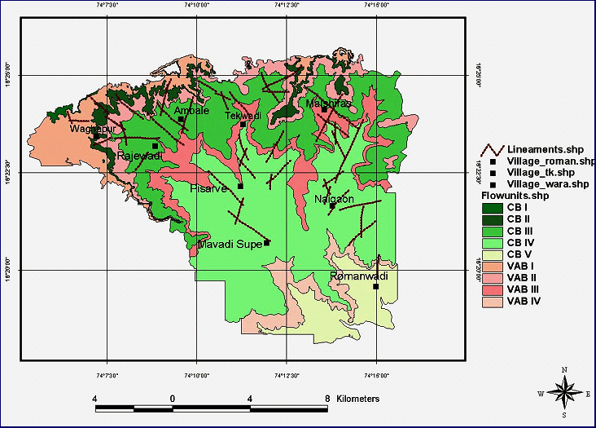

Long-term planning of water resources in a region ought to consider, not only the effective implementation of conservation measures through the process of watershed development, but should also look beyond ‘supply’ side measures. In other words, ‘demand’ management of water resources in a region often holds the key to a complete and sustainable water resources management strategy. The first step in this direction is the development of a conceptual framework for water resources planning, taking into consideration the local conditions rather than “thumb-rule” planning based on broad parameters. GGP is developing such a strategy for a rural enclave of about 10-15 villages in the eastern portion of Purandar taluka of Pune district in Mahrashtra. The programme envisages an attempt to address the problems of natural resources management in project watersheds in order to achieve sustainability of resources. It actually goes beyond the ambit of watershed development and attempts to cover the problem of equitable management of water resources in the area through the development of a water balance for the region.

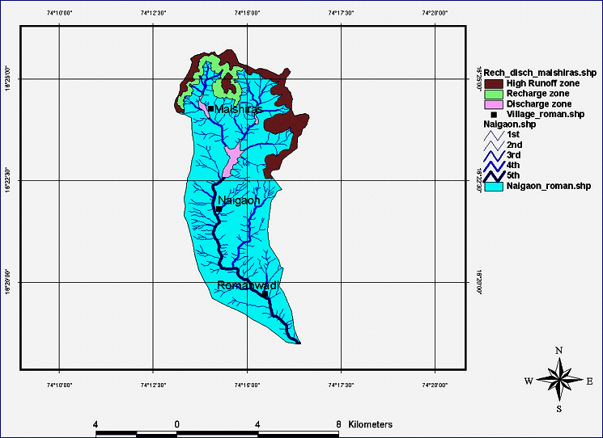

Advanced Center for Water Resources Development and Management (ACWADAM) undertook this investigation to provide scientific inputs for developing a first cut conceptual model for the groundwater resources in the project area. These inputs are based on rapid geological and hydrogeological mapping conducted without any advanced aids such as remote sensing. However, ACWADAM’s experience in hydrogeology helped describe the geological factors governing the accumulation and movement of groundwater
in the region. A broad water resources strategisation was also possible at the end of this exercise to provide direction to GGP on the processes required to consolidate its water management strategy further.

To go to the next step, it suggested that the water resources system be monitored to ensure improvements to the conceptual model and arrive at a fairly accurate overall water balance estimate that will help in the planning and execution of GGP’s water management strategy for the region and assess the exact nature and magnitude of the impacts of programmes on the water resources.

