This document is based on information received from Shri. Shekhar Raghavan of the Akash Ganga Trust, Chennai.

CASE STUDY – The Rain Centre, CHENNAI

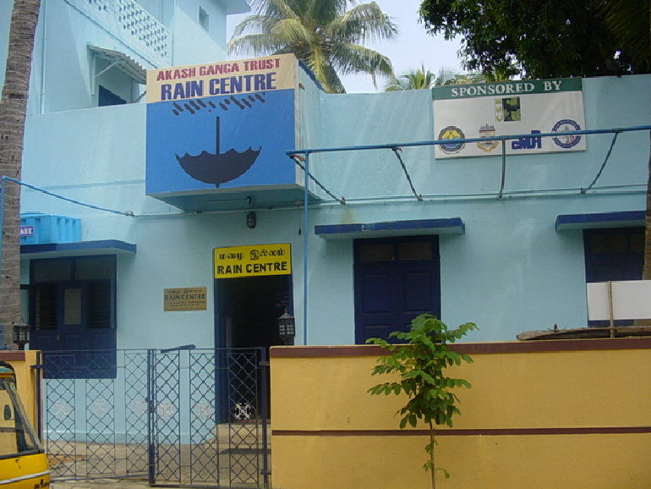

Introduction
60% of India is expected to be living in towns and cities by 2025. Municipal authorities are finding it more and more difficult to meet the water needs of this bourgeoning urban population. A classic example is the coastal city of Chennai (Madras), one of the four major metropolises of India and the capital of the state of Tamil Nadu. Inadequate supply of municipal water over the last two decades has forced the populace to relentlessly tap groundwater for its needs. This over-exploitation has resulted in the sharp depletion of the groundwater table and to deterioration of its quality as well. In Chennai's coastal suburbs in particular, seawater has already intruded into the coastal aquifers, rendering groundwater quite saline.

Rainwater Harvesting Activities in Chennai – Role of the Rain Centre
In order to accelerate the process of creating awareness about the need and relevance of RWH in a city like Chennai, a few like-minded people formed the Akash Ganga Trust in January 2001. On August 21, 2002, the Trust launched Chennai's Rain Centre, inaugurated by the Honorable Chief Minister of Tamil Nadu.
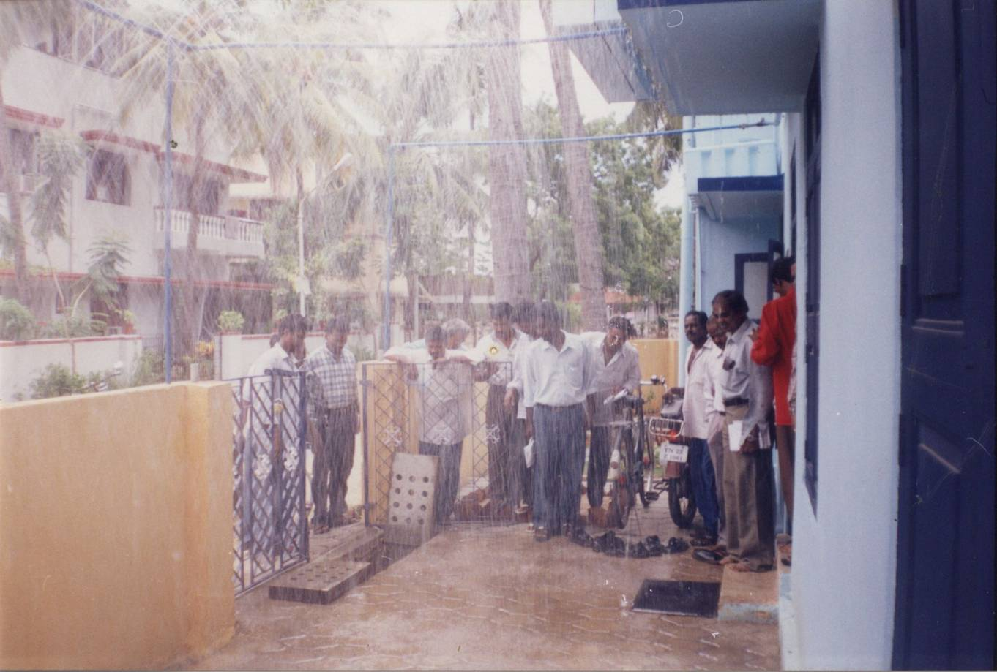
Rain Simulation at Rain Centre
The Rain Centre, the first of its kind in the country, is a one-stop information and assistance center on rainwater harvesting. The initial seed money for the center came from a few non-resident Indians living in the U.S. Further support, in the form of resource material, was provided by Centre for Science and Environment, an NGO head-quartered in New Delhi. The state government of Tamil Nadu is also one of the co-sponsors of the Rain Centre.

The Rain Centre, which is open to all, charges no fee for its services to the citizens. The Centre has been involved in all the three thrust areas, required to promote urban RWH and defined below, since its launch three years ago.
1. Education: Creating awareness regarding the importance of rainwater harvesting, both for immediate uses and also for sustaining the water table in the long run. This is done through posters, videos, booklets and working models.
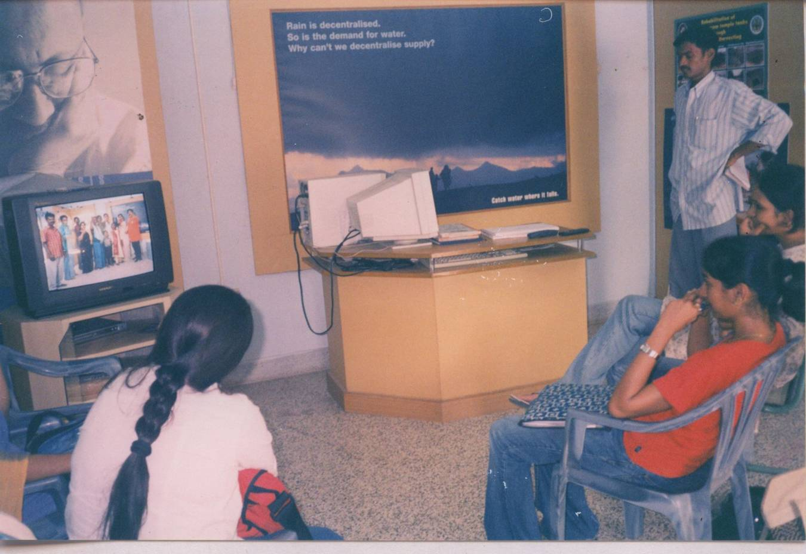
Video Show at Rain Centre
2. Implementation: Designing and conducting workshops and training programmes; providing free, site-specific advice to help citizens implement rainwater harvesting in an efficient and cost-effective manner.
3. Evaluation/Research: Carrying out studies on
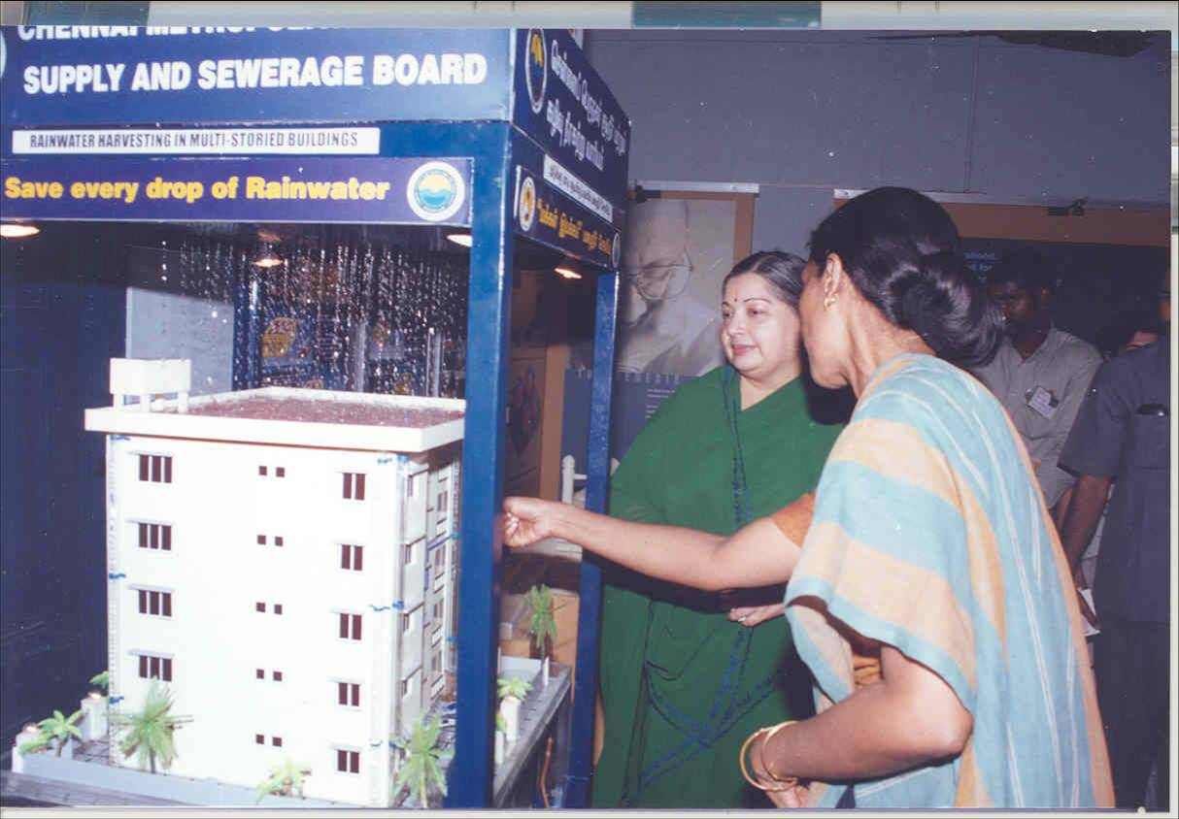
Working Model
i) The nature of the sub-soil in different city neighborhoods and its capacity to absorb large quantities of injected rainwater;
ii) The effectiveness and adequacy of various types of RWH structures; and
iii) The post-monsoon impacts on the quality and exploitable quantity of groundwater in places where RWH has been implemented.

Future Activities
Having created widespread awareness about the importance of RWH both in Chennai and throughout Tamil Nadu, the Rain Centre proposes to follow up by educating residents about potential problems that may result from RWH structures put up without the help of trained resource persons. Residents will also be helped in correcting and repairing any structures determined to be faulty.

As another water conservation measure, the Rain Centre also proposes to promote awareness about the importance of reuse of water that is used for bathing, washing clothes, vessels, vegetables etc.

In addition, the Rain Centre is offering its help and expertise to set up similar centers in other cities in India and is also conducting a survey to select cities in other countries where RWH for large-scale groundwater recharge would be relevant.

The Trust is also interested in setting up, at its own cost, RWH systems in charitable organizations such as old age homes, orphanages, homes for the physically and developmentally disabled, and homes for destitute women.

