

REPLY FORM

Half a Day Workshop : Developing PPCP Projects
29 Apr 2010, New Delhi
IHC, Amaltas hall

We are nominating the following person(s) to attend the programme.

S.№  Delegate (S) Details | Name of the participant | Designation | Mobile Number
1
2
3

Name
Company Details

Designation

Address

Tel

E mail

Fax

Complete the form and mail/fax/email to:
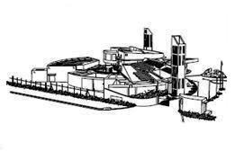 | CII – Godrej Green Business Centre  Survey No. 64, Kothaguda Post,  Near HITEC City, Hyderabad – 500 032  Tel: 040-23112971 – 73 Ext:223  Fax 040 – 23112837  www.greenbusinesscentre.org | C Sripati  Email: sripati.c@cii.in/sabyasachi.nayak@cii.in  +91 09849909672





