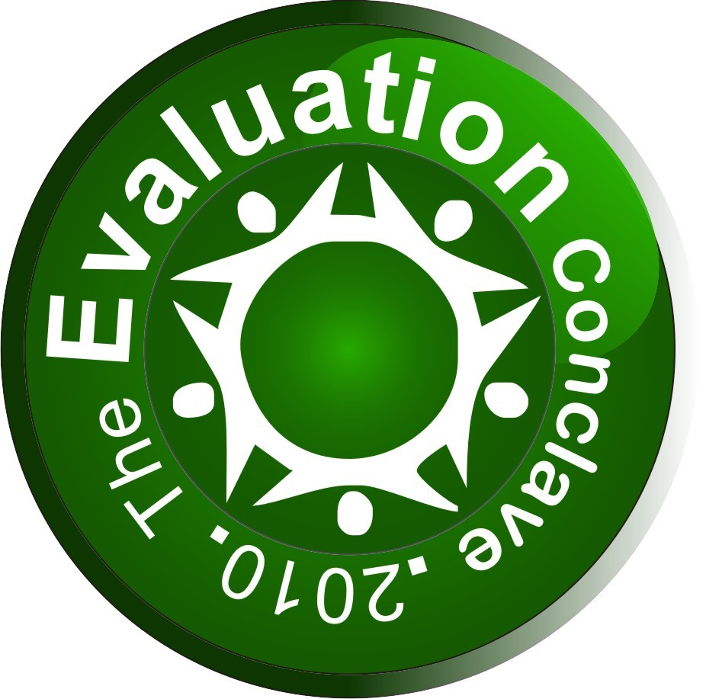
The Evaluation Conclave 2010
October 25-29, 2010 (New Delhi, India)

Registration Form

Name: 1.Mr. / Ms ___________________________________ Email: ________________________________
2. Mr. / Ms. __________________________________ Email: ________________________________
3. Mr. /Ms. __________________________________ Email: ________________________________
Organization __________________________________________________________________________
Designation __________________________________________________________________________
Address __________________________________________________________________________
City ______________________________ State _________________________________
Zip ______________________________ Country _________________________________
Phone ______________________________ Fax ____________________________________
Student Yes No
Registration fee
Sl. no | Categories | Foreign Delegates | Indian Delegates
1 | Multi/bi Lateral/Donor Agencies  Companies/Corporations/Governmental agencies | US $720/- Per Participant | INR 33,000/- Per Participant
2 | NGOs/CBOs/PVOs | US $600/- Per Participant | INR 27,500/- Per Participant
3 | Researchers/Students | US $600/- Per Participant | INR 27,500/- Per Participant
Participants must be regular/ full-time students in order to avail the discounted rate for students. Proof of the same needs to be attached with this registration form.
Total number of participants
(Avail 10% discount on group registration of 3 or more participants)

Mode of payment DD/Cheque No: Date:
Amount: Drawn on Bank:
Date: Place:

For wire transfer details or any other queries please write to us at contact@evaluation.conclave.org

