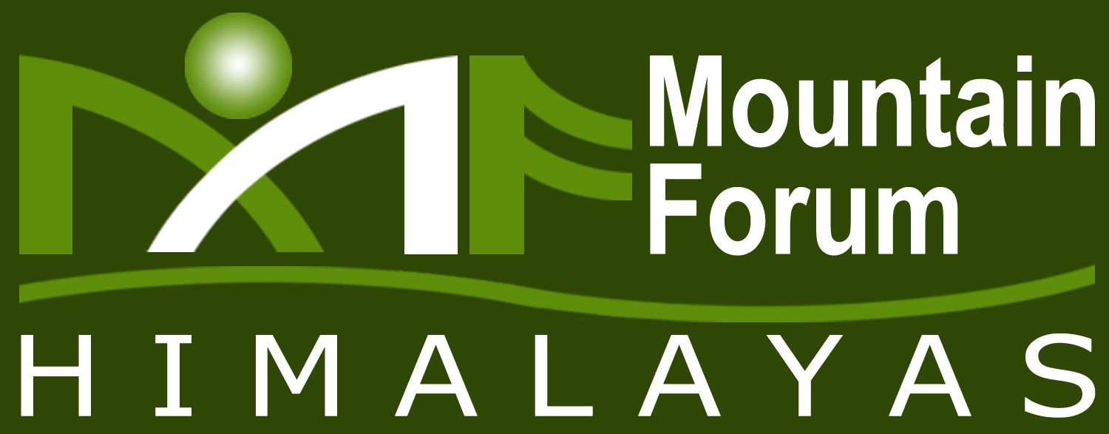

A Platform for Sustainable Mountain Development

Head Office: Shubham Cottage, 1st Floor, Near Block No. 20, B.C.S., Phase – 3, New Shimla – 171009, Himachal Pradesh
Telefax - 0177-2673439, E-mail: mfhshimla@gamil.com Website: www.mfhimalayas.org

Introduction
Mountain Forum Himalayas is an effective model of collective, collaborative and participatory action of different likeminded organization working on the developmental issues (Disaster Management, Mountain Livelihood, Mountain Water and Gender Mainstreaming) concerning the people in the Himalayan Region.
Mountain water is the core areas of concern of MFH and hereby time and again it has taken various active measures for promotion, awareness and sensitization of people on various water related issues to enlist-

- Two-Day State level Consultation on Rebuilding People’s Role in Effective and Sustainable Consumption, Conservation and Management of Water in Himalayas was organized by MFH on 22-23, March, 2007 in Shimla.

- With similar intentions of making mountain people more sensitized about the issues related to Mountain Water and involving their active participation MFH proposes to organize “Parvartiya Jal Utsav” (17th to 22nd March.)
Apart from carrying out the various seminars, presentations, Research works for the Scheduled Days from 17th to 22nd March, 2010. In various Districts of Himachal and Uttrakhand MFH also aims to give recognition to the people who have done pioneer work on various Water issues by entitling them as “Jal Yodhas”. To do so your work and details of the work are needed hereby you are requested to kindly fill in the enclosed Questionnaire. Request is further extended to post back the Questionnaire by 8th-9th February, 2010 on below given address or e-mail the response filled Questionnaire to mfhshimla@gmail.com Fax facility can also be availed by you (fax no.-0177 2673439)
Address
Shubham Cottage
First floor,Near Block No.20,
B.C.S, Phase-3, New Shimla-171009
Himachal Pradesh.
Telefax: 0177 2673157, 2673439
Note-It is to assure that details given in the Questionnaire will only be used to serve the purpose of recognition hereby you are requested to give authentic information. If your work gets nominated (as per the criteria of Deciding Committee) we will revert back to you with further details.
Thank you.
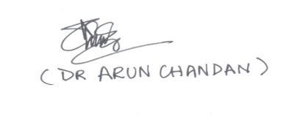
Executive Director
Uttarakhand Office: H. No. 452, Mansarover Colony, Ballupur, Chakrata Road, Dehradun-248001 Uttarakhand
Telefax: 91-135-2755040

Questionnaire for “Jal Yodhas” Nomination

Name

Age

Education

Water related Work done covering issues Water Conservation

Water Purification

Rain water Harvesting

Agriculture & irrigation

Any Other field

Work done as a part of Non-Governmental Organization

Research Work

Government Project

Individual efforts (Interest etc.)

Other (please Specify)

Full Description of Work Done

Summary of Institute with brief description of your work and association between the two.

Any Recognition given to the work (Award, Published etc.) Please Specify with full description.

Declaration:

I hereby declare that the above information given by me is authentic and is to the best of my Knowledge.

Signature
Date

