Organizers Supported By
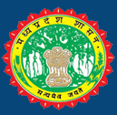




Govt. of Madhya Pradesh

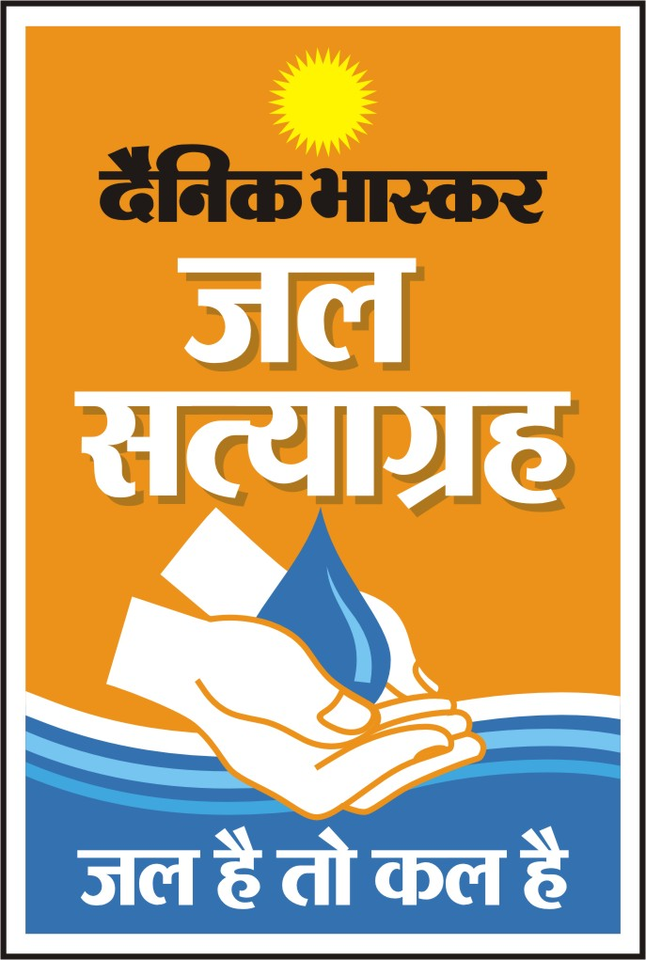

JALSATYAGRAH
National Conference on Water
June 25-26, 2010 at Noor-us-Sabah Palace
Bhopal

Tentative Programme

Day 1 | Program
1000 hrs to 1130 hrs | Inaugural Session  Welcome address by Chairman, Bhaskar Foundation  Address by : Principal Secretary, Panchayati & Rural Development  Address by : Sh Gopal Bhargawa, Hon’ble Minister for Social Justice, Panchayat & Rural Development  Keynote Address by : Mr. Armoogum Parsuramen, Director and UNESCO Representative, Bhutan, India, Srilanka & Maldives  Inaugural Address by : Shri Pawan Kumar Bansal  (Union Minister for Parliamentary Affairs and Water Resources)  Address by Guest of Honour: Shri Shivraj Singh Chauhan, Hon’ble Chief Minister, Madhya Pradesh  Vote of Thanks by : Sh Sanjeev Singh Sethee, Publisher, Water Digest
1130 hrs to 1200 hrs | Tea break
1200hrs to 1330 hrs | Session I  Efficient use of Water : Need for Institutional Mechanism  Chairman: Dr Ajay Mathur DG, Bureau of Energy Efficiency  Speakers-  Er. M. Gopalakrishnan  Secretary General , ICID (International Commission for Irrigation and Drainage)  Sh. Ram Mohan Mishra, Joint Secretary, Ministry for Water Resources, Govt. of India  Expert on Water Audit  Er. R.K. Khanna, Advisor, Water Management Centre, National Productivity Council
1330 hrs to 1430 hrs | Lunch
1430 hrs to 1600 hrs | Session II  Restoration of Water Bodies : Case Studies  Moderator : Shri Abhilash Khandekar , Editor, Dainik Bhaskar  Panelists :  Sh Surya Kant Jalan, Surabhi Seva Sansthan.  Sh Anurag Jain, Secretary, Govt of MP  Sh Rajendra Singh, Chairman, Tarun Bharat Sangh  Shri Vasimalai, Dhan Foundation  Shri Harnath Jagawat, Director  N M Sadguru Water & Development Foundation
1600 hrs to 1730 hrs | Session III  Health & Hygiene : Purity and Availability Matrix  Penalists :  Mr Ravi Sewak, Country Director-India, SafeWaterNetwork  WHO Representative,  Officer from PHE, Govt of M P  Health expert  Speaker from Tata Swatch
DAY 2
1000 hrs to 1130 hrs | Session IV  Water Harvesting & Ground Water Recharging: Every drop is precious  Chairman: Dr. P S Rana, Sr. Vice Chairman (CIDC) and Former Chairman, HUDCO  Panelists:  Dr. S.C. Dhiman, Member Secretary, Central Ground Water Authority, Ministry of Water Resources, Govt. of India  Case studies through representatives of Urban Bodies and NGOs  Representative from BIS  Expert from IIM
1130 hrs to 1200 hrs | Tea Break
1200 hrs to 1330 hrs | Maximizing efficiency, Cleaning impurities: Role of modern Technologies  Chairman: Mission Director, Rajiv Gandhi Drinking Water Mission  Jain Irrigation  Ion Exchange  TATA

** Speakers mentioned in the above programme have been invited but some of them are not yet confirmed.

