_______________________________________________________________________________________________________

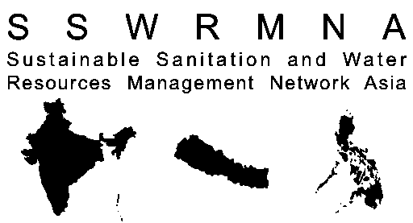  Sustainable Sanitation Water Resources Management Network Asia |   Sustainable Sanitation Center  Xavier University  (Philippines) |   Ecosan Services Foundation  (India) |   Environment and Public Health Organisation (Nepal) |   Seecon International (Switzerland) |   German Technical Cooperation Agency
_______________________________________________________________________________________________________

Training of Trainers Course & SSWM Expert Training Course
Sustainable Sanitation and Water Management (SSWM)

Venue:
Pune

Course Period:
SSWM Expert Course: 23rd September – 7th October 2010
Training of Trainers Course: 11th October – 14th October 2010

Registration form

First Name
Family Name
Date of Birth
Nationality
Position
Organization
Address

Phone
Email
Institutional Affiliation, if any
Why you are applying for this course? (in 100 words)

The Expert Training Course ( 27th September- 7th October 2010)
The 2-week SSWM expert training course will give an overview on Integrated Water Resources Management (IRWM), its basic concept and linkages to the reuse-oriented sustainable sanitation approach including a comprehensive overview on existing technology options and planning approaches. The course focuses on the human influence on the water cycle, the linkages to agriculture, and the sustainable use, treatment and reuse of water resources. It should enable participants get a holistic view on the water cycle and to identify more sustainable and locally appropriate technology solutions in relation to sanitation and water resources management.
Course Fee (incl. course material, 3 meals & 2 snacks per day)
Early bird (until August 14th 2010) | Rs 10,000
Regular registration (until September 26th 2010) | Rs. 12,000
Accommodation (if needed)
Shared Accommodation (good for 2, with air con, bathroom) | Rs 6,000
Note: Please indicate preferred choice with an X in the box

The Training of Trainers Course (11th October – 14th October 2010)
The 1-week training of trainers’ course module prior to the expert course will focus on teaching methods and the design of target group oriented SSWM modules. It will enable participants to design and conduct their own SSWM courses utilizing the philosophy and principles of adult learning. Pre-knowledge on sustainable sanitation and water management issues will be advantageous.
Course Fee (incl. course material, 3 meals & 2 snacks per day)
Early bird (until August 14th 2010 ) | Rs. 12,000
Regular registration (until October 10th 2010) | Rs. 15,000
Accommodation (if needed)
Shared Accommodation (good for 2, with aircon, bathroom) | Rs 2,500.00
Note: Please indicate preferred choice with an X in the box

The Expert Training Course + Training of Trainers Course

Course Fee (incl. course material, 3 meals & 2 snacks per day)
Early bird | Rs 20,000
Regular registration | Rs. 22.000
Accommodation (if needed)
Shared Accommodation (good for 2, with aircon, bathroom) | Rs 8,500
Note: Please indicate preferred choice with an X in the box

Date of Arrival
Date of Departure
Methods of payment
(Cash,/Check/ Bank Deposit)

__________________________
_____ ___________________________________________
Date Signature

Please send the completed form to:
By Post: Sreevidya Satish/Priyanka Patange, Ecosan Services Foundation, Pune
By Email: sreevidya.satish@ecosanservices.org , priyanka.patange@ecosanservices.org

